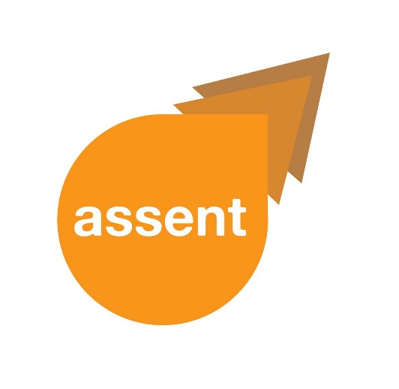**Easy Read**





**________________________________**

|  |  |
| --- | --- |
|  | **ASSENT Newsletter February 2019** |

**________________________________**

|  |  |
| --- | --- |
|  |  |

|  |  |
| --- | --- |
|  | Hereis project ASSENT  **Newsletter 4.** |
|  | **Difficult words**  are in **red** |
| at the **end.** | and **explained** |
| 1. **What have we been doing?** | |
|  | **We** now **have** **permission** |
|  | to **continue**  our **research.** |
| [Inspector 2](https://www.photosymbols.com/collections/socialcare/products/inspector-2) | We will **find out**  **what people think** |
| [Everyone](https://www.photosymbols.com/collections/ideas/products/everyone) | about **including everyone** |
|  | in **research.** |
|  | We will ask |
| [Research Meeting](https://www.photosymbols.com/collections/research/products/research-meeting-big) | * researchers |
| [Meeting Vote](https://www.photosymbols.com/collections/meetings/products/vote-2) | * Research Ethics Committee members |
| [Group 19](https://www.photosymbols.com/collections/people-groups/products/group-19) | * adults with difficulties |
| [Support](https://www.photosymbols.com/collections/socialcare/products/support) | * and people who   support them. |
|  |  |
|  | We have been looking at **guidelines** for **including people in research.** |
|  | We have nearly finished **writing our 1st**  **research paper.** |
| [Papers](https://www.photosymbols.com/collections/information/products/papers) | The paper is about   * **including people in research** by **law** |
|  | * **getting permission**   to do **research** |
|  | * **listening to advice**   from others |
| 1. **The Working Group** | |
| **C:\Users\Yvonne\AppData\Local\Microsoft\Windows\INetCache\Content.MSO\8317182B.tmp** | We had another  **Working Group.** |
|  | Members **thought** |
|  | about the **project website**  to **make it accessible**  for all. |
|  | **Ideas** involved |
|  | * updating **project news** |
| [Questionnaire 2](https://www.photosymbols.com/collections/research/products/questionnaire-2) | * adding a   **feedback form** |
|  | * including **ASSENT goals.** |
| 1. **Other News** | |
|  | Yvonne and Hayley |
|  | **won** an **award** |
|  | at the  **University of East Anglia**. |
|  | **They spoke** |
| **E:\Assent logo - with text.jpg** | **about** Project **ASSENT**. |
|  | Yvonne |
|  | went to a **meeting**  in London. |
|  | The event was  **about guidelines** |
|  | to **help people**  **make decisions** |
|  | around **treatment** |
|  | and **taking part**  **in research.** |
|  | Yvonne **shared ideas**  with other people. |

|  |  |
| --- | --- |
|  | The **Newletter**  is also **available in** |
| **Report** | * **Standard Text** |
| **Large print** | * **Easy Text** |
| **Headphones** | * and **Audio** file. |
|  | To **see another version** |
|  | or **ask questions**, |
|  | **e-mail Emma Jones** on [**Emma.L.Jones@uea.ac.uk**](mailto:Emma.L.Jones@uea.ac.uk) |
|  | or **telephone**  **01603 591125**  or send a text or WhatsApp **message** to **07392 879746**. |
| **Thank you.** | |

**List of difficult words**

**Permission** - Someone telling you that you are allowed to do something.

**Guidelines** – Helpful information on a topic.

**Law** – Rules written by the government.

**Accessible** – Something that everyone can access; for example, this newsletter is available in Standard Text, Easy Read, Easy Text and Audio.