Maytas Hub – Apprentice Guide
https://apprenticeship.uea.ac.uk/MaytasHub/
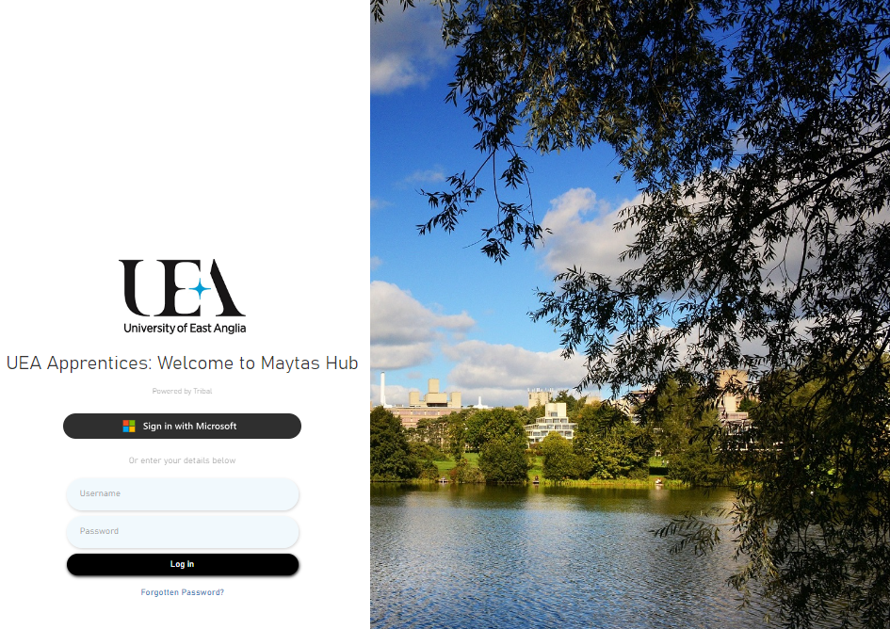
Figure 1. Login screen for UEA Maytas Hub Apprentice Portal

How to login

Logging into Maytas for the first time:
- Email sent to apprentice personal email address from apprenticeships@uea.ac.uk with instructions to complete data collection forms
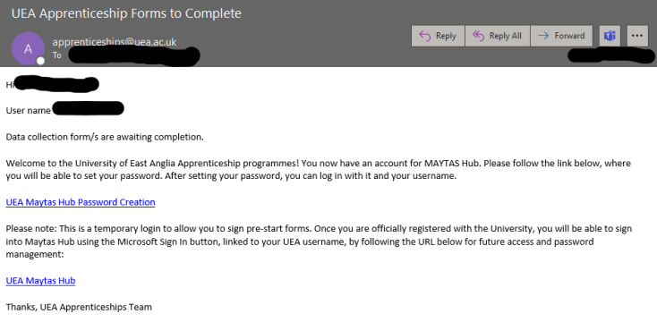
- Apprentice should click the link in the email to create a temporary password
- Apprentice will be taken to a screen to create a new password (password and username are temporary login credentials until UEA email and UEA username are issued)
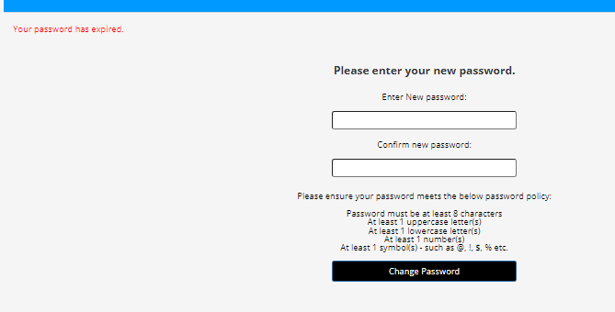
NOTE: if for any reason you get an error “Recovery ID has expired, please request a new one” please follow advice in section below: Error when logging in

- Set the password using the password policy and press ‘Change Password’
- If set correctly the following notice should appear, press Close and login using the username issued within the email and the temporary password.
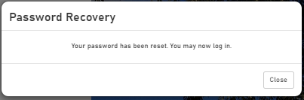
- The land page should appear or a message for data forms to complete.
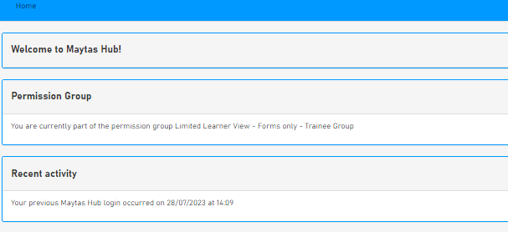

Error when logging in
- If during the process of logging for the first time an apprentice receives the following error, press OK.
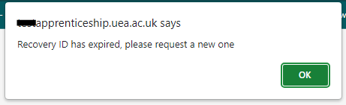
- The apprentice will be redirected to the main login page. Press Forgotten Password

- Enter the username in the original email sent to you and your personal email address, then press reset password
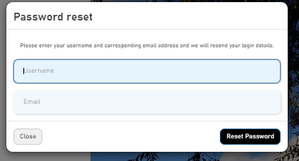
- The following message will appear in the top right of the browser
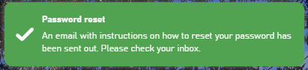
- An email should be received by the apprentice as follows. Follow instructions within.
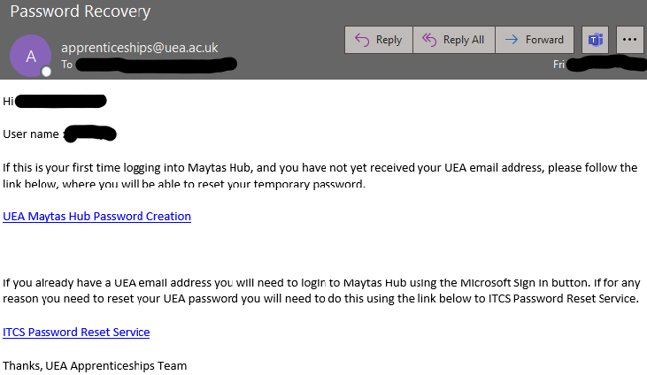
- If apprentice has yet to receive a UEA username, the link UEA Maytas Hub Password Creation should be followed.
- Apprentice will be taken to a screen to create a new password (password and username are temporary login credentials until UEA email and UEA username are issued)
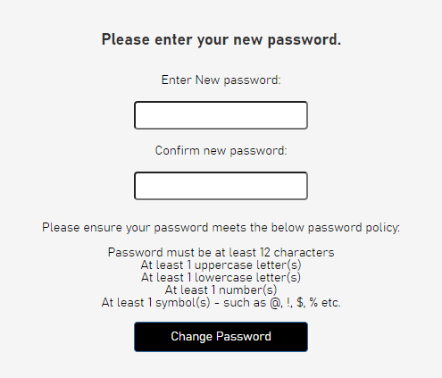
- Set the password using the password policy and press ‘Change Password’
- If set correctly the following notice should appear, press Close and login using username and temporary password.

- The landing page should appear or a message for data forms to complete.

Logging in to Maytas once you have a UEA email, username and password:
- Start by visiting the website: https://apprenticeship.uea.ac.uk/MaytasHub/
- Click ‘Sign in with Microsoft’ (this will use your UEA issued username and password)
NOTE: If for any reason the ‘Sign in with Microsoft’ button does not work once you have a UEA email/username you will need to contact apprenticeships@uea.ac.uk in the first instance for investigation.
DO NOT USE the ‘Forgotten password’ option. Any UEA password reset’s will need to be made via ITCS Password Reset Service - ITCS Password Reset Service.

How to complete a Data Collection Form
- When apprentice logs onto Maytas Hub, if a data form is pending the message below will appear
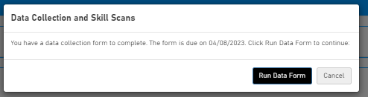
- Press Run Data Form to complete
- Depending on the form issued for completion there may be some visual differences to screenshots below. Complete all required fields.
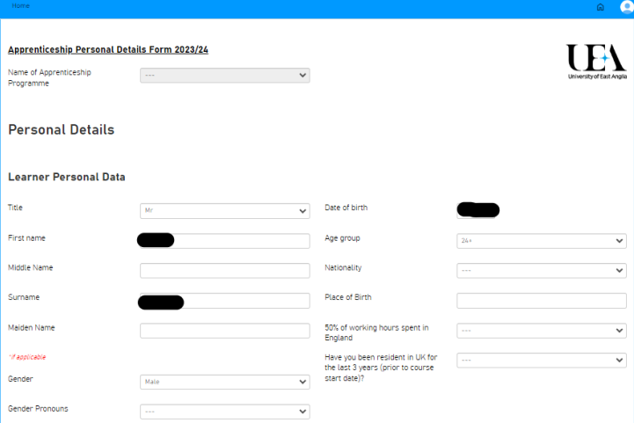

- If an apprentice attempts to save or submit without the required fields, error messages will appear.
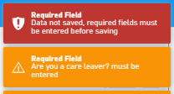
- When all required fields are complete, click submit and a confirmation message will appear as below
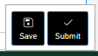
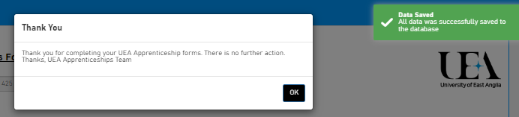

- Press ok and the landing page will appear.
- An email will also be sent to the apprentice to confirm data form completion.
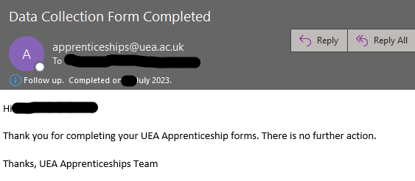

Who to contact for help
If for any reason you are unable to login to Maytas or you cannot view/complete your forms, please contact: apprenticeships@uea.ac.uk, with the subject: Maytas Error and a brief explanation of your problem and one of the team will support you in resolving the issue.

