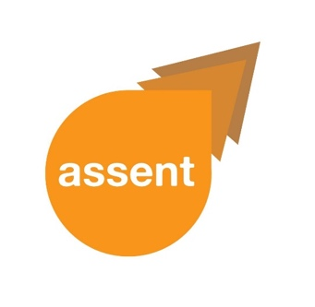

**Easy Read**

|  |  |  |
| --- | --- | --- |
|  |  |  |



**ASSENT Newsletter**

**December 2021**

**_________________________**

|  |  |
| --- | --- |
|  | This is **newsletter 1** for Project ASSENT extension. |
|  | **Difficult words**  are in **red** |
|  | and **explained** |
|  | at the **end.** |
| Year 2018 | Project ASSENT started in **2018** |
|  | Ended in **July 2021**. |
|  | To read our end of **project report** |
|  |  |
|  | You can go to our **website**  <https://www.uea.ac.uk/web/groups-and-centres/assent/documents> |
| **What has been happening?** | |
| **End of Project ASSENT Conference 2021** | |
| Date Jun 25 Year 2021 | Took place on **25th June 2021.** |
|  | It was **online**  Lots of people attended. |
|  |  |
|  |  |
| **Project ASSENT web-based guidance** | |
|  | We made an **online guidance.** |
|  | **Guidance** is about taking part in research |
|  | In a safe and sound way  The **guidance** has **three sections** |
|  | 1. **Laws** about including people in research . |
|  | 2. The **process** used to include people in research; |
| [Support plan3](https://www.amazon.co.uk/Mental-Capacity-2005-code-practice/dp/011703746X/ref=pd_lpo_14_img_0/257-4377106-1196700?_encoding=UTF8&pd_rd_i=011703746X&pd_rd_r=42522434-f0a6-4f48-9a53-d924dcff643c&pd_rd_w=CAYON&pd_rd_wg=ybjqZ&pf_rd_p=7b8e3b03-1439-4489-abd4-4a138cf4eca6&pf_rd_r=KGPB6W002AFT1RSSVKFE&psc=1&refRID=KGPB6W002AFT1RSSVKFE) | 3. **Practical supports** for including people in research. |
|  | Meeting BME  Some **people looked** **at** the **guidance** |
| Improve | They told us we can **make the guidance better** |
| Census Opinions  Now Next 1 | by **asking more people** what they think about it.  And then **doing what the people tell us**. |
| **Project ASSENT Extension** | |
|  | The **Nuffield Foundation** has given us money |
|  | To **make** the **guidance better.** |
| **What we will do to make the guidance better.**  **Focus group discussions** | |
|  | **Group discussion** with those interested in our research. |
| Census Opinions | We will **ask what they think** about the **guidance**. |
| **Paired interview** | |
| Meeting 11 | **Interview** with **adults living with capacity affecting conditions**  Support advice1  and their **supporters** or **carers**. |
|  |  |
| **Development of case scenarios** | |
| Meeting 8 | We will **interview** |
|  | **Researchers** and |
| Care Provider 1 | **practitioners**. |
|  | |
| Tristan 9Sad | We will ask them to tell us real **examples of communication**. |
| **?** | With **adults who live with capacity and communication difficulties**. |
| Tristan 9Sad | **Real examples** of **communication**. |
|  | Will **help researchers** |
| **?** | To **include** adults with capacity and communication difficulties. |
|  | In their **projects**. |
|  |  |
|  |  |
| **Seminar for all researchers** | |
| Zoom Meeting | We will **share our findings**  And **talk about** the **online guidance** |
|  | With **researchers** |
| CQC Group Meet 6 | And **those who approve studies**  in **England** and **Wales** |
| Website Link | The **seminar** will be **online** |
|  | If interested.  Contact the project leader, **Dr Karen Bunning**  Email: K.Bunning@uea.ac.uk |

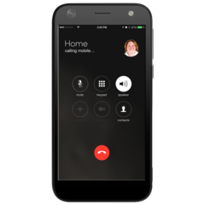

**Telephone:** 01603 591254

|  |  |
| --- | --- |
| **Publications**  Website Link | Check out our **most recent**  **publication**: |
| *  **What are we doing next?** | A systematic review and narrative synthesis of the research provisions under the Mental Capacity Act (2005) in England and Wales: **Recruitment of adults with capacity and communication difficulties**”  The paper looked at the **use of law and guidelines** **by researchers.**  **Few researchers** include **adults with capacity and** **communication difficulties in research**.  **Researchers** used **adaptations to include** adults with capacity and communication difficulties.  We will **continue after we get permission**. |

**The ASSENT team wishes everyone a safe and joyful Christmas break.**



|  |  |  |
| --- | --- | --- |
|  | | |
|  |  | |
|  |  | |
| **Thank you for reading this newsletter!** | | | |
| **Accessible information** | | | |
|  | | This **Newletter**  is also **available in** | |
|  | | * **Standard Text** | |
| **Large print** | | * **Easy Text** | |
|  | | To **see another version** | |
|  | | Or to **ask any questions**, | |
|  | | you can **speak to Karen Bunning.** Her **contact details** are: | |
|  | | **Email:** [k.bunning@uea.ac.uk](mailto:k.bunning@uea.ac.uk) | |
| Mobile Phone | | **Telephone:** 01603 591254 | |
|  | | Choose the **option that YOU prefer.** | |



**List of difficult words**

**Practitioner** – a person who practices something specific. For example, a medical doctor or psychologist

**Focus group**  – a group of people that discuss a particular topic together

**Recruitment** – inviting people to take part in research

**Adaptations** –changing something in

order to support it

**Law** - The rules set down by the Government.