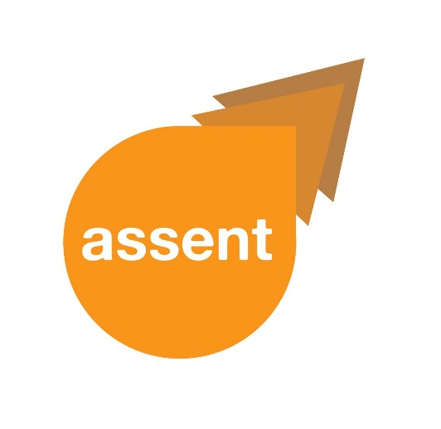**Easy Read**



**________________________________**

|  |  |
| --- | --- |
|  | **Newsletter September 2018** |

**________________________________**

|  |  |
| --- | --- |
|  |  |

|  |  |  |
| --- | --- | --- |
|  | **This** is the second newsletter for project ASSENT. | |
|  | We have been working on the first stage of the project | |
| Nove | and preparing for the second stage of the project. | |
| **What have we been working on?** | | |
|  | | The first block of Working Groups took place in July. |
|  | | The group co-produced project information sheets, |
|  | | a questionnaire for researchers, |
|  | | and interview questions. |
|  | | We have planned more regular Working Groups. |
|  | | In these group we will tell members about the project’s progress. |
|  | | We have been looking at the laws and guidelines about including people in research. |
|  | | We have been looking at how people are included in research. |
|  | | We plan to develop new ways of including everyone in research. |

**9: Any Questions?**

|  |  |
| --- | --- |
|  | We create all our project materials in |
|  | **Easy Text** |
|  | **Audio** |
|  | **Standard Text** |
|  | If you want this Newsletter in any of these |
|  | or if you have any questions, |
|  | please email Dan Leeson on [d.leeson@uea.ac.uk](mailto:d.leeson@uea.ac.uk) |
|  | or telephone  01603 591125 |
|  | or send a text or WhatsApp message to 07392 879746 |
| Thank you for reading this Newsletter | |

