Notice of a First
In the
Family Court at Norwich Combined Court Centre
Case Number Always quote
this
Applicant
Respondent
Applicant's Solicitor's ref
Respondent's
Solicitor's ref

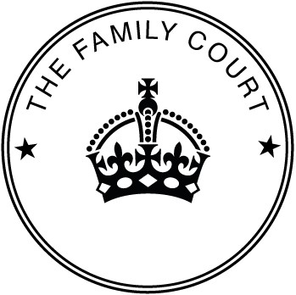
Appointment

The marriage of

Take Notice that
At the First Appointment which will be heard on
at 10:00 am
the [Applicant] [Respondent] [Will] [Will Not] be in a position to proceed on that occasion with a Financial Dispute Resolution appointment for the following reasons:
Dated:

Domestic Abuse Act 2021
Provisions in the Domestic Abuse Act 2021 have the effect of preventing an individual accused of abuse from questioning in person a party or witness in the case who is the victim of the abuse, and also prevents a victim of abuse from questioning in person the accused individual in specified circumstances.
If the court directs that the proceedings be listed for a hearing where oral evidence may be given, form EX740 (person making the abuse accusation) or form EX741 (person accused of abuse) ‘Application and information needed by the court to consider whether to prevent (prohibit) questioning (cross-examination) in person’ may need to be completed so that the court can consider whether questioning in person should be prevented. The court will send the appropriate form with
the court order.

