|  |  |
| --- | --- |
| **Project ASSENT February 2019 Newsletter**  **Progress Update** | |
| **Standard Text** | |
| Welcome to Newsletter Number 4 for Project ASSENT.  Our research is headed by the University of East Anglia and funded by the Nuffield Foundation (Law in Society Programme). | We are delighted to announce that we have gained full ethical approval to continue with ASSENT Stage 2. We will explore people’s thoughts about including adults with difficulties in communication and/or understanding in research.  We will ask the opinions of adults with such difficulties, those who support them, members of researcher ethics committees, and researchers. Our Team Research Associates, Yvonne Plenderleith and Hayley Ryan, are identifying places where we can recruit participants. More updates will follow. |

**The Working Group**

**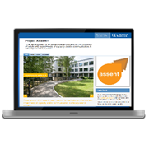***Our Working Group includes: Experts-by-Experience of aphasia after stroke; autism spectrum conditions; dementia; head injury; learning disability; and mental health conditions, as well as those who support them. Members are from local user-led organisations in Norwich or have established connections with the University of East Anglia.*

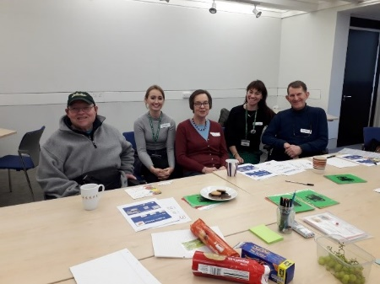**Project ASSENT Website**

Working Group members continue to meet every three months. January’s meeting was about the ASSENT website. We discussed ways in which it could be made to appeal to a wider audience. Ideas involved providing both summaries and details, adding a feedback form, and highlighting project objectives on the front page.

[](https://www.google.co.uk/url?sa=i&rct=j&q=&esrc=s&source=images&cd=&cad=rja&uact=8&ved=2ahUKEwjOnq2gw-XdAhVEqxoKHYx-AX4QjRx6BAgBEAU&url=http://www.mencapliverpool.org.uk/want-help/easy-read-services/&psig=AOvVaw0RV57GCi-M7ZtH1YQ2BCJa&ust=1538493010059520)**Materials in accessible formats**   
We aim to make materials in accessible formats so that everyone can hear about our project. The Newsletter is available in Standard Text, Easy Read, Easy Text and Audio.

|  |
| --- |
| . |
|  | |
| **Future Updates**  If you would like further information on our project, please contact Emma Jones: Emma.L.Jones@uea.ac.uk with your name, interests and contact details. We will send our bi-monthly newsletter to you and keep you informed.  **Thank you for reading the fourth Project ASSENT Newsletter.** | |
|  | |

**Update on Stage 1: Ethico-legal Landscape**

**1.1 Documentary Review from the Health Research Authority (HRA)**

Current guidelines recommended by the HRA for including adults with communication and/or understanding difficulties in research have been reviewed. We are analysing the content to identify any support for inclusion but also any inconsistencies and oversights in advice for researchers.

**1.2 Law Paper**

We have undertaken most of the research for our law paper, which will be the first publication from the ASSENT project.  Professor Rob Heywood produced a full first-draft and other Team members have since provided feedback. Rob is now in the process of revising the paper in preparation for submission at the end of March 2019.

The paper is focused on several interesting points, including the scope of the Mental Capacity Act 2005 in respect of research, the problems with the criteria for ethical approval, and the difficulties with the consultee system in practice. The target journal for the article is *Medical Law International.*

**1.3 Researcher Summit Award**

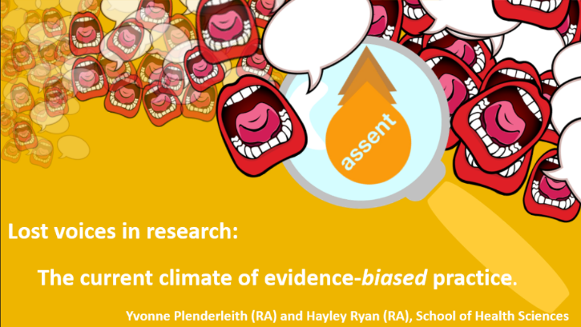

Yvonne and Hayley were awarded first prize at the University of East Anglia Researcher Summit. The competition was based on a single Powerpoint slide (left) and three-minute presentation. The event was an opportunity to highlight the importance of establishing an ethically-robust means of including people with communication and/or understanding difficulties in research.

**1.4 Decision-Making and Mental Capacity Conference**

Yvonne attended a recent conference about the new National Institute for Clinical Excellence (NICE) guidelines on decision-making and mental capacity around consent to treatment. The meeting offered the chance to consider the differences regarding consent to treatment versus research with health professionals, lawyers and policy-makers.