



The Seeing Red Project - Improving the End-of-Life Care Pathway across West Norfolk Geographic Place

Alice Dean, Clinical Educator, Tapping House, King’s Lynn, UK and Norfolk Initiative for Coastal and rural Health Equalities (NICHE Anchor Institute), Norwich, UK.
Ethics approval was sought from the Calicott Guardian and the Information Governance lead at Tapping House.
The funding for the Embedded Fellowship that enabled the 'Seeing Red' programme of learning, development and evaluation was made by the Norfolk Initiative for Coastal and Rural Health Equalities (NICHE), Anchor Institute at the University of East Anglia.

Background
In England, achieving a person’s preferred place of death is a national priority (NHS, 2019). 63% of people wish to die at home, yet hospital remains the most common place of death (Public Health England, 2016). Higginson (2016) notes that in the UK most people do not die under the care of a Specialist Palliative Team. Higginson (2016) and NHS England (2015) highlight the need to move towards educating generalist hospital staff to recognise death and have the confidence to have important conversations with patients and their families regarding wishes at end-of-life. The National Palliative and End of Life Care Partnership (2021) agree, stating that clinicians at all levels need to be educated and supported to provide quality end-of-life care and this should be considered a priority for everyone.
It is widely accepted that West Norfolk have an increasingly ageing population and in the last ten years the number of people aged 65 and over has increased by 17.9% (Age UK, 2024). This naturally results in an increasing number of patients requiring end-of-life care in the local acute trust and with the most recent Care Quality Commission report highlighting a need for improvement in the quality of the end-of-life care provided (CQC, 2020).
Proactive identification and planning can result in improved end-of-life care, an increased number of people dying in their preferred place of death, and a reduction in hospital bed days (The Gold Standards Framework International, 2024). Last July, the local acute trust and hospice collaborated and were awarded funding for an embedded fellowship from the Norfolk Initiative for Coastal and rural Health Equalities (2025) to improve the end-of-life care pathway across West Norfolk Geographic place.

Aim
The Seeing Red Project was an embedded service evaluation improvement project with the aim to provide enhanced care to those in the last days of life across West Norfolk.
For the purposes of this project, patients in their last days of life were identified and defined by considering The Gold Standards Framework (GSF). Those patients categorised as Red patients under the GSF were the focus of this project.
The aim of The Seeing Red Project was to deliver, and improve the accessibility to, high quality end-of-life care without delay across West Norfolk. The objective was to identify and achieve the preferred place of death (PPOD) for GSF Red patients within the Queen Elizabeth Hospital NHS Foundation Trust in Kings Lynn.

Approach
Initially, the project involved both formal and informal education and modelling to generalist hospital staff. Data was collected monthly for twelve months on whether the patient’s preferred place of death was achieved, the number of bed days spent waiting for the person’s preferred place of death, and qualitative feedback from staff and patients for each of the three workstreams. Data was also collected from some of the key stakeholders within the rural area, highlighting barriers and facilitators they face when they are involved in rapid end-of-life discharges from the acute sector. The Seeing Red Project focussed on the core themes of Norfolk Initiative for Rural and Coastal Health Inequalities such as sustainable workforce development and transformation, system collaboration and transformation through partnership working and improving health inequalities across rural and coastal communities (NICHE, 2025).
There were three main workstreams for the project.

1. Role Modelling and Embedded Clinical Education
The Clinical Project Manager for Seeing Red spent twelve months working alongside the End-of-Life Discharge Co-ordinator and across various wards at Queen Elizabeth Hospital Kings Lynn Foundation Trust (QEHKLFT). The End-of-life Discharge Co-Ordinator was a new dedicated role within the Palliative Care Team and the start of the role coincided with the start of Seeing Red. The embedded nature of the role of the Clinical Project Manager for Seeing Red had the aim of upskilling generalist ward staff and the End-of-Life Discharge Co-Ordinator in recognising and prioritise actively dying patients whilst building confidence to initiate conversations about approaching death.

- Gold Standards Framework (GSF) Training n=6 Participants

One medical ward in the acute trust was nominated to complete The Gold Standards Framework Hospital Training Programme (GSF, 2025). This consisted of six key stakeholders within the clinical area, including the Ward Manager, medical consultant and the wards Clinical Co-ordinator. Due to the timing of the next available programme, this part of the project was guided by the Lead Nurse for Palliative and End-of-Life Care within the trust to support with evaluation and gaining the recognised GSF accreditation.
This was initially the only formal education that was going to be offered as part of The Seeing Red Project. However, at the start of the project in September 2023 it was very clear there would be a delay in starting the GSF training programme which could not be commenced until April 2024. This provided an opportunity to think differently about what other formal training options may be available for generalist staff which led to the development of the third workstream.

- Education was formally offered through Quality End of Life Care for All® n=14 Participants

Quality End of Life Care for All® (QELCA®) is an innovative programme in end-of-life care education which was designed by St. Christopher’s Hospice. The programme focuses on transformational learning theory with the aim of empowering and enabling participants from any discipline to become change agents in order to achieve improved quality for patients and their families at the end-of-life (St. Christophers, 2024; Quality End of Life Care for All ®, 2024).
QELCA® comprises of three classroom days, two practice experience days across the hospice setting followed by six Action Learning sessions once a month so that participants are supported with their ‘Priorities for Change’ project. Classroom days are tailored to the needs of the group and so for the two programmes run during Seeing Red the programme comprised of sessions such as ‘Symptom Management’, ‘Recognising Dying’ and an ‘Am I Dying’ role play session so that participants could practice those important conversations around patient wishes at end-of-life.
The Seeing Red Clinical Project Manager and the Ward Manager for the Inpatient Unit at the hospice facilitated two intakes of this programme with seven participants in each intake who worked in various clinical roles across the inpatient setting at the QEHKLFT including, Physician Associates, Occupational Therapists, Physiotherapists, Healthcare Assistants, Registered Nurses, Trainee Nurse Associates as well as including the End-of-Life Discharge Co-ordinator.

Parallel to these three workstreams was embedded partnership working between the local hospital and hospice to prioritise GSF Red patients. This included service evaluation of barriers and enablers by jointly working with key stakeholders to aim to achieve rapid discharge at end-of-life.

Outcomes and Discussion

Role Modelling and Embedded Clinical Education
Bandura’s social learning model (1977) and Whitehouse et al (2022) highlight the importance of learning within the care setting. Freeman and Wood (2023) support this model, highlighting the importance of the role modelling approach to encourage embedded learning in generalist settings in order to improve the quality of palliative care delivery.
The first workstream to be implemented was the role modelling of the Clinical Project Lead to work alongside the new dedicated End-of-life Discharge Co-ordinator role. This involved upskilling the End-of-life Discharge Co-ordinator and other generalist hospital staff to recognise dying and to support the use of palliative tools such as The Gold Standards Framework and The Karnofsky Scale (1949) to prioritise the patient caseload for that day. To do so, the Clinical Project Manager for Seeing Red had an honorary contract with the QEHKLFT and spent one day a week alongside the End-of Life Discharge Co-Ordinator.
It was very important at the beginning of the project for the Clinical Project Lead to remain neutral across both the QEHKLFT and the hospice and gain an understanding of both organisations’ barriers and come up with mutually beneficial ways of improving the end-of-life pathway. It is widely recognised by the literature that a mutual understanding of each other’s organisational challenges is key to developing improved relationships amongst key stakeholders (Tan and Blackford, 2015; Richardson, 2016; Collins et al, 2022; National Palliative and End of Life Care Partnership, 2021; and Haywood et al, 2014).
Prior to The Seeing Red Project, hospice patients were assessed at the QEHKLFT by a palliative nurse from the hospice. One of the first key barriers highlighted by the hospital palliative team was that this is a barrier that could potentially be removed by the hospice automatically accepting referrals from the hospital’s Palliative Care Team, trusting their expertise and therefore saving time and resources. The Clinical Project Manager analysed data by source of referral which showed that hospital referrals generally had patients admitted who had the shortest length of stay at the hospice. The data also showed that referrals from other sources such as community services/GPs resulted in longer admissions for patients therefore Palliative Nurses continued to assess these patients with the aim of ensuring that patients met the service criteria, whilst in turn increasing accessibility and bed availability.
Following a trial period of hospice staff not assessing and accepting the clinical judgement of the Palliative Care Team at the QEHKLFT, this pathway remains in place and appears to be a sustainable change as a result of the project. Back in July-September 2023, at the start of the project, the average length of stay on the Inpatient Unit at the hospice was 24 days. The most recent data from January-March of 2025 shows that the average length of stay is 16.5 days. This shows that this change to the pathway had a positive effect on the average length of stay on the Inpatient Unit in terms of economic benefit.
A new end-of-life discharge checklist was used to try and empower the generalist staff to ensure that patients leaving hospital for their PPOD had the correct tools and support in place to enable this such as Recommended Summary Plan for Emergency Care and Treatment form (Resuscitation Council, 2024), referral to community teams, appropriate medications and medication charts and this was based on feedback from key stakeholders receiving end-of-life patients back into their care about what aspects could facilitate a smoother and more expedient discharge to the patient’s home, or care home or nursing home.
The role modelling aspect of The Seeing Red Project included sharing knowledge with a wide range of healthcare professionals, such as teaching healthcare assistants how to physically position patients who have audible secretions as a proactive way to try and alleviate symptoms whilst waiting for registered nurses to give medications. This also involved supporting medical consultants to involve patients and their relatives when reviewing their Recommended Summary Plan for Emergency Care and Treatment wishes (ReSPECT) upon to their discharge to their PPOD in order to avoid any unwanted readmissions to hospital.
Following the patient’s journey allowed for continuous ad hoc teaching with a wide range of generalist hospital staff along the way. A major part of the role involved facilitating important conversations with patients and their families around end-of-life care. Bell et al (2009) suggest that the best way to develop communication skills at end-of-life is through interaction with patients and their relatives in real time. Bryan et al (2016) highlight the importance of empowering generalist staff to have increased confidence in having important conversations as staff can often have the knowledge but can have a fear of getting it wrong when having important conversations. Consequently, the project focused on attempting to build confidence with the aim that this increased confidence in generalist staff would increase the number of conversations had, and in turn, increase the number of patients having their Preferred Place of Death (PPOD) achieved.
This workstream also involved facilitating discharges, whether this was to the hospice or to the patient’s own home with the support of Hospice at Home or a Fast Track funded domiciliary care agency. New tools were implemented such as a Palliative Care Folder so that each ward area has access to all of the Palliative Discharge information for all three of the counties that access the hospital. The West Norfolk Discharge information included the Tapping House services numbers such as Rapid Response number, a crucial service for those to be able to access unplanned end-life care needs for those with less than a year prognosis with the aim of benefiting those with a longer prognosis in addition. This was difficult to evaluate effectively due to so many other factors affecting end-of-life discharges.
The End-of-Life Discharge Co-Coordinator reported their key takeaways from the project were that they were now able to use the Gold Standards Framework (The Gold Standards Framework International, 2024) to recognise where a patient is in their prognosis and use this to prioritise their caseload daily. The participant also reported an increased confidence when liaising with doctors to encourage them to speak with patients and their families and have open and honest conversations about their wishes including preventing unwanted readmission to hospital and updating their ReSPECT (Resuscitation Council UK, 2024) forms when they are being discharged from the acute setting with a palliative prognosis.
Below are some of the qualitative feedback from patients and their loved ones with regards to the embedded role modelling aspect of Seeing Red.
“The transition from the hospital to here (the hospice) was seamless and happened the same day; they knew everything about me and the same nurse who I saw at the hospital was here when I arrived which was so reassuring”.
“The hospital and hospice team worked so hard together to get my wife home to where she wanted to be as quickly as possible. I’m so grateful to fulfil her last wish”.
“Thank you for your honesty about my husband’s condition. It’s so important to him to die at home and I’m so glad you were honest and gave us the choice about whether to wait for more care or to prioritise getting him home to be with me”.

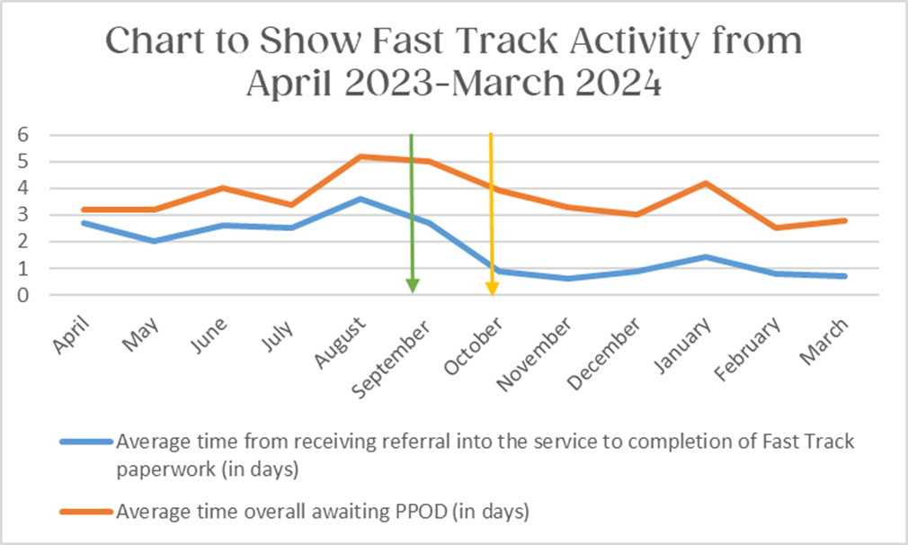

The graph above shows that, on average, in August 2023 prior to the role becoming a dedicated role within the palliative team, the amount of time a patient spent waiting from being referred into the service to their referral for their preferred place of death being completed was 2.7 days in April 2023. The chart shows a clear correlation after six months of dedicated End-of-Life Discharge Co-ordinator being in post. When data was collected at the end of the project- this reduced to an average time of 0.6 days in March 2024 evidencing that referrals to the person’s PPOD were on average being completed on the same day as they were made known to the service.
Prior to the commencement of The Seeing Red Project the End-of-life Discharge Co-ordinator role sat within the generalist discharge planning team in the acute setting. This meant that previously, there was no role specifically dedicated to prioritising patients who were dying over general discharges. Previous data shows that this had a negative impact on the amount of time a patient waited for their preferred place of death. Whilst it is obvious there are significant benefits to the patient of a more rapid discharge to a person’s PPOD, there are also economic benefits to the trust. Gould et al’s (2020) study estimates that an “excess bed day” which refers to a hospital stay that extends the expected length of time whereby a patient is fit to be discharged but waiting for social care or placement, costs on average £345 and that a general hospital ward bed costs £586.59 per day. This “excess bed day” figure is echoed by The Department of Health and Social Care in 2023. Overall, this reduction in bed days could potentially have a marked financial benefit for the trust.

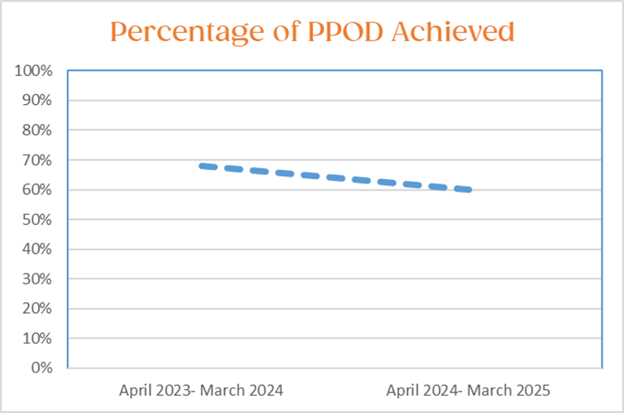

The graph above shows the percentage of PPOD achieved for those patients on the End-of-Life Fast Track caseload and therefore deemed to be in approximately their last six weeks of life. The data shows that on average, for the 12 months following April 2023, PPOD was 68% and that this rate decreased compared to 60% achievement rate from April 2024-March 2025. Whilst this decrease is disappointing in terms of the aims of the project, there are several factors that influenced this.
Firstly, it could be argued that there is some evidence that an increased recognition of dying resulted in an increased caseload of patients.

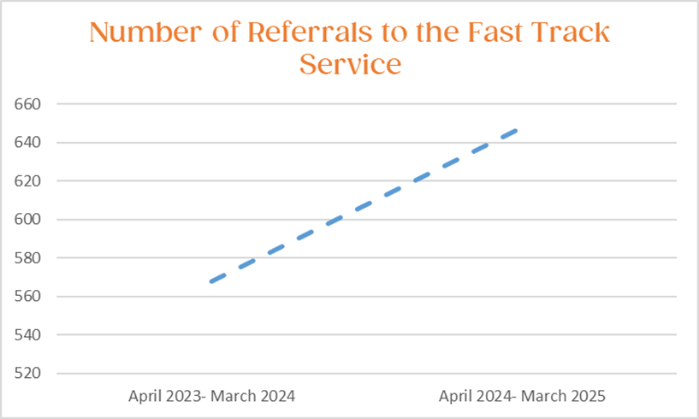

This graph shows the number of referrals received to the Fast Track Service comparing the start of the project to the end. The data shows that the number of referrals has risen from 568 patients on average for the year of April 2023- March 2024 to 648 patients for the year of April 2024- March 2025. Therefore, it could be reasoned that this is why the Preferred Place of Death rate has actually decreased in the last year as demand for the service and for an end-of-life bed has increased markedly. It could also be suggested that this is due to the increase in generalist staff knowledge and confidence to recognise dying, therefore inpatient referrals have increased as a direct result. This theory is supported by the National Audit for Care at the End-of-Life data (NACEL, 2024). The NACEL data showed that in 2023 75% of staff within the trust felt confident in recognising dying; in 2024 this rose to 95% (NACEL, 2024). Whilst this could be down to a wide variety of factors, this data does highlight an increase in staff confidence within the acute trust at recognising dying.
The NACEL audit shows that staff feel more confident in recognising dying and this could be linked to staff feeling more confident in having important end-of-life conversations and more empowered to recognise those imminently dying. However, it could be argued that as identification of GSF Red patients and preferred place of death increases, so does the demand for ‘Fast Track’ placements or hospice beds which could have resulted in a decreased achievement of preferred place of death due to high demand for these beds.
There were several other factors that could have impacted the PPOD results. Over the course of the project, there several previously existing Fast Track Nursing Home placement beds that were closed and/or became unavailable. As services became more stretched, Fast Track Continuing Healthcare were required to make their criteria more stringent and only accept those patients who were rapidly deteriorating and so it became much more difficult for those patients who were dying, but not as rapidly, to have access to this funding or expeditious placement. It should also be noted that one unforeseen effect of generalist staff recognising dying sooner and referring to the patient’s preferred place of death increases demand for end-of-life care beds as patients potentially occupy those beds for longer than if imminent death was only recognised at the last moment, or if those patients were to die in hospital.
Prior to the commencement of Seeing Red, hospice bed occupancy rate was 70% in July-September of 2023 and this has since increased to 85% for January-March 2025. It was apparent that patients often arrived at Tapping House very late in their trajectory, sometimes spending only short hours on the Inpatient Unit before dying. It is beneficial to the quality of end-of-life care delivered for patients to spend longer at the hospice prior to death as patients and their loved ones have a longer amount of time to complete last wishes and enjoy all that the hospice has to offer whilst conscious. However, this does result in an increased bed capacity at the hospice and can result in larger waiting lists at times. Early identification and enhanced communication skills are great to determine PPOD, but it could be argued that more capacity for end-of-life beds in West Norfolk is essential as it is not always possible to achieve PPOD if there are no beds available. This poses the dilemma of patient and family experience versus cost efficiency and bed capacity.
After The Seeing Red Project concluded, Pedar’s Way Unit opened in the QEH in December 2024, a five bedded unit for those who transfer out of hospital is not possible.
It should be noted that obtaining service user feedback was met with challenges. It can be difficult to ascertain feedback when evaluating end-of-life care due to the nature of the evaluation is not usually the priority for the family of the deceased at that time.

Gold Standard Framework Outcomes
The Gold Standards Framework Hospital Programme commenced in April 2024 and ran until May 2025 and required the involvement of multidisciplinary team members from the chosen medical ward to attend online webinars once a month for twelve months.
Initially, the outcomes were tangible. The Ward Manager and Ward Co-Ordinator set up an Advance Care Planning board for patients and their families which explained what the term ‘end-of-life’ means and where support can be sought, both in hospital and in the community. The team implemented a GSF board for clinical staff and GSF codes were included in patient handovers to highlight patients’ needs and wishes and highlight those GSF Red patients requiring a more rapid discharge from hospital.
However, there were several barriers that were too challenging for the team to overcome. These included challenges such as the ward having to move to another area due to construction work which meant losing the Multi-Disciplinary Team office space and there was no funding available to pay for GSF/Advance Care Planning boards on the interim ward. The team reported a lack of medical input as there was poor continuity of doctors, with only one interim consultant and rotating junior doctors. The Ward Manager and Clinical Co-ordinator who had been leading the team and programme had initially been promised allocated protected study time to be able to work on the portfolio, however the Ward Manager was then moved to a medical ward as acting Ward Manager to cover staff sickness in order to meet service needs.
One positive takeaway is that the members of staff that were able to attend all reported that their clinical knowledge of GSF had increased and therefore their understanding of how to recognise where a patient is in their journey and what support and care they need a result. However, due to this disruption and lack of continuity and system failure, engagement with the programme went no further. Team members highlighted that the sessions included healthcare professionals from a huge variety of hospital across the country, meaning that the training was quite generic. It could be argued that this this highlights the downsides of a very structured, generalist programme of education that is not specially tailored to the needs of the organisation and is not able to be supported by the wider organisation.

Quality End of Life Care for All® Outcomes
One of the first key impacts that came to light was that the team found it immensely valuable to have a deeper understanding of the services the hospice provided, the criteria for these services and how they can refer into these services. It was clear that prior to the programme the team had a limited knowledge of the wider services available for patients and their families with a palliative diagnosis in West Norfolk. The learners cascaded this information within their organisation, and this has therefore directly impacted patients and their families knowing about and accessing these services.
Participants managed to achieve some practical changes within the acute setting such as implementing two-handled beakers for patients across the entire hospital. This came about as one learner saw that the hospice beakers had two handles and were much easier for patients to use, therefore increasing their independence and maintaining their dignity. During the practice experience debrief it was commented on how the beakers in their workplace were only ever one handled and this was often very impractical when it came to patient independence if they had weakness to one side or were particularly frail. Whilst initially the transformation was aimed at improving independence for those at the end of their lives, this participant was able to implement the beakers in all clinical settings across the entire trust, showing how widely the QELCA® programme reached. Another example of a tangible improvement was increasing the availability of matching crocheted hearts for patients who are imminently dying or have died, for their loved ones to have as a token of continuous connection when they could not be together. Several of the participants picked up on this during their time shadowing on the Inpatient Unit and agreed this was an achievable and measurable goal for their clinical areas. One participant uses crocheting to practice mindfulness and therefore this had added benefits for them as they were able to contribute to the stock of hearts whilst practicing some self-care. Participants collected qualitative data from patients and their families to provide a rationale and evidence the impact of the use of crocheted hearts to their line managers and as a result now have these more widely available for any patients and their families at end-of-life across these clinical areas.
Outcomes did not only include practical changes. Following one of the practice experience days in the hospice setting, one of the nursing assistant’s key priorities for change was to be more present with her patients. The participant reflected very candidly about the fact that they are often so emersed and overwhelmed by the workload that they can overlook the person in the bed, focusing more on the task at hand. They reflected on the fact that they have no extra time with patients, but that in the time that they do have they feel they could be more present with their patients by getting to know the patient as a person and treating them as more of an individual than a ‘task that needs completing’. During the course of the programme they reported they were actively doing this as part of their ‘Priorities for Change’ and found that they had more enjoyment from their work, resulting in increased job satisfaction from interacting meaningfully and ultimately expressed they experienced less burn out as a result.
Not all of the participants’ ‘Priorities for Change’ were achieved by the end of the course. This was due to different processes that were in place which some learners felt did not allow for change to be implemented in a timely manner, despite their best efforts. It should be mentioned that the fact the learners were so engaged and willing to be change agents within their own organisation played a huge part in the success of the programme. The support provided by the acute trusts’ Palliative Care Team also had a marked impact on the programme and resulted in the added benefit of increased collaboration and partnership working between the organisations.
Another key outcome was a change in culture one of the participants reported amongst the physiotherapy team. Firstly, one of the physiotherapists attending the programme reflected on the importance of providing quality mouthcare to patients and explained that actually, they would have time to support patients with this and that if patients had more comfortable and hydrated mouths they may be more likely to be able to communicate their goals and this may support a smoother patient assessment. They explained that whilst they appreciated time is often a huge barrier for nursing staff to provide mouthcare to patients, they felt that given some training that this was something that their therapy team could support with. Therefore, part of their ‘Priority for Change’ included one of the Specialist Palliative Care Nurses providing a mouthcare training session to the members of the therapy team so that they were equipped with the knowledge and skills to provide mouthcare to patients. This demonstrates how ‘out of the box’ thinking and effective leadership from a change agent can have a direct impact on the wider acute team and could potentially result in a better quality of care delivered to patients.
This participant also explained that after reflecting on her practice experience day, they reevaluated the importance of rehabilitative palliative care. They explained that patients who were deemed to be at the end-of-their lives were automatically discharged from their caseload as it was believed that their input was no longer necessary. However, over the course of the QELCA® programme, the physiotherapist reported that their mindset had shifted and that the goals and wishes of the patient were considered, such as wishing to maintain the strength they had to be able to maintain independence with certain tasks for as long as possible. This participant reported that their decision to keep the first end-of-life patient on their caseload in their clinical setting received scepticism from the wider team as to the benefits of this. However, on witnessing the clear benefits to the individual patient this has resulted in a change in practice and end-of-life patients are now assessed on an individual case basis and, where appropriate, kept on caseload as common practice.
This participant added that they initially had a student shadowing them who was unsure of the benefit of this, however this student decided to use this patient as their case study to complete their final dissertation on providing rehabilitative palliative care at end-of-life and the importance of the physiotherapy role in end-of life-care. This demonstrates a significant cultural shift within the team, and it could be argued that influencing practitioners at such an early stage in their career is evidence of the embedded transformation and wider impact that QELCA® can have, demonstrating the sustainability aspect that the programme offers.
An overarching theme of the participants’ feedback was they felt their confidence in both recognising a dying patient and then having important conversations and caring for those at end-of-life had increased since the start of the programme. The quotes are direct qualitative end of programme feedback from QELCA® participants.
“I have more confidence in communicating about death, dying and discharge options for patients”. Learner from January QELCA® Intake.
“I will continue to honour end-of-life care and voice when I feel patients are dying and have these difficult conversations”. Learner from April QELCA® Intake.
“My confidence to have conversations with my patients about death, dying and their wishes has massively increased and I now feel empowered to have these conversations and am doing so on a much more regular basis”. Learner from January QELCA® Intake.
Whittaker and Watson (2020) argue that teaching only goes so far. Bell et al (2009) and Brighton et al (2018) support this, inferring that clinicians need to have the confidence to trial the skills they have gained with real patients and relatives for the teaching to be effective. It could be argued that the NACEL audit results reflect increased confidence, and this has potentially resulted in more patients being referred to the End-of-life Discharge Co-ordinator and the Fast Track caseload therefore increasing.
QELCA® was also used as a way of gaining insight from those ‘on the shop floor’ to identify what the barriers and facilitators were of a rapid discharge at end of life and these formed part of the first workstream for The Seeing Red Project.
Overall, there were many positive outcomes from the programme. QELCA® demonstrates that experiential learning, role-modelling and reflecting on one’s own practice are key components when striving to transform the quality of end-of-life care. Change agents that are motivated and demonstrate good leadership skills are required to make the programme’s aim of increasing the quality of end-of-life care successful.

Learning and Recommendations
One of the key recommendations that The Seeing Red Project highlighted is the continuing need for more palliative beds in the community. It is very apparent that whilst it is vital generalist practitioners are recognising death sooner, this in turn increased the demand for access to palliative care services. It only appears ethical that, if healthcare professionals are more aware of patient wishes and patients have a greater opportunity to discuss their preferred place of death, that when this time comes people in West Norfolk have equal access to end-of-life care beds and quality end-of-life services to enable them to achieve these wishes.
The Seeing Red Project has highlighted how vital role modelling is in embedding sustainable quality improvement and transformation. This method was used in order to upskill generalist staff and improve the quality of care delivered as opposed to relying on more ‘old fashioned’ teaching and education delivery. The embedded nature allowed the project to reach a much wider audience of generalist staff and enabled increased sustainability of workforce development and transformation. The recommendation would be that embedded role modelling is used more widely when aiming to achieve care quality improvement, sustainable education and system transformation.
The next key recommendation would be that there is future funding for sustainable training programmes such as QELCA®. Whilst it is difficult to directly compare the QELCA® programme and the GSF programme due to so many variables, it is clear there was a stark different in the outcomes between the two programmes. This demonstrates the need for teaching programmes that are tailored to the organisations’ specific needs. It also highlights the need for education to be much more based on reflecting on experiential learning experiences and enabling staff who are already motivated to be role models by empowering and supporting them system wide to become change agents in their organisations.
Due to West Norfolk’s rural landscape and travel time, patients and their families are often not within close range of a hospice, palliative care services or beds and due to the increasingly aging population demographic in our area, there are simply not currently enough palliative care services available to meet the demand. It is therefore vital generalist health and care professionals have the skills, knowledge and confidence to ensure that patients receive quality end-of-life care and programmes such as QELCA® can support with this.
The Seeing Red Project very much relied on the acute setting and the hospice having a shared understanding of each other’s challenges and a shared goal. This highlights the need for system collaboration between organisations to work collegiately with the shared aim of improving the quality of end-of-life care for people across West Norfolk.

Conclusion
Further evaluation would be valuable from other key stakeholders as this was difficult to obtain.
This project has enabled closer, sustainable, working relationships between the acute hospital and the hospice which demonstrates the value in system collaboration in transforming the patient journey at end-of-life. The ‘embedded’ nature of the project has built new opportunities to forge stronger, more collegiate ways of working to enable better outcomes at end-of-life for patients across West Norfolk.

The views expressed in this report are those of the author and may not necessarily align with those of other stakeholders.

Acknowledgements
Thanks to Emma Clark, Nurse Consultant in Palliative Medicine, Pamela Chapman Lead Nurse for Palliative and End of Life Care and the Palliative Care Team at The Queen Elizabeth Foundation Trust, Nicola Ellis Chief Executive Officer at Tapping House and the Tapping House Team, Liz Bryan, Independent Palliative and End of Life Care Education Consultant QELCA®️, The Gold Standards Framework International and to the Norfolk Initiative for Coastal and rural Health Equalities University of East Anglia Anchor Institute for funding the project.
Thanks also to all the participants who have contributed so actively throughout the project.

References

Age UK (2024).’How Age UK Norfolk is helping West Norfolk’. Available at: https://www.ageuk.org.uk/norfolk/about-us/news/how-age-uk-norfolk-is-helping-in-westnorfolk/#:~:text=In%20King%27s%20Lynn%20and%20West,aged%2065%20years%20and%20 over. (Accessed on 20.10.2024)
Bandura, A. (1977) ‘Social Learning Theory’. Prentice-Hall.
Bell, K., Boshuizen, H., Scherpbur, A. (2009) ‘When only the real thing will do: junior medical students learning from real patients. Medication Education, 43 (6), pp 1036- 1043. Available at: https://pubmed.ncbi.nlm.nih.gov/19874495/
Blackford, J. and Tan, Y. (2015) ‘’Rapid discharge’: issues for hospital-based nurses in discharging cancer patients’ home to die’, Journal of Clinical Nursing, 24 (2). Pp 2601-2610. Doi:10.1111/jocn.12872
Brighton, L., Bristowe, K., Gough, N., Koffman, J., Millington-Saunders, C., Nadicksbernd, J. and Selman, L (2018), ‘‘Difficult Conversations’: evaluation of multiprofessional training’, BMJ Supportive Palliative Care, 8(1), pp45-48. Doi: 10.1136/bmjspcare-2017-001447.
Bryan, L., Gillet, K. and Reed, l. (2017), ‘Using action learning sets to support change in end-of-life care’, Leadership in Health Services, 30 (2), pp 184-193. Doi: 10.1108/LHS-10-20160055
Bryan, L. and Gillet, K. (2015) ‘‘Quality End of Life Care for All’ (QELCA): the national roll out of an end-of-life workforce development initiative’. British Medical Journal Supportive & Palliative Care. Available at: Doi: 10.1136/bmjspcare-2014-000816
Care Quality Commission (2024). ‘Learning culture: Quality statement’. Available at: https://www.cqc.org.uk/guidance-regulation/providers/assessment/single-assessmentframework/safe/learning-culture (Accessed 19.05.2024)
Care Quality Commission (2020). ‘The Queen Elizabeth Hospital King's Lynn NHS Foundation Trust’. Available at: https://www.cqc.org.uk/location/RCX70/inspection-summary#life (Accessed on 12.06.2025)
Collins, P., Efstathiou, N., Jennens, H., Jones, J. and Walker, W. (2022) ‘Family experiences of in-hospital end-of-life care for adults: A systematic review of qualitative evidence’ Journal of Clinical Nursing, 32 (9-10). Pp2252-2269. Doi: 10.1111/jocn.16268
Dean, A (2024) ‘P-93 Seeing red project – improving the end-of-life care pathway across West Norfolk geographic place’, British Journal of Supportive and Palliative Care, 14 (4), Available at: https://spcare.bmj.com/content/14/Suppl_4/A45.1
Freeman, W. and Wood, N. (2023) ‘Embedding palliative education and learning into care homes: a prospective pilot study of observational feedback and role modelling’ BMJ Supportive and Palliative Care, 13 (5). Doi.org/10.1136/spcare-2023-HUNC.10
Gould, D., Guest, J., Keating, T. and Wigglesworth, N.(2020) ‘Modelling the annual NHS costs and outcomes attributable to healthcare-associated infections in England’, British Medical Journal Open, 10 (1), Doi: 10.1136/bmjopen-2019-033367.
Karnofsky, D. and Burchenal, J. (1949) ‘The clinical evaluation of chemotherapeutic agents in cancer’. In: MacLeod CM, ed. Evaluation of Chemotherapeutic Agents. New York, NY: Columbia University Press; 1949:191–205.
Haywood, C., Lwton, J. and McConaghy, M. (2014) ‘Working in partnership: hospice and hospital discharge support team initiative’ BMJ Supportive and Palliative Care, 4 (1) Doi:10.1136/bmjspcare-2014-000654.265
Higginson, I. (2016), ‘Research challenges in palliative and end of life care’, BMJ Supportive and Palliative Care, 34 (10), pp 2-4. Doi: 10.1136/bmjspcare-2015-001091
McCarthy, J., Molloy, C. and Tyrrel, D. (2016) ‘The impact of an end-of-life healthcare ethics educational intervention’, Clinical Ethics, 11(1). Available at: https://journals.sagepub.com/doi/abs/10.1177/1477750915622037
McMurray, A., Mahmoud, M. and Meujohn, N. (2018) ‘Innovation in public sector organisations’. Cogent business and management’, 5 (1), pp 1-12. Available at: https://www.tandfonline.com/doi/full/10.1080/23311975.2018.1475047 (Accessed: 09.06.2024).
National Audit of Care at the End of Life (2024). Available at: https://www.nacel.nhs.uk (Accessed on 14.04.2024)
National Palliative and End of Life Care Partnership (2021) ‘Ambitions for Palliative and End of Life Care: A national framework for local action’ 2021-2026 Available at: https://www.england.nhs.uk/publication/ambitions-for-palliative-and-end-of-life-care-anational-framework-for-local-action-2021-2026 (Accessed on 20.10.2024)
NHS England (2015). ‘Transforming end of life care in acute hospitals’. Available at: https://www.england.nhs.uk/wp-content/uploads/2016/01/transforming-end-of-life-careacute-hospitals.pdf (Accessed on 14.10.2024)
NHS. ‘The NHS Long Term Plan’ (2019) Available at: https://www.longtermplan.nhs.uk/wp-content/uploads/2019/08/nhs-long-term-plan-version-1.2.pdf (Accessed on 14.05.2024)
NICHE Anchor Institute (2025). ‘Norfolk Initiative for Coastal and Rural Health Inequalities’. Available at: https://www.uea.ac.uk/groups-and-centres/projects/niche/reports-and-publications (Accessed on 12.01.2024)
Public Health England (2016). ‘Statistical commentary: End of Life Care Profiles, February 2018 update’. Available at: https://www.gov.uk/government/statistics/end-of-life-care-profilesfebruary-2018-update/statistical-commentary-end-of-life-care-profiles-february-2018-update (Accessed 22/10/2024)
Resuscitation Council UK (2024). ‘ReSPECT’. Available at: https://www.resus.org.uk/respect (Accessed on: 24.10.2024)
Richardson, H. (2016) ‘Inequalities in end-of-life care still exist’, BMJ End of Life Journal, pp1-2. Doi: 10.1136/eoljnl-2016-000029.
St. Christopher’s (2024) ‘Quality End of Life Care for All’. Available at: https://www.stchristophers.org.uk/qelca (Accessed on 20.10.2024)
The Department of Health and Social Care (2023). ‘Hospital beds: Costs’. Available at: https://questions-statements.parliament.uk/written-questions/detail/2023-03-14/165361
The Gold Standards Framework International (2024). ‘The Gold Standards Framework: Everyone deserves Gold Standard end of life care’. Available at https://www.goldstandardsframework.org.uk (Accessed 12.10.2024)
Quality End of Life Care for All ® (2024). ‘About QELCA®’. Available at: https://qelca.co.uk (Accessed 10.10.2024)
Watson., S. and Whitaker, B. (2020), ‘Implementing real talk: interprofessional education intervention enabling clinicians to develop confidence in open and honest conversations about dying’, BMJ Supportive and Palliative Care, 10 (1). Available at: https://spcare.bmj.com/content/10/Suppl_1/A24.3
Whitehouse C, Tinkler L, Jackson C, Hall H, Webster J, Hardy S, Copping J, Morris P, Manley K (2022), ‘Embedding research (ER) led by nurses, midwives & allied health professionals (NMAHPs): the NMAHP ER Model’. BMJ Leader, Doi:10.1136/ leader-2021000578

