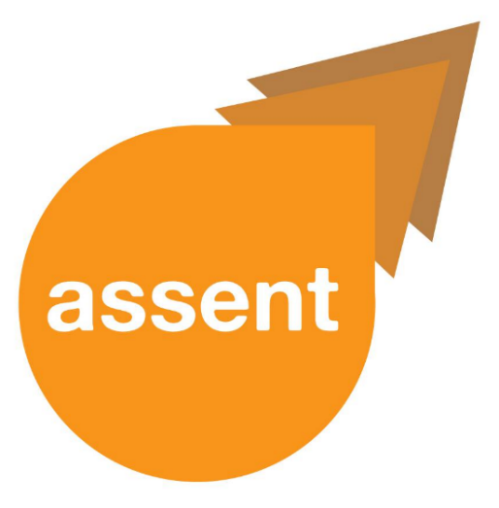

**Easy Text**

**Welcome to Project ASSENT  
Newsletter Number 2: September 2018**  
  
The Project ASSENT newsletter will update you **every two months.**

**What have we been doing?**

We have been working on the **first stage** of the project. We have been looking at the **laws and guidelines about including people** who have communication and/or understanding difficulties in research. We have also been looking at **how people are included in research.** We plan to **develop new ways** of including everyone in research.

**Project ASSENT September Newsletter**

We have also started preparing for the **second stage** of the project.

**The Working Group**

The **first block of Working Groups** took place in July and August 2018. The group members coproduced the project **information sheets, a questionnaire for researchers and interview questions.** We decided to plan more Working Groups. This will help members stay updated with project progress and help us with any problems.

Members of the Working Group include people living with:

* **aphasia** after stroke,
* **autistic spectrum conditions,**
* **brain injury,**
* **dementia,**
* **learning disabilities,**
* and **mental health conditions.**

Those who support adults with understanding and/or communication difficulties are also members of the Working Group.

**Materials in accessible formats**

All Project ASSENT materials are available in the following formats:

* **Standard Text**
* **Easy Read**
* **Easy Text**
* **Audio**

We want to make sure that **everyone can access information** about Project ASSENT. Please email [D.Leeson@uea.ac.uk](mailto:D.Leeson@uea.ac.uk) if you have any comments about this Newsletter. You can tell Dan if you would like this Newsletter in **any other format.**

**How do I find out more about Project ASSENT?**

Please contact Dan Leeson at [D.Leeson@uea.ac.uk](mailto:D.Leeson@uea.ac.uk) with your name, interest and contact details.



You can also Text or WhatsApp us!

Our mobile number is **07932 879746**

*Thank you for reading the ASSENT September newsletter*