NICHE Fellows shortlisted for two Nursing Times Awards 2025
On the evening of 22nd October 2025 at the Grosvenor House Hotel, Park Lane London, a table of NICHE partners waited expectantly to hear the results of two categories of particular interest. Kate Garraway was the evening compare, explaining her own experiences of caring for her husband Derek, who sadly passed away from COVID associated complications.
NICHE fellow, Anca Mena was shortlisted for the Learning Disability Nurse of the Year and was supported at our table by manager Hillary Mitchell from Hertfordshire Partnership NHS Foundation Trust and the NICHE team.
The second award was the King’s Award for Innovation in Integrated Care which focused on the work achieved by the NICHE fellows, most of whom were in attendance. Bonnie Teague (NSFT), Alice Dean (Tapping House), and Anca Mena (Herts) with our fourth fellow Rene Gray (JPUH) was unable to attend in person.
Amongst a strong list of nominations per category we were unsuccessful in bringing home one let alone two of the award winner trophies. However, it was a great accolade to have been nominated and share the evening together with our NICHE Stakeholder Advisory Group Chair, Alex Stewart, and UEA’s Dean for Health Sciences, Professor Christopher Burton.
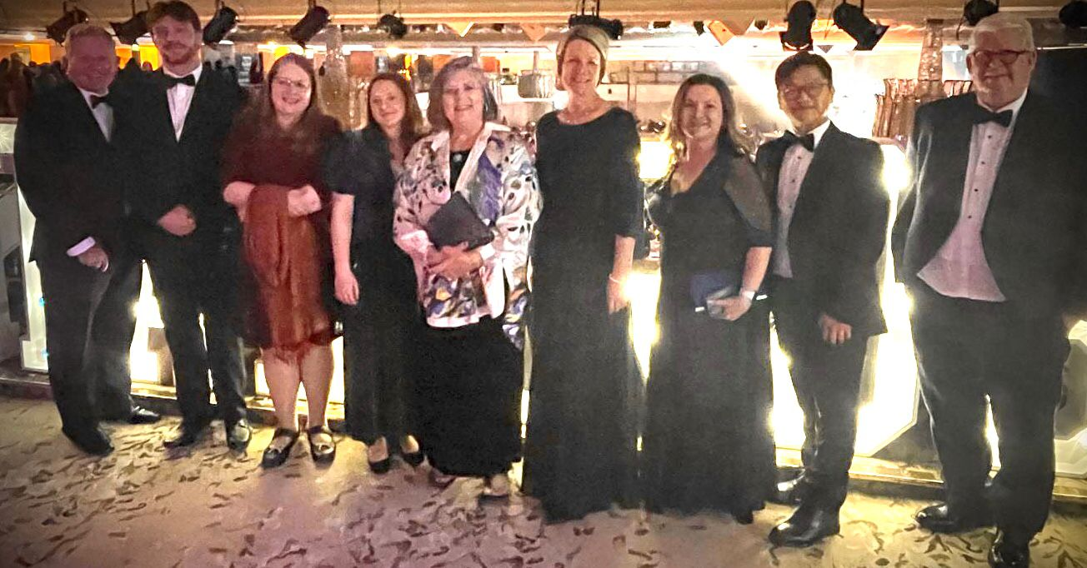
Thank you goes to all those who continue to engage and support the NICHE work across our system partners.
Left to right: Prof Jonathan Webster, Idris Phillips-Fry, Dr Bonnie Teague, Alice Dean, Prof Sally Hardy, Hillary Mitchell, Anca Mena, Dr Johnny Yuen, Alex Stewart; Photograph with kind permission Prof. Christopher Burton.

