ScrapBot Olympics – League Table and Fixtures

There are five scoring games:

* Poster challenge
* Pinball
* Sumo
* Hungry Hippos
* Obstacle Course

Your robot will be awarded between 1 and 12 league points for its performance in each event; better performance earns more points! The robot with the most points at the end of all five events will be the ScrapBot Olympics 2024 champion.

Some games are single player (only 1 robot playing at a time), other events will be multiplayer (1 vs 1). For the multiplayer games, robots will be split into four groups. These groups will change between games, so each robot will not face the same robot twice. Where a school has entered two robots, its robots will be allocated to different groups.

# **The Poster [submission prior to event]**

Posters will be printed prior to arrival on the event day and displayed for other teams to see.

Posters will be judged against the 5 criteria given in the general ruleset document (see table below). There are 100 game points available broken down by each criterion.

|  |  |  |
| --- | --- | --- |
| ***Criteria*** | | ***Maximum points available*** |
| **Names** | Team name, team members, school, and robot name. | 10 |
| **Design Objectives** | What qualities did you want your robot to have? Why? | 20 |
| **Design Process** | How did you go from kit to robot? How was this process informed by the design objectives? | 25 |
| **Material Sourcing** | Provide evidence of reclaimed materials; simple costing demonstrating low-cost ethos; indicate any donated materials. | 25 |
| **Reflections** | What would you improve? Why? | 20 |

Each robot’s game points will be ranked against the entire field (all 12 robots), and league points awarded accordingly (1-12 points). For more information on the posters, see section B2 of the ScrapBot Ruleset 2024.

# **Pinball – single player [10:15]**

Each robot will take on the pinball table: a 2m x 2m arena full of challenges which earn points.  
More points are awarded for tricker challenges!

|  |  |  |
| --- | --- | --- |
| ***Challenges*** | | ***Points awarded*** |
| **Seesaw** | Seems easy but inclines can be difficult | 25 |
| **Swinging Gate** | Very heavy, might need a run up. | 50 |
| **Golden Goal** | Get a ball into an allotted area. | 25 |
| **Targets** | Easy, Medium, & Hard | 25, 50, & 75 |
| **Barrels** | Topple the barrels to receive the points.  Different size barrels earn different points. | 1, 2, or 3 |

Each robot will have 90 seconds to complete as many challenges as possible. Only one attempt is allowed.

Each robot’s game points will be ranked against the entire field (all 12 robots), and league points awarded accordingly (1-12 points).

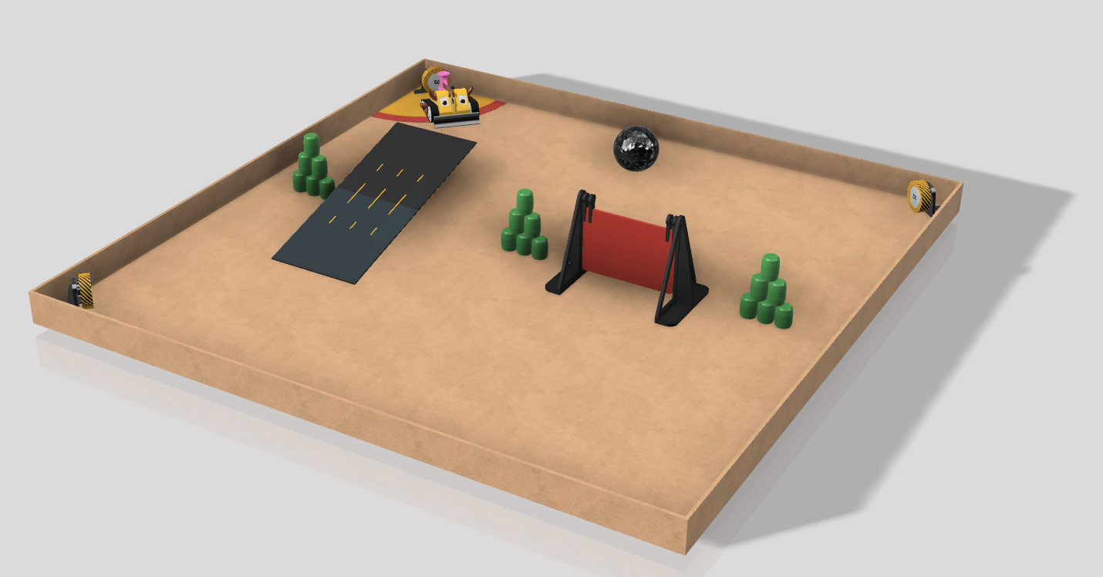

Figure : Pinball arena example

# **Obstacle Course – single player [11:00]**

Each robot has a single attempt to complete an obstacle course in the fastest time.

The obstacles include:

* Uneven terrain
* Ramps
* Slaloms
* And more!

This event will include penalties. If the robot gets stuck you can free it manually, incurring a small time penalty (5 seconds). You must attempt every obstacle at least once, but can skip an obstacle, incurring a larger time penalty (10 seconds).

The time of each robot will be ranked against the entire field (all 12 robots) and league points awarded accordingly (1-12points).



Figure : The assault course arena will be revealed on the day of the event.

# **Sumo - 2 player event [12:30]**

Each robot will be placed into one of four groups. Every robot in a group will play every other robot in the group (round robin).

In a bout, two robots will be placed on a raised 1m x 1m arena. The aim is to push your opponent out of the ring or immobilise them (turn them over) within the allotted time of 60 seconds.

|  |  |  |
| --- | --- | --- |
| ***Possible Outcomes*** | | ***Points awarded*** |
| **Win** | You have pushed your opponent out of the ring or immobilised them. | 4 |
| **Draw** | Both robots are still active at the end of the time. | 2 |
| **Lose** | You have been pushed out of the ring or immobilised. | 1 |

Each round you will receive game points. Each robot’s game points will be ranked against the entire field (all 12 robots), and league points awarded accordingly (1-12points).

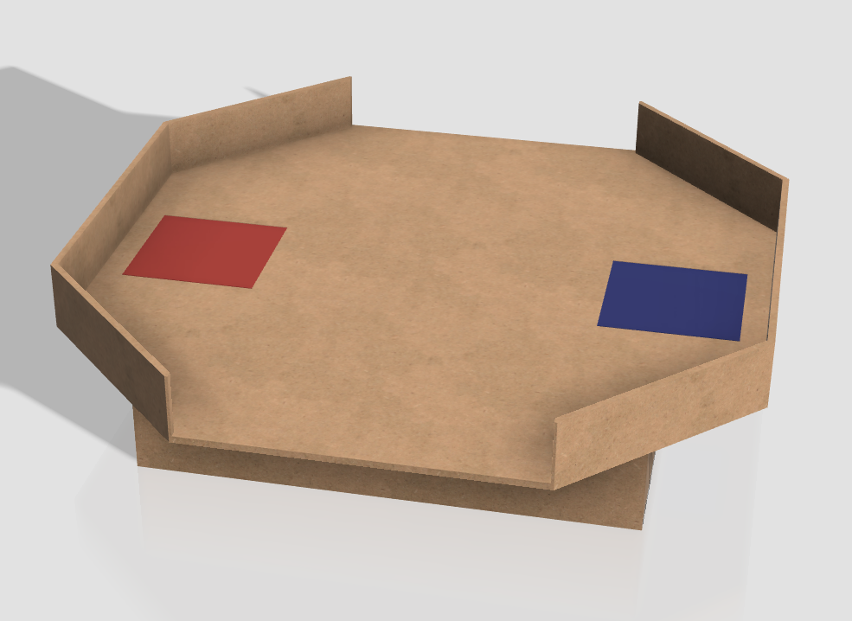

Figure : Sumo arena example

# **Hungry Hippos – 2 player event (13:00)**

Each robot will be placed into one of four groups. Every robot in a group will play every other robot in the group (round robin).

Two robots will be placed on opposite sides of a walled 1m x 2m arena. In the centre of the arena will be a collection of barrels, or “Hippo Food”. The objective is for each robot to bring back as much hippo food to their side of the arena in the allotted time of 60 seconds.

|  |  |  |
| --- | --- | --- |
| ***Hippo Food Flavours*** | | ***Points awarded*** |
| **Green** | Most common and the largest food. | 1 |
| **Yellow** | More rare than green, medium size. Tasty. | 2 |
| **Red** | The rarest and most delicious food, and the smallest in size. | 3 |

Each round you will receive game points. Each robot’s game points will be ranked against the entire field (all 12 robots), and league points awarded accordingly (1-12points).

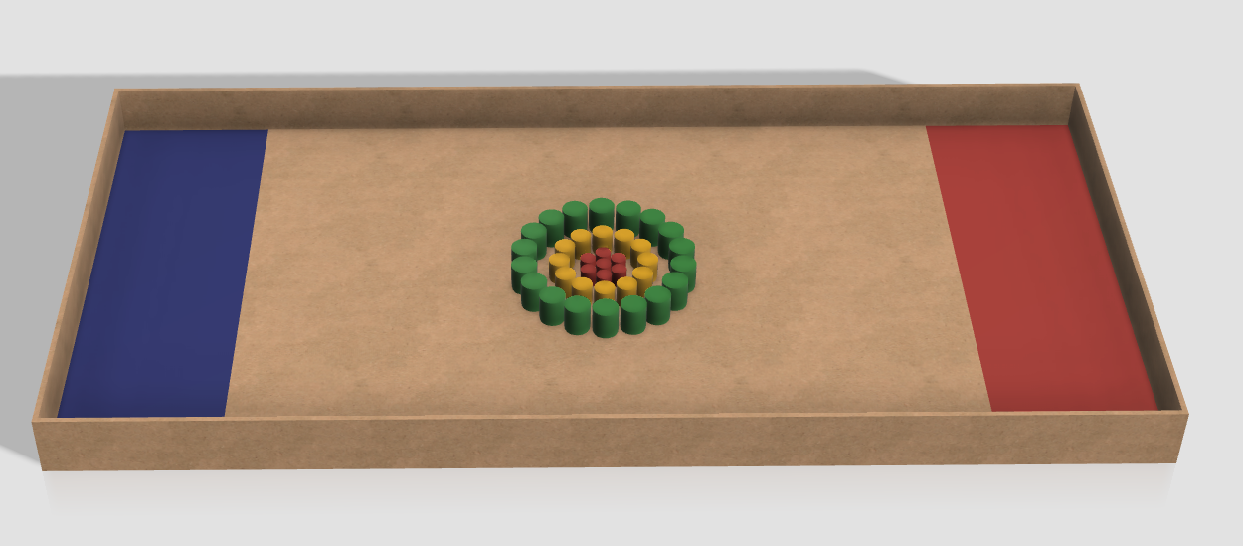

Figure : Hungry Hippo example arena