
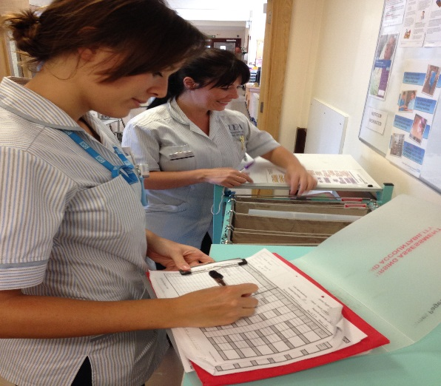

Clinical Educator workshops
Session for CLiP Clinical Educators to understand coaching principles and supporting clinical areas.

4th and 5th April 2016, Room 01.10A
Edith Cavell Building, University of East Anglia
10.00 – 16.00

For details contact David Huggins 01603 597049 or email d.huggins@uea.ac.uk
To book a place, please contact Sharon Ingham
s.ingham@uea.ac.uk

