
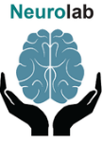

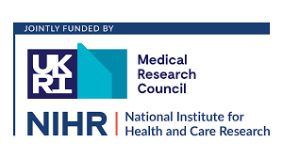
PARTICIPANT INFORMATION SHEET

Spatial Inattention Grasping Therapy (SIGHT) for Spatial Inattention post-stroke project

You are invited to take part in a new project.
Please read this sheet carefully. Please ask questions.

PART 1: The SIGHT PROJECT
What is this project about?
Spatial Inattention (also known as spatial neglect) means a person does not notice things on one side.
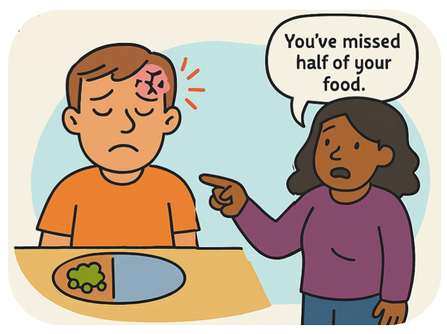

It is common after stroke.

There is no effective treatment.

Spatial Inattention Grasping Therapy (or SIGHT for short)
SIGHT is a therapy for spatial inattention.

A therapist will explain how to do the therapy.

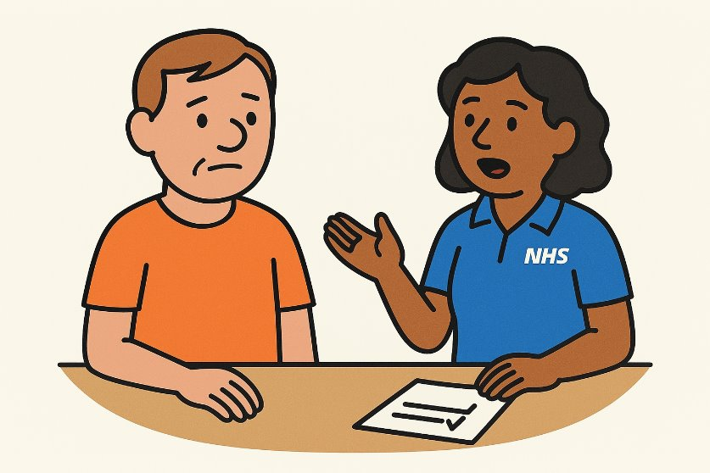

We want to see if SIGHT alongside normal care improves spatial inattention more than normal care alone.

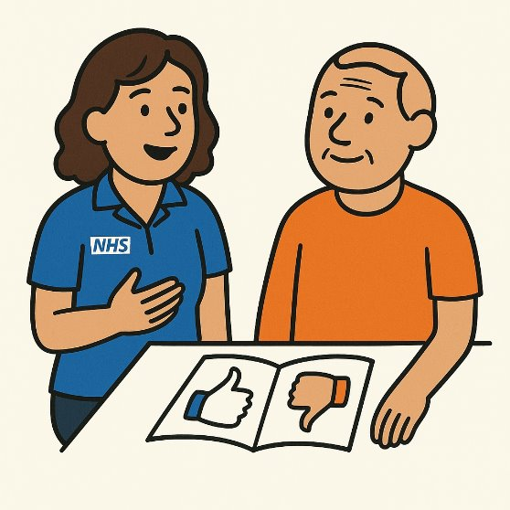

We want to see who benefits most from SIGHT.

You will still receive your normal care.

Why me?
You have had a stroke.
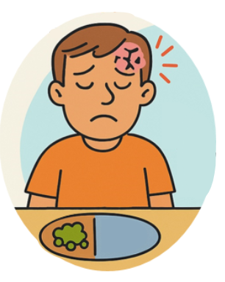

You may have signs of spatial inattention.

Do I have to take part?
Taking part is voluntary.

You can decide.
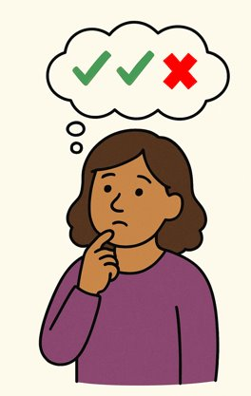

You may wish to choose a relative or friend to help you decide.

You may want to discuss the project and share this sheet with that person.

You will have at least 24 hours to consider taking part. Please ask questions.



You can stop at any time.

If you do stop, you do not have to give a reason, and you will still get your normal care.
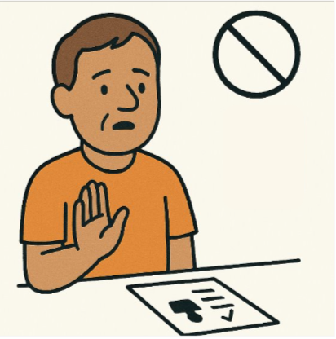

What happens if I take part?
You will sign a consent form to show you understand the project and want to take part.
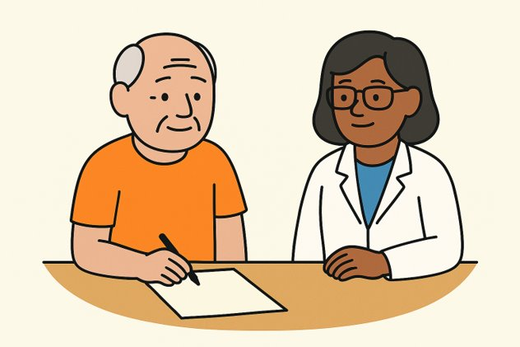
You will do some tests and questionnaires which involve testing your visual and thinking abilities.

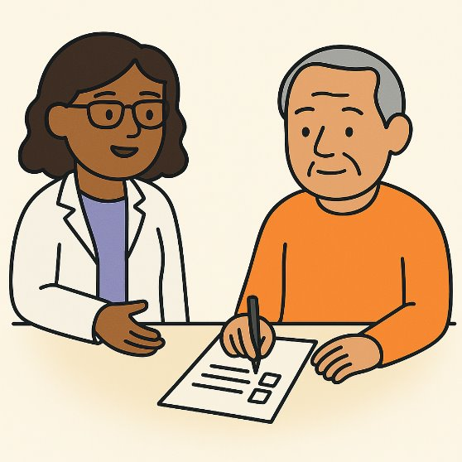
These will take about 1 hour 10 minutes.

You can take breaks or do these in separate sessions.


You may also complete a brain scan if you agree and are able to have a scan.
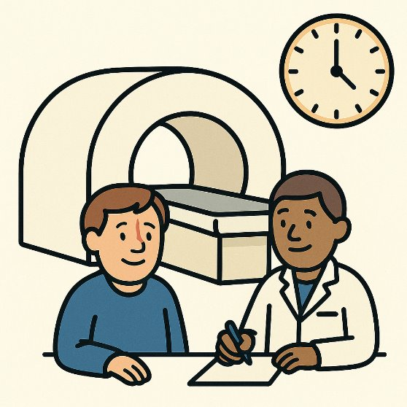
This is optional.

We need two groups, so we can see if SIGHT improves spatial inattention more than normal care alone.

A computer will decide which group you are in.

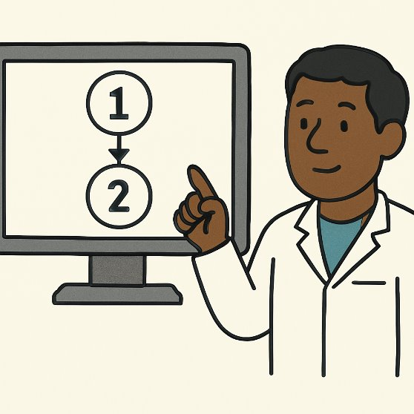

It is like flipping a coin.

One group will receive SIGHT alongside normal care.

They will have 7 sessions of SIGHT Therapy, which consists of supervised exercises targeting spatial inattention, across 10 days.

Each session of SIGHT Therapy is 30 minutes.

The other group will receive normal care.

You will not be told directly whether you are receiving the SIGHT therapy or not.

After 10 days, you will do some tests and questionnaires.

This will take about 45 minutes. You can take breaks.

Around 3 months later, you will do some tests and questionnaires again.

This will take 45 minutes to an hour. You can take breaks.

If you have been discharged home, you will be visited at home.

One questionnaire will be posted to you, for you to complete before the visit.

This questionnaire asks about the impact of the stroke on your daily life, including information which you may consider to be of a sensitive nature.

You will be supported to answer these, but you do not have to complete all sections if you do not wish to

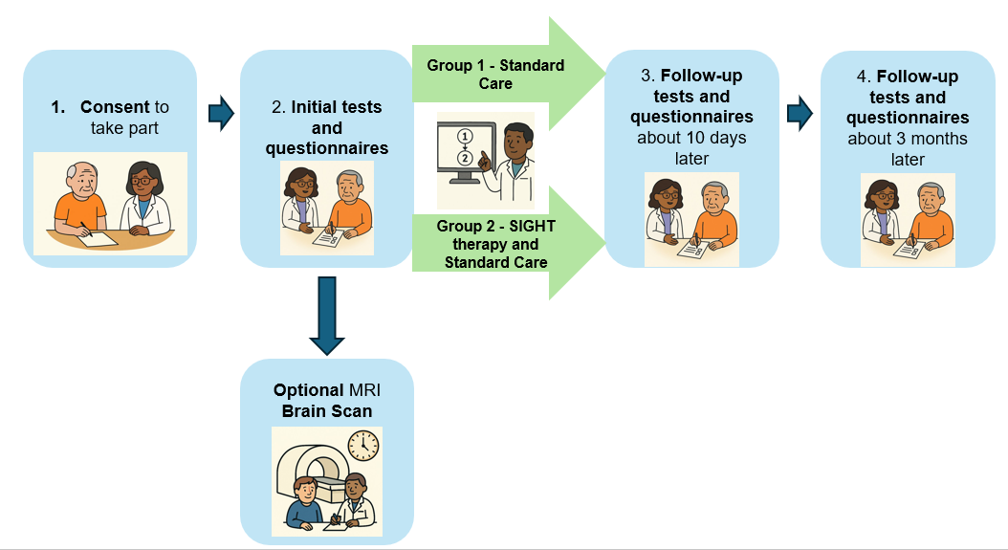
This picture shows what would happen if you took part:

What happens if I take part?
Optional brain scan
This project includes an optional brain scan.

If you consent to a brain scan, a researcher will complete a brain scan (MRI) screening form with you.
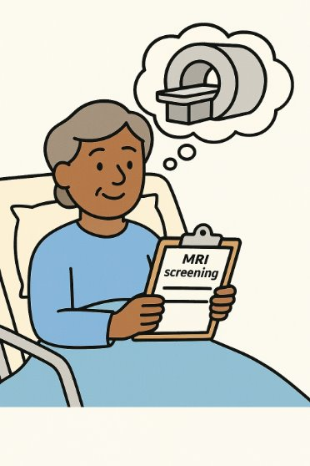
This form asks whether you have any metal in your body.

If you have any metal in your body, or are not sure, you will not be able to have a brain scan.
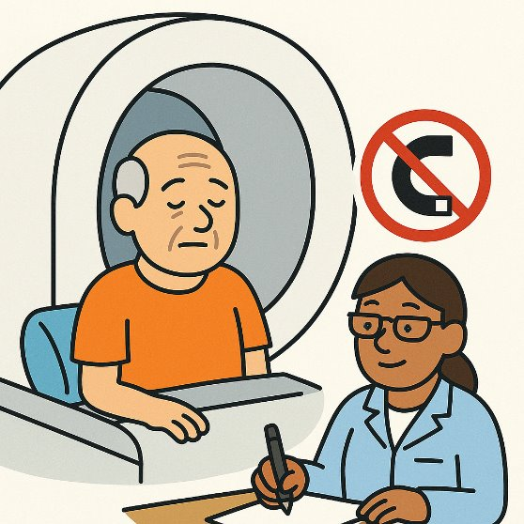

The scanner is in the hospital.


The scan will take about 30 minutes.

MRI does not use radiation.

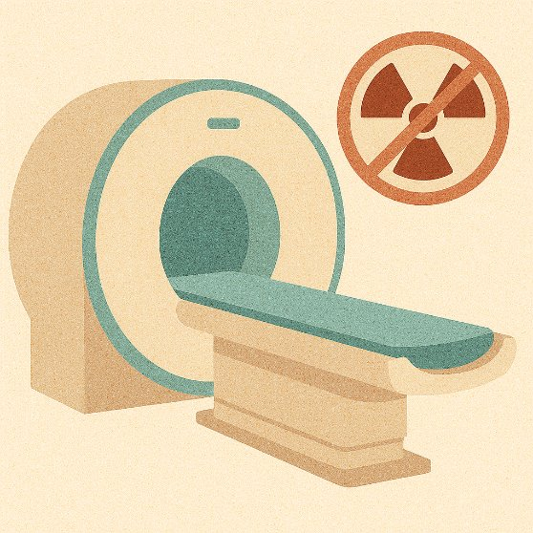

There will also be time for a nurse to help you get to the scanner and to get ready for the scan.

You will be able to speak to staff during the scan.

The scanner may be loud, and due to the enclosed and restrictive space in MRI scanners, those with claustrophobia may experience some distress.

You will have a panic button to squeeze if you need.
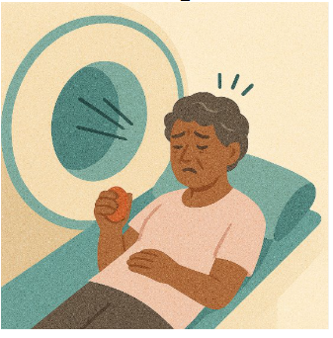

Earplugs will be provided to help reduce the loud noises you hear from the scanner.
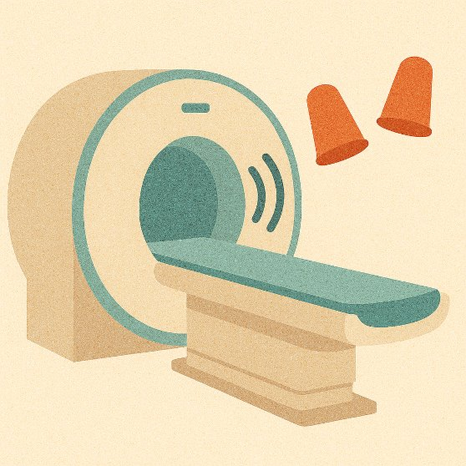
Brain scans are safe and non-invasive.

You can stop at any time.

The brain scan is optional.

You can still take part in the project even if you do not want to have a scan.

What if something goes wrong?
This is unlikely.

Please contact the project team- their contact details are on page 27.

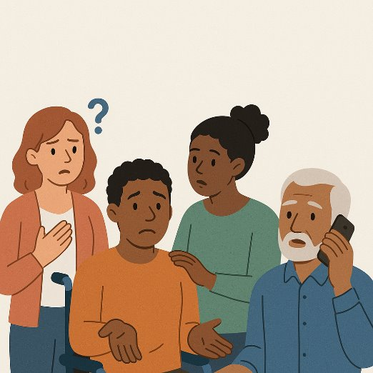

Are there any problems with taking part?
There are no known risks.

You might get tired, but you can take breaks.

You should stop if you feel any pain and tell the project team.

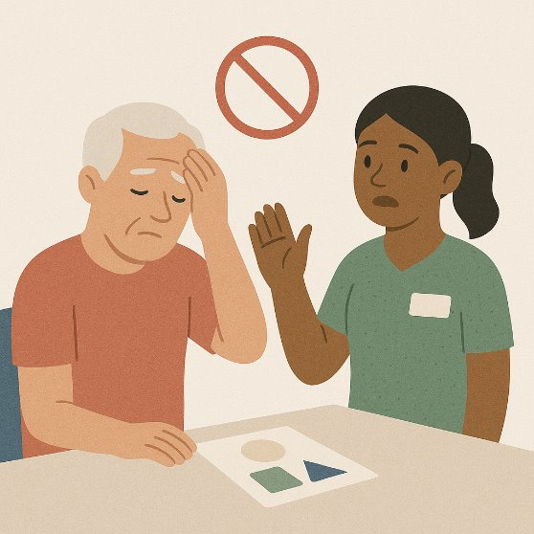

Will it help me if I take part?
We cannot promise it will help you.

The project may help stroke survivors in the future.
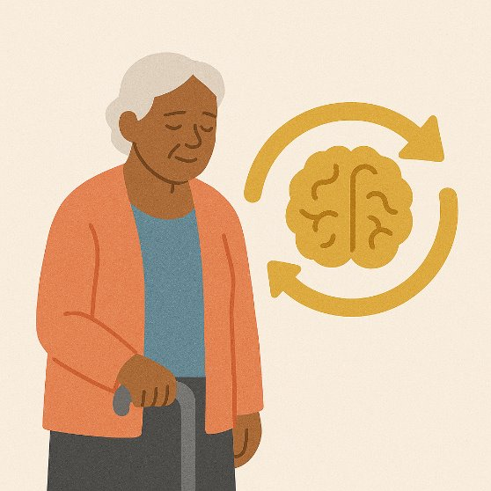

Talking to a friend or relative about the project
You may wish to discuss this project with a friend or relative.



You may wish to share this information sheet with that person.

They may be able to help you decide if you would like to take part in the project.

They could help you arrange the follow up appointment at 3 months if you have been discharged home.

.

What happens if I experience changes to my mental capacity (thinking skills)?

Following a stroke, some people experience changes to their mental capacity (thinking skills).

These changes can lead to someone not being able to consent.

You may wish to ask a friend or relative to be your consultee.
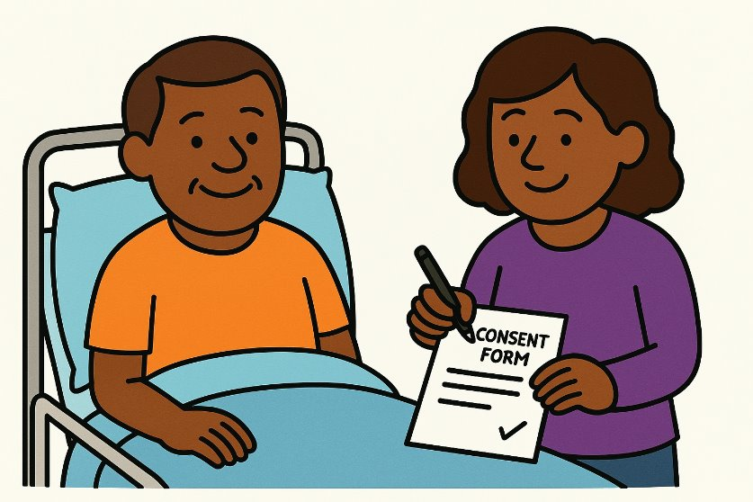
You can provide their contact details to the project team.

If you experience loss of capacity, this consultee could decide on your behalf if you would want to continue the project.

This consultee could also help you with making appointments with the project team.

What happens when the project ends?
You will still get the same normal care.

Contact your GP or care team if you need to talk about your care.



Is the project ethical?
An ethics committee looked at this project.



XXXX Research Ethics Committee think the project is ethical.

PART 2- Data protection and confidentiality
What information will be used?
How will we use information about you?

NHS staff, researchers at the University of East Anglia and regulatory authorities may look at:

- Relevant parts of your medical records

- Your consent form

- Data collected during the project


Only project team members who need to speak to you or look at your information will know your name and contact information.
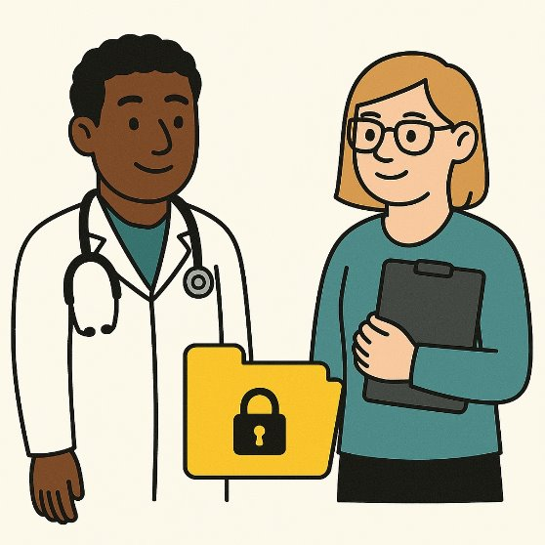
All data will be kept confidential.

What will happen to the results?
How will we use information about you after the study ends?

The results may be published and presented to other researchers.

The data may be shared with other researchers on an online database.
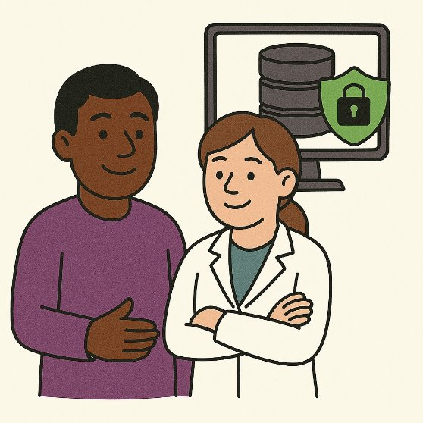

Your name and identifying information will not be shared.
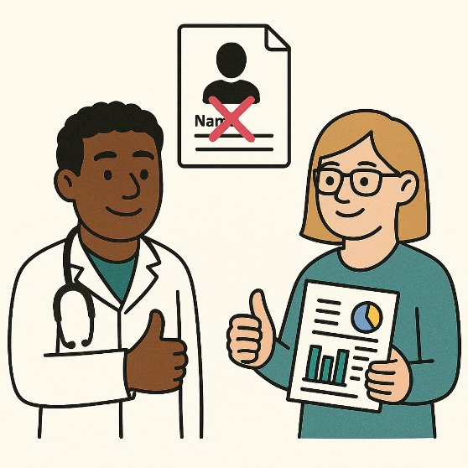

You can choose to receive a summary of results when the project ends.
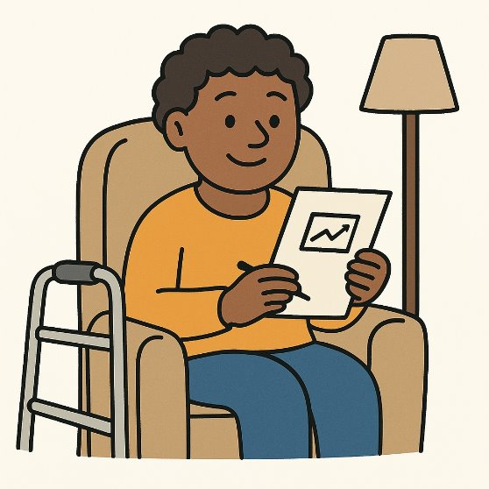

Is it confidential?
You will be given a project code; this will be used instead of your name.

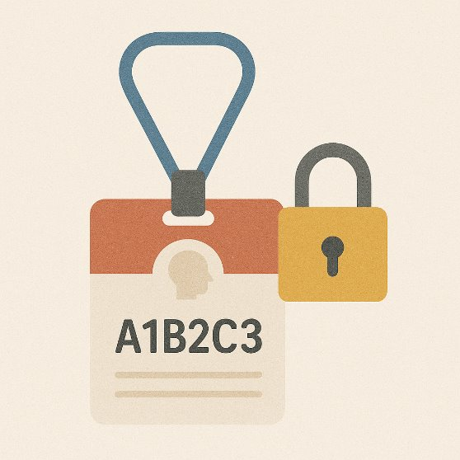

All data will be stored with your project code.

What are your choices about how your information is used?

Identifiable data (your name, address, email address, phone number) will be destroyed 12 months after the project ends.

We can keep this longer if you want us to tell you about future projects or to hear about the results of the project.

You can ask to stop taking part in the study at any time by speaking to a member of the research team or by contacting (add name of PI).

If you do, we will destroy your identifiable data.

All other data collected up to this point will be retained. If you agreed to receive the information about the outcome of the research, we will send this to you.

If you choose to stop taking part in the project, we would like to continue collecting information about your health from your hospital.

If you do not want this to happen, tell us and we will stop.

Information will be kept confidential unless there is a danger of harm to you or someone else.
If we find something unexpected in your results, we will inform you.

If you agree, we will inform your GP, who will take any action that is needed.

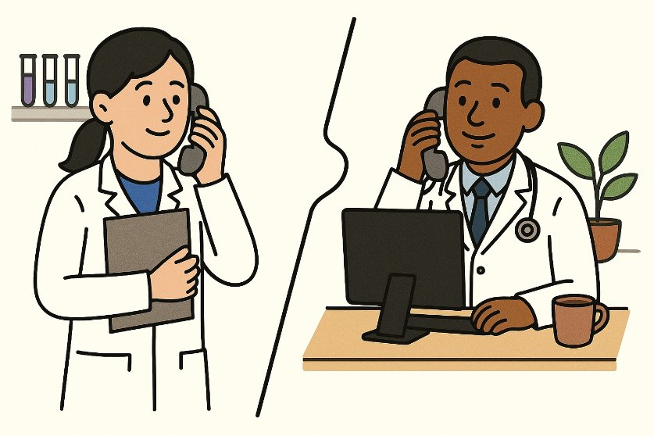

We will tell your GP you are taking part in this project.

Where can you find out more about how your information is used?

Further information about how your data will be used in the study and afterwards is produced by the Health Research Authority. Please ask your hospital research team for a copy of this information.

PART 3 – Future Research
Future Research
The Neurolab at the University of East Anglia is always looking for volunteers to help with brain injury research.

Joining our group of volunteers means we can tell you about future projects you can help with.
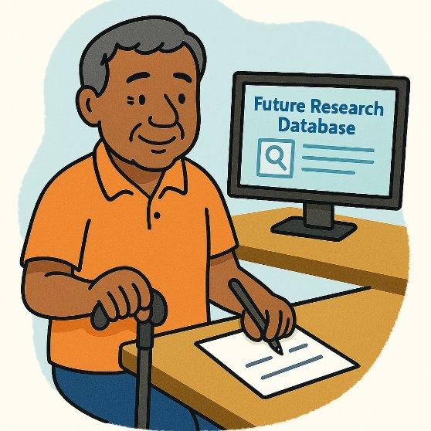
This is optional.

Taking part is voluntary.

You can decide. You can ask questions.

You can stop at any time.

You can stop at any time.

Your information would be stored on a secure spreadsheet on a password- protected computer.

We will store:

- Your name
- Contact information
- Details about your stroke
- Results on tests you have done during our research

There are no known risks

You can ask us to remove your information at any time

If you do, we will destroy your identifiable data


There is no direct benefit to you.

The research may help stroke survivors in the future.

We will only use your information to tell you about future research opportunities.



You will not be contacted about future research until you have finished taking part in the SIGHT project.

You can decide if you want to take part in a study.

Joining the future research volunteer group is optional.

This project is jointly funded by the Medical Research Council and the National Institute for Health and Care Research.

The project is run by the University of East Anglia and the Norwich Clinical Trials Unit

If you want to talk to a person not in the project team, please contact:
Name:
Email: Phone:

If you want to share your experience of being in this project, please contact your local Patient Experience Team.
[Insert details of local PALS service here]

If you want to complain about how researchers have handled your information, you should contact the research team. If you are not happy after that, you can contact the University of East Anglia’s Data Protection Officer at dataprotection@uea.ac.uk

If you are not happy with their response or believe they are processing your data in a way that is not right or lawful, you can complain to the Information Commissioner’s Office (ICO) by visiting www.ico.org.uk or calling 0303 123 1113.

Project Team
[Insert details and photo of local site PI]

Dr Stephanie Rossit (Chief Investigator)
Email: S.rossit@uea.ac.uk
Phone: 01603591674

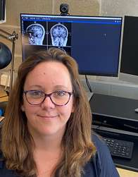

Thank you for reading this information sheet

