Contributors Profiles and Photos

Dr Shaun Cardiff

Senior Lecturer and Program Lead at Fontys University of Applied Sciences, Eindhoven, The Netherlands.

My interest in workplace culture is related to my work as program lead (research, projects etc.) for professional development and person-centred practice. I am interested in how professionals in health and social care (can) enact person-centeredness in their care-, learning- and work (peer and leadership) relationships, particularly at the micro-level of workplaces.

Margaret Codd

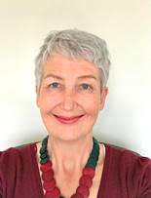
I am a nurse, currently working as a Quality Improvement facilitator with the Health Service Executive in Ireland. I have had an extensive career working in Ireland and the USA, in the areas of critical care and Head & Neck Oncology and as a manager leading and developing large Directorate teams, practice development, quality improvement and change management. At national programme level, I was Nurse Lead for the National Clinical Programme for Palliative Care (NCPPC) and Co-lead of the National Person-centred Programme.

I was introduced to critical creative companionship during the National Person-Centred Programme and I was honoured to be the first winner of the Angie Titchen International Community of Practice of Person-centred Research (ICOP) Award and to have the opportunity to work with Angie using in a critical creative companionship from 2019-2022. For me the Award provided a breadth and depth of growth and flourishing that I could not have achieved alone and had a transformative impact on me as a whole-person-centred practitioner, facilitator and leader. I am delighted to share my experience and learning with participants on this programme.

Professor Alex Fink


Alex Fink is an Assistant Professor in Social Work at Augsburg University, where he supports young people and aspiring/seasoned professionals to lead change toward a socially just world. He conducts and supports participatory and youth-led program evaluation and participatory research with partners in many youth-serving organizations around the state and globally. He also collaborates with his students on practitioner-research, including co-designing a conference called AMPLIFY Youth Work for social and youth workers across the globe to convene around pressing challenges during COVID-19.
Dr Donna Frost
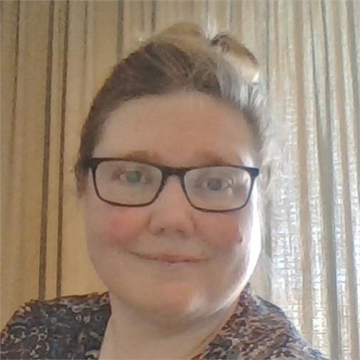
PhD, MSc (Nursing), BHSc (Nursing), NZRN.]
Programme Lead, Master Advanced Nursing Practice programme, Fontys University of Applied Sciences, Tilburg, The Netherlands.
Donna gained her nursing registration in New Zealand and has worked in nursing, practice development and academic roles in New Zealand, the United Kingdom and the Netherlands. She believes in the transformative power of critical creativity, practice development and collaborative and creative research methods. Advancing consultant practice in the health professions creates chances to learn from each other as we work towards person-centred spaces, cultures and hopefully systems. This endeavour requires ongoing creativity, effort, courage and vigilance; we need each other to make it possible.
Claire Hardwick
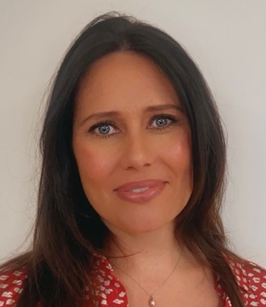
Clare qualified as a Speech and Language Therapist in 2001, with a career spanning over 23 years in acute hospital settings. She developed her expertise at St Mary’s Hospital, London, and Barts and The London NHS Trust, where she built a specialist interest in working with patients affected by acquired neurological disorders, trauma, and critical care.
Since joining her local Hospital trust October 2016, Clare initially served as Head of Speech and Language Therapy. She currently holds the role of Associate Director for Therapy Services, overseeing Speech and Language Therapy, Physiotherapy, Occupational Therapy, Dietetics, Orthotics and Podiatry within the Trust. Clare’s leadership style is grounded in authentic leadership, driven by her core values of empowerment, inclusivity, and transparency. She passionately advocates for the therapy team, ensuring that the voices of therapists are heard and valued.

Karen Hammond
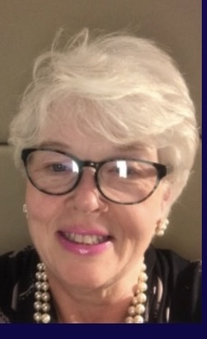
I have worked in the NHS for the whole of my career with clinical leadership and managerial roles across nursing and midwifery. During this time, I have been involved in reviewing Maternity services in Southeast England, Wales and Gibraltar, making recommendations for improvements by developing person-centred effective workplace cultures.

In my many roles I have developed my facilitation skills and this now underpins every aspect of my practice. It has led me to explore all avenues of practice development as a complex methodology with my passion for service transformation and improving staff and patient experiences.

I have studied and explored critical companionships on many levels and have seen amazing changes within practice. I worked in collaboration with an NHS Trust’s leadership program supporting doctors as a critical companion and I was able to experience first-hand how a surgeon implemented critical companionship at the bedside. This was a powerful life affirming experience.
Dr Michele Hardiman

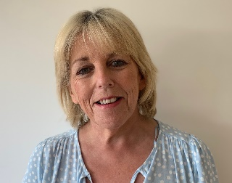
Practice Development and Education and Research Facilitator, Assistant Director of Nursing Blackrock Health Galway Clinic Ireland
Affiliate Member Centre for Person-centred Practice Research, Queen Margaret University, Edinburgh UK
Associate Lecturer Nursing and Health Science, Atlantic Technology University, Castlebar. Ireland

Michele is an experienced nursing leader with focus on quality and clinical standards and bringing evidence into practice. She holds two nursing qualifications in General and Mental Health Nursing and continues to work in a hospital setting on a part-time basis to ensure her knowledge is up to date and relevant to staff on the ground.
Michele is passionate about Person-centred Practice using facilitation techniques to enable practitioners and teams to develop knowledge and skills to change the culture and context of care in all healthcare environments. She is a member of the International Community of Practice of Person-centred Research.
Her PhD research focused on facilitating person centred leaders to enable transformation in practice. Her Facilitation model titled ‘Facilitation on the Run’ is currently used in a variety of educational and healthcare organisations worldwide.
Michele is a strong and strategic healthcare leader with extensive experience in healthcare and hospital leadership, mental health service and team development. More recently she has led on practice development initiatives in a variety of setting that have transformed the culture and context of care. This in turn has led to the reduction of incidents and accidents; reduction of complaints; happier more contented teams and attraction of quality staff.

Carrie Jackson

Carrie is a passionate embedded practice development researcher running her own consultancy working with communities and practitioners to grow and sustain innovative health and social care solutions through commissioned work. She was co-founding Director of the England Centre for Practice Development (ECPD) established with Professor Jan Dewing and Professor Kim Manley CBE and colleagues from the International Practice Development Collaborative (IPDC) in October 2011. She has led a number of complex research, consultancy and innovation projects in the field of leadership, culture change, improvement and transformation in the UK and internationally. She currently holds several Visiting Professorial roles in Australia and is Visiting Senior Fellow in the School of Health Sciences at UEA. She recently co-designed and co-facilitated the East of England Multiprofessional Aspiring and Consultant Practitioner programme. In her spare time, she is a social justice campaigner helping many people overcome issues of access to care, services and support.
(Carrie’s role in this resource was creating a context for it to happen)
Dr Famke v. Lieshout

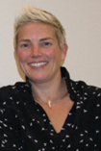
Famke has a background in healthcare as a nurse and health scientist in the field of health education and health promotion. She leads on the program ‘Person-centred learning –and workplace contexts’, within the knowledge center 'Person-centred practice in the ageing society' and is lecturer at Fontys University of Applied Sciences within the Institute of People and Health Studies (NL). In 2013 she finished her doctorate at the University of Ulster (UK). Her study focused on systems of support in facilitating participatory research methodologies. Famke is an experienced action research facilitator, is the founder of the Action Research Company in the Netherlands. She is first author of a book on Action Research in Dutch (2017, 2021). She facilitates transformative research projects in nursing homecare settings, hospitals and local communities and provides methodological support as supervisor and co-facilitator and supports in writing grant applications. Famke has a wide national and international network. She is passionate about the use of arts, creativity and storytelling in research and practice development.

Professor Kim Manley CBE

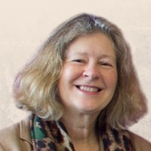
Emeritus Professor, Faculty of Medicine and Health Sciences, University of East Anglia, England, UK

Emeritus Professor, Faculty of Medicine, Health and Social Care, Canterbury Christ Church University, UK

Kim is internationally recognised for integrating research and scholarly inquiry, practice development, facilitation of workplace learning, improvement and leadership development to achieve and sustain workplace cultures that are person centred, safe, effective and good places to work.

She currently co-leads the development of the multi-professional consultant capability and impact framework for Health Education England, aligned to advanced practice, systems leadership and embedded research. This also builds on a long history of workforce development and capabilities wrapped around service users/citizens and focussing on person centred approaches.

As a key partner in establishing the International Practice Development Collaborative in the 1990’s she has continued to position practice development as relevant to all healthcare professions and a key partner to other improvement approaches, offering sustainability through collaboration, inclusion and participation.

Kim is committed to transformation that addresses whole systems integrated working, is passionate about helping staff to develop their potential and flourish, and for patients and service users to experience excellence. In 2000, she was awarded the CBE for quality patient services, in 2015, identified as one of the Nursing Times top 50 leaders and in 2018 recognised as one of seventy nurses having most impact on the National Health Service (NHS) since its inception in the NHS 70 year celebrations. She has over 180 publications, six edited books and has examined many doctoral studies internationally.

Mary Mulcahey

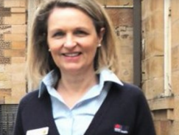
Nurse Educator, Person Centred Care –Prince of Wales Hospital, New South Wales, Australia

Mary leads skill development in coaching, clinical supervision and leadership with a strong focus on person centred compassionate approach to patient care delivery. She is committed to enhancing workplace culture and delivering safe quality care in the Emerging Nurse Manager Program that she co-ordinates. Consulting and facilitating initiatives that promote and support workforce wellbeing are other areas that Mary is passionate about. Mary is particularly interested in promoting Critical Companionship as a means for high challenge and high support to enable optimal performance. She has also facilitated groups while working in critical creative ways, primarily through the use of Mandalas as a tool for transformation to enable human flourishing.

Lorna Peelo-Kilroe

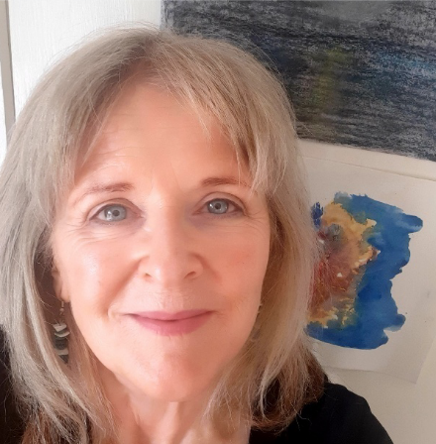
My name is Lorna Peelo-Kilroe and I am a nurse working in the Irish Health Service in the Health Service Executive (HSE) Office of Nursing and Midwifery Services Director. I have 20 years of experience as a practice developer and facilitator of person-centred workplace culture enablement, influenced by the work of Professors Kim Manley, Brendan McCormack, Jan Dewing, Tanya McCance, Angie Titchen and others on workplace culture and practice development.

Prior to working in the HSE I worked in the NHS for a number of years as a District Nurse and during this time I acquired an interest in approaches to developing practice and challenging taken-for-granted practices that lead me down the facilitation pathway.

I am currently undertaking a PhD in Queen Margaret University, exploring the possibility of creating conditions that enable human flourishing when we try to develop new ways of working and engaging together. During this time I have had the pleasure of experiencing critical companionship/critical creative companionship with Dr Angie Titchen who is one of my supervisors. This experience has given me the knowledge and skills to be a critical companion and use critical creative companionship to develop my own practice, support my everyday work, and do the same with others. I am delighted to have this opportunity to share some of my experience on this programme

Dr Angie Titchen
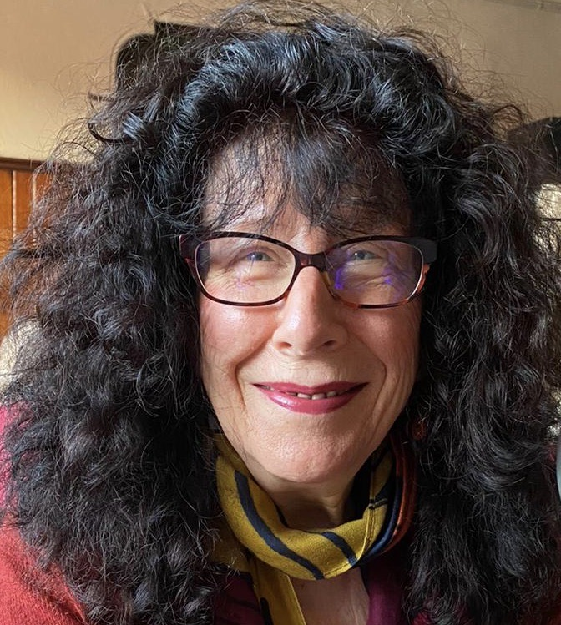
Independent consultant, critical-creative companion, writer, activist and campaigner Originally a physiotherapist, I set up two UK stroke units in the 1970’s and particularly loved working alongside physiotherapy students, patients and families in an experiential, co-learning kind of way - although I did not have the words for that back then! After travelling the world with a backpack, I did a Masters degree in Rehabilitation Studies at the University of Southampton. Some years later I received the British Educational Research Association Award for the best PhD thesis awarded by a British University in 1999. As a doctoral student at the University of Oxford, researching with nurses at the John Radcliffe Hospital, Oxford, I created a conceptual framework for critical companionship, a transformational, person-centred facilitation approach that I have continued testing and developing throughout my career in the NHS, professional bodies and universities in the UK, as well as, in universities in Australia and The Netherlands.
With 26 years working at the cutting edge of phenomenological and action-oriented research and practice development, I brought this experience to the design, implementation and evaluation of facilitation development programmes for healthcare teams wishing to deliver person-centred, evidence-informed practice. This work includes helping practitioners to become practitioner-researchers studying their own practice. I am passionate about practice development and bringing criticality and creativity together and have published widely on: critical creativity, critical companionship; transformational practice development and research; qualitative research; professional artistry; the nature of professional practice and expertise; professional knowledge and; facilitation of experiential learning. I am listed in the Thomson Reuters 3000 most influential researchers globally, more due to those I have written with, in my view!
More recently, with critical companionship deeply embedded and embodied in who I am as a person, I am an activist and campaigner in my local community and find it works with citizens as well!

Karen Tuqiri

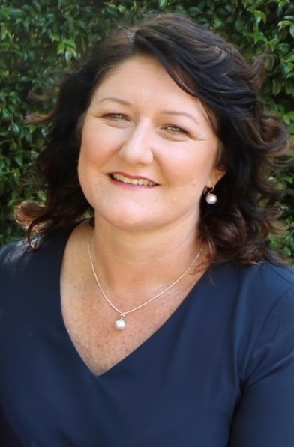
Karen Tuqiri is the Director of Nursing at The Prince of Wales Hospital, Sydney and Associate Adjunct Professor, University of Technology, Sydney.
Programs of work Karen leads focus on workforce development, quality improvement, patient safety and implementing evidence-based practice change whilst developing a deeper understanding of the influence of leadership on workplace culture. She is a current PhD candidate with her area of study focused on developing a deeper understanding of the relationship person-centred practice has on patient safety outcomes.

Renne Ward 16/10 – Kim chasing

Professor Jonathan Webster

Professor of Practice Development and Strategic Lead for Research and Scholarships, School of Health Sciences and Co Director, ImpACT Research Group UEA.
Honorary Professor of NMAHP Research, James Paget University Hospitals NHS Foundation Trust and Associate Facilitator, The Foundation of Nursing Studies
Jonathan’s career stretches over 30 years working for the NHS and across Higher Education. A Registered General Nurse since 1990 he has worked in both secondary and community settings in the UK and Australia. His clinical practice expertise is older people’s nursing having held two Consultant Nurse posts for Older People. During this time, he led programmes of education, practitioner centred research, evaluation and practice development having held honorary gerontological and practice development fellowships with the Royal College of Nursing Institute.
Jonathan held NHS Board level roles for 8yrs as a Director of Nursing/ Quality and Chief Nurse across Clinical Commissioning and Regulatory organisations in London and latterly the South East. In his current post within the School of Health Sciences at UEA he is leading work on ‘The Guiding Lights for Effective Workplace Cultures’ and ‘The Teaching and Learning Care Home Programme’ working in collaboration with The Foundation of Nursing Studies. He is currently the Dissertation Module Lead on the MSc in Advanced Practice and teaches on both undergraduate and post graduate programmes blending teaching, learning, research and evaluation. In his Honorary appointment with the James Paget Hospital NHS FT he is working with Trust colleagues on the Research Scholarship Programme.
Jonathan has been involved in national and international work related to older persons’ care; leadership development; workplace culture; practice development; quality improvement and clinical assurance. His professional interests lie in developing person-centred cultures of practice that enable those involved in health and care to work in partnership with service users and their supporters through practice development, service transformation and action research.

