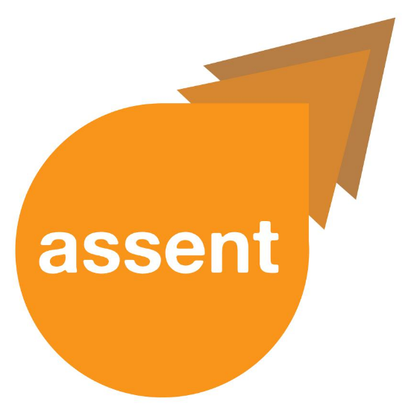

**Easy Text**

**Welcome to Project ASSENT  
Newsletter Number 1: June 2018**  
  
A project newsletter will update you every two months.

**Project ASSENT**



**What is Project ASSENT?**

The project is about involving people who have difficulties with understanding and/or communicating in research. There are laws and recommendations about including people in research. People who have these difficulties can still be left out. Services based on research may then not be suitable for them. We want to find better ways for researchers to include people with understanding and/or communication difficulties. The goals for project ASSENT are to:

1. make sure that everyone has a voice in research,
2. create new guidelines for researchers,
3. develop tools to support participation.

The project is funded by the Nuffield Foundation until November 2020.



**Who belongs to the research team?**

|  |  |  |
| --- | --- | --- |
|  | **Dr. Karen Bunning**  Principal Investigator    [K.Bunning@uea.ac.uk](mailto:K.Bunning@uea.ac.uk) |  |
| **Professor Peter Langdon**  Co-Investigator 1  profile image for Professor Peter Langdon  [P.E.Langdon@kent.ac.uk](mailto:P.E.Langdon@kent.ac.uk) | **Dr. Anne Killett**  Co-Investigator 2    [A.killett@uea.ac.uk](mailto:A.killett@uea.ac.uk) | **Professor Rob Heywood**  Co-Investigator 3    [R.Heywood@uea.ac.uk](mailto:R.Heywood@uea.ac.uk) |
| **Dr. Ciara Shiggins**  Advisor    [C.Shiggins@uea.ac.uk](mailto:C.Shiggins@uea.ac.uk) | **Yvonne Plenderleith**  Research Associate  **Photo**  [Y.Plenderleith@uea.ac.uk](mailto:Y.Plenderleith@uea.ac.uk) | **Hayley Ryan**  Research Associate    [H.Ryan@uea.ac.uk](mailto:H.Ryan@uea.ac.uk) |

Our core team members come from a range of backgrounds:

speech and language therapy, clinical psychology,

occupational therapy, and law.

**Who else is involved in Project ASSENT?**It is important for us to understand the needs and preferences of adults with difficulties in communicating and/or understanding. We are working closely with those who experience:

* aphasia after stroke,
* autistic spectrum conditions,
* brain injury,
* dementia,
* learning disabilities,
* and mental health conditions.

**Project ASSENT**

Those who support adults with understanding and/or communication difficulties are also advisers on the project.

**Reference Group:** Some individuals have chosen to join our Reference Group. We discuss the project with them, they tell us what they want, and help us to solve problems.

**Working Group:** Other people are part of our Working Group. They will develop questions for interviews and questionnaires.

**How do I find out more?**

Please contact Dan Leeson at [D.Leeson@uea.ac.uk](mailto:D.Leeson@uea.ac.uk) with your name, interest and contact details.