|  |
| --- |
| **Project ASSENT February 2019 Newsletter** |
|  |
| **Easy Text**  **Welcome to Project ASSENT Newsletter 4: February 2019**      **What have we been doing?**  We have gained **ethical approval** to continue **Stage 2**. We will **explore** people’s **thoughts** about **including adults** **with** communication and/or understanding **difficulties** **in research**.  **We will** **ask adults with difficulties**, **those who support them**, **members of research ethics committees**, and **researchers**. Our Team Research Associates are finding people to take part.  **Materials in accessible formats**  We aim to be accessible so that everyone can hear about Project ASSENT. The **Newsletter is available** in **Standard Text, Easy Read, Easy Text** and **Audio**. |

**The Working Group**

Our Working Group **includes Experts by Experience** in

* aphasia after stroke
* autistic spectrum conditions
* dementia
* learning disability
* and mental health.

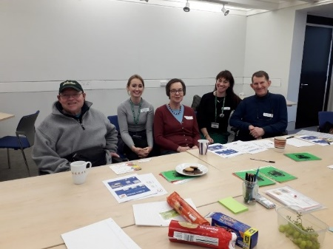

Representatives are individuals **from local user-led organisations** andthose with **connections to the University of East Anglia**.

**Project ASSENT Website**

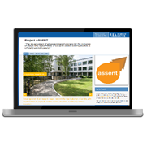The Working Group **members meet every 3 months**. **January’s meeting** was about the ASSENT **website**. We spoke about **making information available** to different people.  
  
Ideas involved

* providing **summary pages**
* adding a **feedback form**
* sharing **project objectives**.

|  |
| --- |
| **Update on Stage 1: Ethico-legal Landscape**  **1.1 Document Review**  The focus is on the **guidelines for including adults** **with** communication and/or understanding **difficulties** **in research**.  We are **looking for** any **support for inclusion**. We will also **find** any **gaps in advice** for researchers. |
|  |
|  |
| **1.2 Law Paper**  We have nearly **finished** our **research about the laws** for including adults with difficulties in research. Professor Rob Heywood wrote a first draft of our paper and Team members gave feedback. Rob is **revising it** for **submission** to Medical Law International **in March** 2019. It will be the 1st ASSENT publication.  Interesting **points** in the paper are about   * the **scope of the mental capacity act** for research * **problems with** **ethical approval** * and **practicalities of** the **consultee process**. |

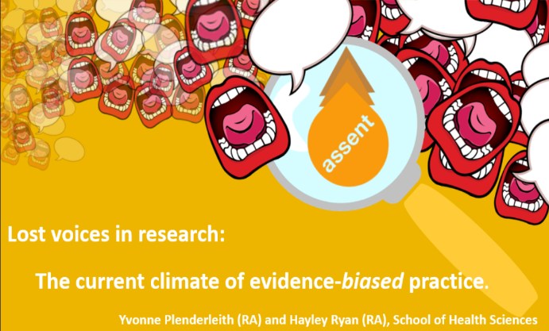  
Yvonne Plenderleith and Hayley Ryan **won** at the **University of East Anglia Researcher Summit**. The prize was **for a PowerPoint slide** (above) and **3-minute presentation**. They spoke about the **importance** of developing an **ethical way** of **including people** **with** communication and/or understanding **difficulties in research.**

**1.** **3 Researcher Summit Award**

**Future Updates**[](https://www.google.co.uk/url?sa=i&rct=j&q=&esrc=s&source=images&cd=&cad=rja&uact=8&ved=2ahUKEwiZnqOU2s3bAhULbRQKHczpBEIQjRx6BAgBEAU&url=https://cheekymunkey.co.uk/how-to-recall-an-email/&psig=AOvVaw2UFqEOLiavmLqkcsc616M1&ust=1528878318064994)

Please **e-mail** **Emma Jones**: **Emma.L.Jones@uea.ac.uk** with your name, interests and contact details. **We will send** the **Newsletter and project** **reports** to you. **Thank you** for reading.

**1.4 Decision-Making and Mental Capacity Conference**

Yvonne attended a **conference about** the new clinical guidelines on **decision-making and mental capacity**. Health professionals, lawyers and policy-makers were there. Differences in advice around **consent to treatment and research were** **discussed**.