THE SECURE BASE MODEL DIMENSIONS

The Secure Base model sets out five dimensions of caregiving, each of which is associated with a corresponding developmental benefit for the child. The dimensions overlap and combine with each other to create a secure base for the child, as represented below.

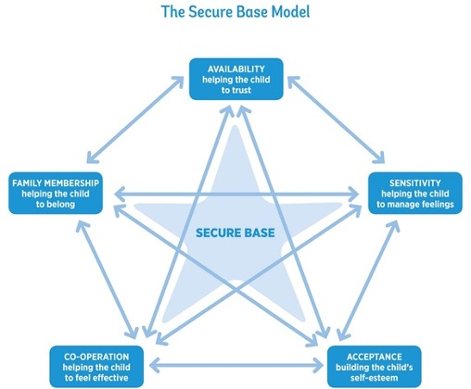er

AVAILABILITY – helping the child to trust
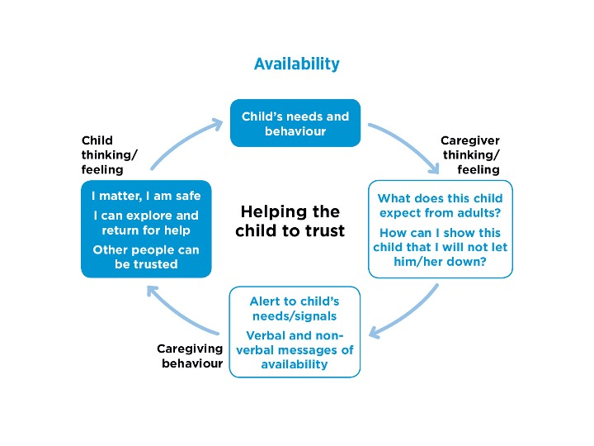

This dimension focuses on the caregiver’s ability to convey a strong sense of being physically and emotionally available to meet the child’s needs, both when they are together and when they are apart. When the caregiver can do this, the child begins to trust that their needs will be met warmly, consistently and reliably. Anxiety is reduced and the child gains the confidence to explore the world, safe in the knowledge that care and protection are there if needed.

The child’s needs and behaviour
Most children who come into foster care and adoption, from infancy to adolescence, have lacked available care and protection from birth family caregivers. They have often experienced parents who have reacted to the child’s needs with frustration, anxiety and rejection, or have reacted unpredictably according to their own needs and preoccupations. Each of these reactions from parents will cause children to have anxieties and uncertainties around caregiving and their own safety and security. They will find it hard to trust that an adult will always be available or that their needs will be met consistently, safely and kindly. Most detrimentally, parents may have reacted to a needy child with unpredictable anger or frightening aggression, causing the child to feel deep fear, panic, confusion and helplessness. The child is then likely to associate closeness with feelings of fear and dread and feel panicked by the approach of any potential caregiver, however trustworthy they may be.
These deeply rooted experiences may lead children either to distance themselves from their new caregivers, to clamour constantly for their attention, to feel helpless, or to be determinedly in control. These defensive strategies, associated with insecure attachment patterns, which may have been necessary for survival in a troubled birth family, can become problematic, stressful or hurtful to new caregivers who want so much to nurture, soothe and protect children from further harm.

Caregiver thinking and feeling
The challenge for new caregivers is a complex one. The eventual goal is to change the children’s expectations of adults – to convince children that they can rely on adults to care for them and meet their needs. Firstly, however, they may have to disentangle some confusing messages. Through words and behaviour, children who need your care may be indicating ‘I don’t need you, I prefer to look after myself’, or ‘I need you all the time, but can never be satisfied by you’, or ‘I can only manage my anxiety by controlling you and everything that happens in the household’.
New caregivers may have to remind themselves of the true needs that lie behind these messages and this is no easy task when they are accompanied by extremely resistant, needy or hostile behaviour. Caregivers may need additional support, therefore, to help them to think about this particular child’s previous experiences and speculate on what does this child expect from adults? In the light of this, the caregiver can think in a more focused way about the question, How can I show this child that I will not let them down? Trust-building interventions can then be targeted more precisely.

Caregiving behaviour
With this in mind, caregivers can begin to be more alert to their child’s needs and signals and then take opportunities to do and say things that will begin to change the child’s expectations of themself and of adults. They will give verbal and non-verbal messages of availability. But – and this perhaps, is the greatest skill of secure base caregiving – they will find ways of doing this that feel comfortable and acceptable to the individual child, such as knowing when to move closer and when to wait for a child to make the first move themself. Also important is the capacity of the caregiver to generate flexible theories about what is going on for the child (e.g. this behaviour may be caused by a bad experience in early childhood, a difficult day at school or both), to try different approaches and to wait patiently for small changes.

The child’s thinking and feeling
As children begin to trust that close adults are not going to disappear or let them down, their thinking will begin to change in subtle ways. They will begin to gain a sense of I matter, I am safe, I can explore and return to my secure base for help, and, crucially, other people can be trusted.
As anxiety is diminished, the drive to explore, learn and play becomes greater. There will be greater confidence and competence to venture away from the secure base and discover the wider world – but there will also be an increasing capacity to rely on caregivers for comfort and nurture and to enjoy appropriate closeness. Signs of progress in these areas may be slow to appear, but they are among the most exciting and rewarding for caregivers to observe.

SENSITIVITY – helping the child to manage feelings
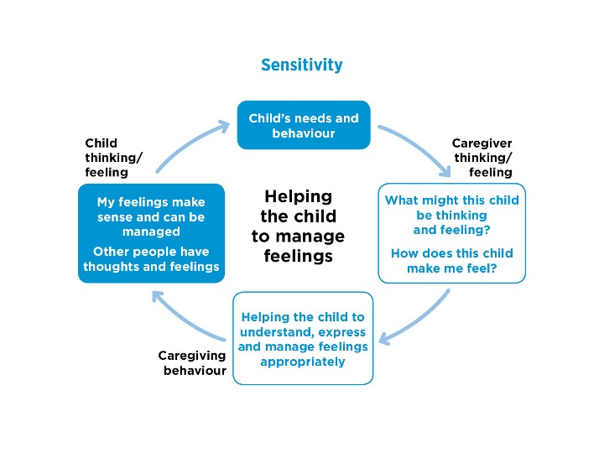

Sensitivity refers to the caregiver’s capacity to “stand in the shoes” of the child, to think flexibly about what the child may be thinking and feeling and to reflect this back to the child. The sensitive caregiver also thinks about their own feelings and shares them appropriately with the child. The child thus learns to think about and value their own ideas and feelings and the thoughts and feelings of others and is helped to reflect on, organise and manage their own feelings. This capacity to reflect on, manage and regulate feelings then enables the child to reflect on, manage and regulate their behaviour.

The child’s needs and behaviour
Children from difficult backgrounds have mostly lacked opportunities to have their thoughts and feelings acknowledged and understood – this can be true for children from infancy to adolescence. They may have been in situations where there was no one able or available to help them deal with strong feelings, so panic, anger or despair may have overwhelmed them at times. Or they may have had caregivers who denied or mis-labelled their feelings, distorting their sense of reality to the point where they could not discern the “truth” of what they felt in any situation. A child may have accidentally knocked over a glass and be very upset about the harm caused, but be told that they had done this deliberately to upset their mother and that they didn’t care. Sometimes, children will have been cared for by adults who could not manage and regulate their own feelings and children may have been blamed or feel themselves to blame for chaos or violence in the household. For a range of reasons, previous caregivers may have been too anxiously absorbed with their own distress or too preoccupied with their own needs to attune themselves to the minds and feelings of their children.
Lacking the resource of a safe and containing adult mind or a supportive scaffolding for managing their feelings, children develop their own ways of coping with them. This might involve expressing their feelings excessively, using feelings to control others, holding feelings in or denying that they exist at all. Each strategy is problematic in a foster or adoptive family setting, where feelings need to be communicated fairly openly, in a managed and regulated way, in order to build trusting relationships.

Caregiver thinking and feeling
For new caregivers, a primary task is to reflect on and make sense of their children’s feelings and how they are reflected in their behaviour. They must attempt to tune in to their child, stand in the child’s shoes and try to imagine – what might this child be thinking and feeling? They need to be particularly thoughtful about the child’s previous experiences and flexible in their thinking about how these might have shaped their thinking processes and expression of feelings. Although it is painful to do so, the capacity to project oneself into the mind of a child who has been maltreated is important. It is from this starting point that caregivers can begin to think about the child’s beliefs and expectations of themself and others and to reflect on how this might connect with their current behaviours.
The caregiver’s thinking will not only be about what is in the child’s mind about the present and the past – it will also be about making sense of the way in which the child reacts to small daily events. But the darkness of aspects of the child’s history and the impact of the child’s anxiety and dysregulated feelings on carers can, if not fully understood, disturb the mind of the caregiver or the cheerful and positive atmosphere of the household. In this context, there is really no substitute for a caregiver to have a containing relationship with a thoughtful, reflective social worker, who can bear the pain and cope with the complexity of thinking about the child’s history and current behaviours accurately, without distortion and without being overwhelmed, and who can allow the caregiver to reflect honestly on the question, how does this child make me feel?

Caregiving behaviour
With this supportive framework in place, caregivers can begin to adopt a range of approaches geared towards helping children to understand and express their feelings appropriately. An important first stage is that of naming feelings, helping the child to reflect on them, recognise them and think about their origin. Often, the expression of feelings is either suppressed or excessive and caregivers must help some children to show feelings more freely and others to contain and express them more appropriately. In order to help children to understand and respond to the feelings of others, caregivers need to feel comfortable in expressing and discussing the full range of their own feelings. In particular, they can show children that mixed feelings are “normal” and that combinations of love and anger, longing and distrust, anxiety and eager anticipation are part of the human condition – affecting not only them but also their birth parents, foster carers, adoptive parents, friends and social workers.

The child’s thinking and feeling
The emotional education provided by sensitive caregivers enables the child to discover that my feelings make sense and I can manage my feelings, gaining confidence that feelings will not become overwhelming to themself or others. Finally, the child can be helped to understand that other people have thoughts and feelings that must also be taken into account.
As the child’s thinking shifts and develops in these important ways, feelings are better regulated, and there is a likelihood of more constructive relationships, greater empathy and more pro-social than antisocial behaviour.

ACCEPTANCE – building the child’s self-esteem
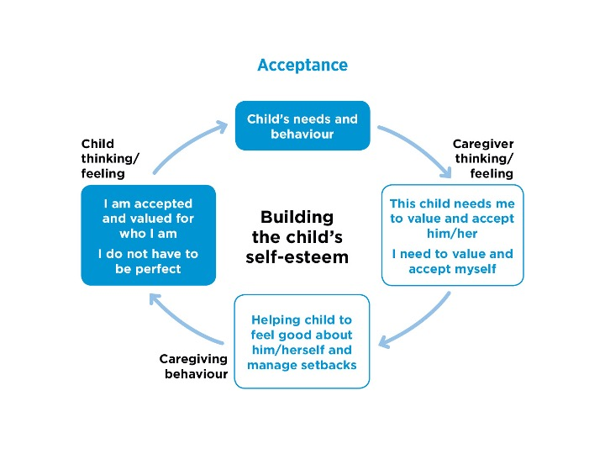
Acceptance is a necessary part of secure base caregiving. This dimension describes the ways in which the caregiver is able to convey that the child is unconditionally accepted and valued for who they are, for their difficulties as well as their strengths. This forms the foundation of positive self-esteem – the child feels good about themself. They can experience themself as worthy of receiving love, help and support and also as robust and able to deal with setbacks and adversity. This both reinforces a positive internal working model and builds resilience.
This area of caregiving builds on the dimensions of availability and sensitivity. Children need to learn to trust and to manage their feelings in order to believe the praise of caregivers and to take up opportunities that are on offer. But building a child’s self-esteem through activities can also build and reinforce trust and help a child to manage anxiety and express both positive and negative feelings more freely.

The child’s needs and behaviour
Many children who come into foster care and adoption have a profound sense of worthlessness and low self-esteem, often complex and deep-rooted in origin. Their early parenting may have lacked warmth and acceptance. For some children, family life may have been frightening at times and the tendency for young children to see themselves as having some responsibility for negative events can lead them to experience themselves as dangerous, bad and worthy only of rejection or punishment.
Low self-esteem for children may also be connected with multiple separations and losses of familiar people and, for some children, may be compounded by the stigma and sense of difference incurred by being fostered or adopted. Children, therefore, are likely to have deep-seated doubts about their fundamental goodness, whether or not they deserve loving care and whether or not they will receive it if they are “naughty” or needy.
Children who do not have an internal working model of close adults as warm and accepting, and themselves as loved and loveable, will find it hard to face the world with confidence. They have not learned that they can be both “good and bad” at different times, “clever or not so clever”, and yet still be accepted and valued. They often believe that if they cannot be the best, then they must be the worst. The danger, then, is that a child becomes trapped in a negative cycle expecting failure or rejection and behaving in ways (anxiously or aggressively) that are likely to produce this outcome.

Caregiver thinking and feeling
Caregivers must hold in mind the sense that this child needs me to value and accept them, whatever the stresses of caring for the child may be. Alongside this, and especially if caring for the child is challenging, the caregiver must remember that I need to value and accept myself, so that their own emotional resources do not become depleted. This may be a key area of intervention for support workers. Caregivers who are feeling overwhelmed by their child’s needs may need to be reminded of their strengths and skills and that it is the child’s history that is creating problems in the family, rather than their own shortcomings as caregivers.
Caregivers need to have a belief in the child as special and be able to develop hopefulness about their potential. Schofield et al (2000) found that successful caregivers invariably were able to express this belief, in spite of a child’s difficulties, e.g. ‘Very hard work…but he’s got the potential to be a really nice young man’; ‘She’s an absolute rogue. And you would never want that squashed. It’s lovely. It’s just got to be channelled’ (pp. 198–9).
By modelling acceptance of both strengths and difficulties in the caregiver, support workers can also convey the message, ‘You do not have to be perfect’, alongside providing caregivers with advice, discussion and training that will help them to develop new approaches and to parent positively.

Caregiving behaviour
Caregivers can then build a range of skills and strategies for helping the child to feel good about themself and to manage setbacks. Difficult behaviour can be approached in ways that do not undermine the caregiver’s own self- esteem or that of the child. The positive message to the child is: ‘Nobody is good at everything but everybody is good at something’, and so there is a focus on activities and interactions that both help caregivers to regain their sense of being competent and successful and enable children to feel positive about themselves.
This positive approach does not mean that behaviour difficulties are not challenged or that goals are not set to reduce behaviours that are upsetting or antisocial. On the contrary, it is critical for children, especially older children, to feel acceptable and accepted not only in the family, but also in their peer group and the wider community. Caregivers, therefore, have to manage a careful balance between accepting children as they are and helping them to change aspects of behaviour that threaten their acceptance by others.

The child’s thinking and feeling
The goal is for children to begin to think: I am accepted and valued for who I am. I do not have to be perfect in order to be loved and valued.
For some children, feeling good about and accepting themselves will always prove difficult, even with the most sensitive and accepting care. But self-esteem is so critical to healthy development that even small degrees of progress are worth working for.

CO-OPERATION – helping the child to feel effective
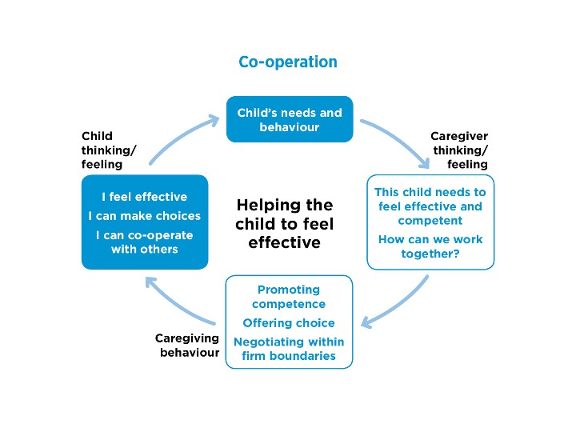
Co-operation is a key goal of a successful caregiving relationship. Within this dimension, the caregiver thinks about the child as an autonomous individual whose wishes, feelings and goals are valid and meaningful and who needs to feel effective. The caregiver therefore looks for ways of promoting autonomy, but also working together and achieving co-operation with the child wherever possible. This helps the child to feel more effective and competent, to feel confident in turning to others for help when necessary, and to be able to compromise and co-operate.

The child’s needs and behaviour
Fostered and adopted children have seldom experienced this co-operative approach to parenting as part of their early care. Birth parents who were struggling with their own needs may have been over-controlling and intrusive, denying children the opportunity to make choices, to feel competent and be effective. Parents may have lacked the skills or capacity to negotiate, resulting in interventions that were harsh and abrupt or weak and ineffective. Additionally, in stressed and disadvantaged households there are often fewer opportunities for play, fun and mutually enjoyable activities.
For a range of reasons, therefore, children may not have developed a sense of themselves as competent individuals, nor of adults as co-operative partners, either in exploration and play or in managing difficulties. As a result, they may become passive and over-compliant in their relationships with adults or they may seek excessive control and influence over them.

Caregiver thinking and feeling
Most caregivers would agree that all children need to feel effective and competent and they will know that most children enjoy and benefit from opportunities to act on their environment, make choices and take gradual steps towards independence. But children who feel ineffective and who have lacked appropriate control and influence in their lives can behave in ways that trigger difficult feelings and painful associations in their caregivers, making it harder for them to work towards these goals.
In most cases, therefore, caregivers may need help in taking a step back to consider: ‘How is this child affecting my sense of effectiveness and competence?’ Understanding your own experiences and the extent to which you need to be in control or are finding it hard to take control can be an important first step in co-operative caregiving. Shared thinking about the child’s earlier experiences of caregiving and the ways in which issues of competence and control might have been handled with the child in the past can also be helpful for the caregiver. This leads to a stronger position from which to address the questions: How can I help this child to feel more effective and competent? and How can we work together? The caregiver is then able to take a step back, and think in terms of forming a co-operative partnership with the child in order to achieve their shared and separate goals.

Caregiving behaviour
In co-operative caregiving, there are two important areas of “additional” parenting activity. The first is to help children to learn that it can be safe and rewarding to be active in completing tasks, solving problems for themselves, and making choices. To achieve this, caregivers will need to actively structure an environment that promotes competence and offers choice, providing opportunities for their children to feel genuinely effective. At all times, sensitive caregivers must be mindful of the delicate balance between facilitating appropriate dependency and promoting appropriate independence.
The second task for caregivers is to help children of all ages to experience co-operative relationships in which each partner contributes to the other’s goals. This involves making co-operation enjoyable, actively demonstrating that sharing and working together can be rewarding and fun. At the same time, negotiating within firm boundaries ensures that safe and reasonable limits are set and comfortable compromises can be reached when necessary.

The child’s thinking and feeling
The caregiver must bear in mind that the child will need to have a developing trust in a secure base before they can feel safe enough to tackle a difficult task or make new choices. Only when the foundations of trust are in place will the child be able to take the risk of thinking and behaving differently, being assertive but also co-operative.
Experiences of becoming increasingly competent to solve problems, to approach challenges and to make choices will help the child to feel more effective. And positive experiences of working together with trusted adults will develop the sense that it is rewarding to compromise and co-operate.

FAMILY MEMBERSHIP – helping the child to belong
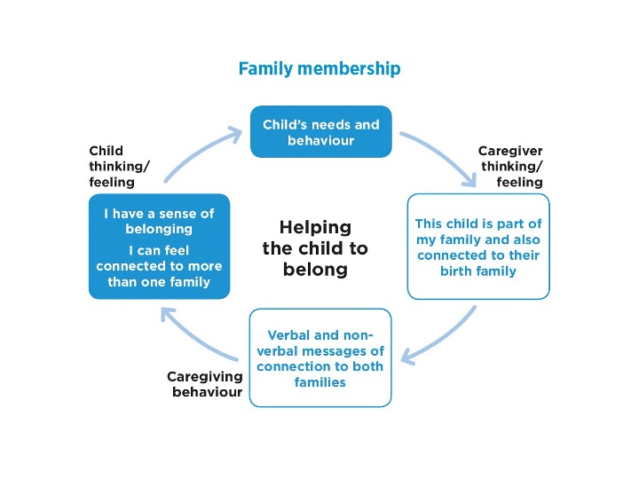

Family membership is a vital strand of healthy emotional and psychosocial development. A child who has no close family relationships will carry feelings of psychological and social dislocation. In contrast, the certainty of unconditional family membership can provide anchorage and the reassurance of practical and emotional support throughout life, acting as a psychosocial secure base for exploration, identity and personal development.
The family membership dimension refers to the capacity of the foster carer or adoptive parent to include the child, socially and personally, as a full family member, in ways that are appropriate to the longer-term plan for the child. At the same time, the caregiver must help the child to establish an appropriate sense of connectedness to their birth family. For children in short-term care with a plan to return home, the sense of connection to the birth family may be the dominant source of family membership and sense of belonging. In permanent placements, the long-term foster or adoptive family will be the primary source of membership and belonging, with the birth family role depending very much on the quality of the child’s relationships with birth family members and the quality of any contact. In kinship foster care, adjustments will also need to be made to family relationships and roles. But whatever the nature of the child’s family connections to foster, adoptive or birth families, they will need both a sense of belonging and help to develop a coherent family narrative that makes sense to them at their particular age and stage.

The child’s needs and behaviour
Each child separated from their birth family will bring a unique set of experiences of family life and each of these experiences will have shaped their expectations of the new environment and their sense of what it means to be a family member.
It is important to remember that, for most children, there will have been good times as well as difficult ones, positive memories as well as sad or frightening ones. For all children, the challenges of adapting to a new family life are enormous. Depending on their age and understanding, all children will be grappling with different degrees of loss (of people, places, pets and friends), uncertainty (How long will I stay? Do they really want me?) and anxiety (Will I be safe? Will I fit in?). The simple tasks of getting up in the morning and having breakfast in an unfamiliar setting can be mountains to climb for a child. It is hard to overestimate the potential stresses and strains that are involved in making the move to a new family, while managing feelings of loss and strong, although in some cases potentially harmful, ties to birth families.
Once the child begins to settle in the foster or adoptive family, these early messages of acceptance as part of the family will become consolidated so that they can feel reassured that they belong. Even in those circumstances, where there is some uncertainty about the future plans for the child, full inclusion in the family routines and activities is an essential part of providing a secure base that reduces the child’s anxiety and restores self-esteem.

Caregiver thinking and feeling
Caregivers will need to be aware that a child’s sense of connection to the birth family and foster or adoptive families will vary according to the nature of the plan for the child and the quality of relationships in both the birth family and the new family.
For instance, a child who is to have a short stay in a foster family with a plan to return home will usually need a fairly close involvement with birth family members and events, but will also value being treated just the same as other foster family members. Children in long-term foster families will need and can be expected to be treated as full family members through to adulthood, even in the absence of legal parental responsibility for the carers. Most foster children will also have continuing contact with their birth family that has to be managed constructively. Adoption confers full legal membership of the new family, with support provided into adulthood, but adopted children need also to achieve a sense of connection with their birth families, whether through contact (where appropriate) and/or through open, reflective discussion within the adoptive family.
What is important in all cases, however, is the capacity of the foster or adoptive family to both welcome and absorb new members and also to be thoughtful, reflective and open towards the individual child and their birth family. The thinking is therefore complex since it involves holding a balance between two powerful and sometimes conflicting ideas: this child is part of our family as well as connected to their birth family.

Caregiving behaviour
For caregivers, the primary task is to provide an environment that is emotionally warm, physically comfortable, accepting, and supportive of its members and that sets clear but reasonable expectations for shared living as a member of the family. The variations in how family membership is communicated are enormous and span the full range of culture, class, language, social norms and religious practice. It is here that we see a clear link to attachment theory, since sensitive caregivers provide the sort of environment described above and yet also have the capacity to be reflective in relation to the child’s needs and feelings about birth family membership.
Sensitive caregiving in this dimension therefore involves seeking opportunities to provide verbal and non-verbal messages of connection to both families. These must be sensitively adapted to the child’s changing needs and circumstances, with the aim of helping the child to feel a coherent sense of identity in what may be a complex network of relationships.

The child’s thinking and feeling
The combination of inclusion and recognition of having connections to more than one family can enhance the child’s felt security – ‘I am safe and secure in this family, but I can also think and talk about how I feel about my birth family.’ Over time, this will allow children to process their complex feelings, recognise and express different and mixed feelings, and manage their dual or sometimes multiple family connections at a level that feels compatible with their particular circumstance, wishes and feelings. They can move towards a position where their thinking and behaviour reflect a coherent sense of self and acceptance that ‘I belong’ and ‘I can feel connected to more than one family’.

