

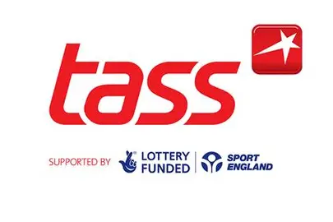
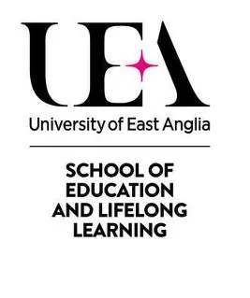

MSc Scholarship and Placement 2026-2028
Graduate Strength and Conditioning Coach
Scholarship and Placement Length: 2 Years
Masters Scholarship: Fully funded (UK Home Fee Value) on the following course: MSc Professional Practice in Sport (Part Time) 2026/27 | Postgraduate Course | UEA. UEA Sport Kit, Gym and Swim Gold Membership at UEA SportsPark, CPD and Training.
School of Study: uea.ac.uk/study/subjects/sport-and-health
Placement Host: UEA Sport Performance Sport: UEASport
Additional Funding: Students may wish to access further financial support at Funding for postgraduate study - GOV.UK and Postgraduate Scholarships Finder to support living costs
Location: University of East Anglia, Norwich, UK (In person requirement 4-5 days per week)
Application Deadline: Thursday 23rd July 2026 Interview Date: Monday 10th August (In person)
This unique scholarship and voluntary placement combines a professional coaching opportunity within the University of East Anglia Strength and Conditioning Department with academic study toward a Master’s degree in Professional Practice in Sport. The post is designed for an ambitious graduate seeking to develop both their applied coaching skills and academic understanding of high-performance sport. It aligns to advice from the UKSCA: The UK's Professional Body for Strength and Conditioning | UKSCA
As a Talented Athlete Scholarship Scheme (TASS) Delivery and Dual-Career Accredited Site; this role will develop and work closely with talented Athletes, Focus Sport Teams and students to benefit their pursuit of athletic excellence. The coach will also work with community users/clubs, fellow Multi-disciplinary Professionals and Industry Governing Bodies at our award winning Sportspark UEA.
The coaching experience is paired with a fully funded (UK Home Fee Value) place on the identified masters degree at the university working alongside our highly regarded academic team and making use of specialist delivery and research facilities on campus. The student’s research activity will be designed to directly affect the placement role in action with support of a specialist supervisor, and academic credit is awarded for close linkage of the placement role to academic reflection and exploration through the modules offered.
This scholarship and placement opportunity is open to people with the following essentials:
- Undergraduate honours degree in any Sport and Exercise Science subject area, Social Science of sport with underpinning sports science, Sports Development, Physical Education, Physical Activity and Health, Sports Coaching, or related discipline at a 2:2 or above.
- An understanding of qualitative and quantitative research methods in sport
- Level 2 Gym Instructor and/or Level 3 Personal Training Qualification
- Willingness and commitment to completion of a two-year placement and MSc study programme
- Experience in coaching or leading groups of people
- Excellent interpersonal and communication skills, initiative and professionalism
- Ability to balance academic workload and coaching commitments with a willingness to learn
- DBS check or willingness to complete one

In the instance that multiple applications for this scholarship are received we will assess the following desirable criteria;
- Experience delivering strength and conditioning sessions in a range of sports
- Basic knowledge of athlete monitoring and performance testing.
- First Aid and Mental Health First Aid Qualification
- Safeguarding qualification

The student will commit to a 4-5-day working week to include all elements, the below outlines a typical’ schedule’* that includes the MSc contact study time, protected study and rest time, and an indication of contact placement hours. There is no formal requirement for weekend work.
* schedule is an example of potential organisation of time, exact arrangements to be made with lead mentor.

 | Monday | Tuesday | Wednesday | Thursday | Friday
07:00
08:00
09:00
10:00
11:00
12:00
13:00
14:00
15:00
16:00
17:00
18:00
19:00
20:00

MSc Taught Contact Time – Dark Green
MSc Self-Study Time – Light Green
Placement Role – Yellow (16 hours per week, over 39 weeks per annum)
Protected Rest - Blue

To Apply: Send a CV (max. 3 pages) and Cover Letter detailing how your experience meets the criteria to Julia Robathan at J.Robathan@uea.ac.uk.
We welcome applications from a diverse range of people, including international students. In the case that the scholarship is awarded to a non-UK Home student, the applicant will be responsible for paying the difference in fees required.

