

Coaching students in the workplace

‘Unlocking the potential to maximise performance’

Coaching for Coaches

Working across the east of England

Introduction

Effective support of learning in practice is based on a concept of ‘coaching’ whereby the focus is developing students’ confidence, competence and performance through enhanced mentoring skills. A main aspect of this approach is that students are expected to take responsibility for their learning.

Coaching encourages the student to identify their own learning needs and to work out how they might achieve them.

Coaches tease out answers through probing questions, rather than just telling; coaches help students learn rather than teaching them. Coaches help a student unlock their own potential to maximise their own performance.

When a student defines their own leaning, they are more likely to be motivated to work, take responsibility and be committed to achieve their goals

The student is responsible for their learning choices

The coach is responsible for the quality of the learning experience.

Coaching Team

Students can learn from many members of the health care team, not just their mentor. We would encourage all members of the team to share their knowledge and skills by coaching students.

The idea is that wards will have a mixture of students from different years who can support and learn from each other, although they are supervised by a variety of staff (whilst still maintaining 40% access (directly or indirectly)time to a mentor) and be coached by any registered professional for the duration of that shift. An example of a first year student supervision could be:

Collaborative Learning in Practice Learning Log

This learning log is to be used on a daily basis unless specified otherwise by the Clinical Educator in your area. The coach/mentor’s comments and signature are required on the log for validation purposes.

Name of student: Sarah Smith | Date: 11/01/2017 | Named mentor: A N Other
Learning Objective | Evidence/Student Self Reflection | Coaches Feedback  (should include feedforward)  Please date and sign next to your comments
Clinical Learning:  What is the drug Bisoprolol and how does it work? | I have produced a piece of work looking into my learning outcome. The sources I used are:  BNF  Library  Patient notes  Discussion with mentor  This has helped me to link to practice because I am now aware of the different drugs that Bisoprolol can interact with. I am also now aware of the main side effects so am able to carry out patient’s care more effectively. | Objective achieved-Y/N  Linked well to practice-Y/N  Showed good level of understanding-Y/N  Comments –  Y  Y  Y  Sarah shows excellent use of her learning hour, good discussion surrounding side effects  A N Other (11/01/17)

Unexpected Events:  (Does not need to be filled out each day) | Learning Outcome/Student Self Reflection | Coach Feedback  (should include feedforward)  Please sign next to your comments
Student signature: ………………………….
Day coach signature: ……………………………

Differences between mentoring and coaching.

London Leadership Academy (2014) What is coaching? NHS London Leadership Academy

Mentoring | Coaching
Ongoing relationships that can last for a long time | Relationship generally has a set duration
Can be more informal and meetings can take place as and when the client need advice, guidance and support | Generally more structured in nature and meetings are scheduled regularly
More long-term and takes a broader view of the person | Short-term and focussed on specific development
Mentor is usually more experienced and qualified than the client; often a senior person in the organisation who can pass on knowledge, experience and can open doors to otherwise out of reach opportunities | Coaching is generally not determined by the level of the experience of the coach has of the clients formal occupational role – rather this professional distance can help to unearth assumptions that people from the same field accept critically.

Key skills of coaching – Using challenging questions

- Essential to overall process
- Find out about coachee (entry behaviour)
- Explore any issues
- Clarify goals and actions
- Encourage coachee’s to make progress (you can do it!)

Coaches ask questions, this is important because it creates possibilities for learning and for gaining fresh perspectives.
Allows students to question and explore gaps in their knowledge rather than you ask them, in this way the students are made responsible for their own learning.

Coaching questions may be used:

What do you make of that?
What do you think is best?
Tell me more about that?
What do you think that means?
What is an example?
What are the options?
How else could you handle that?
Can you tell me what you mean by that?
Can you talk me through why you think that’s the right thing to do?
Can you say more about that?
Can you explain why you did it that way?

Coaching model

- One to one – individuals are supported to achieve individual goals
- Group – intermittently and usually group work undertaken within a short timescale
- Systems – set up for family, government of community groups. Used to help motivate and develop moral to think beyond “strategic planning”
- Models – Spiral Model and the GROW model

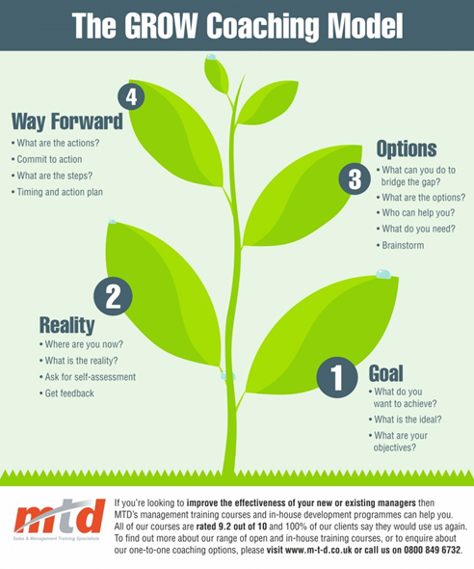

Assessment of competence

This assessment guides the mentor to the selection of the most appropriate style of coaching:
Another form of assessment of competence is the use of Miller’s pyramid. This is a very useful tool to enable coaches to assess their students’ competence and proficiency.
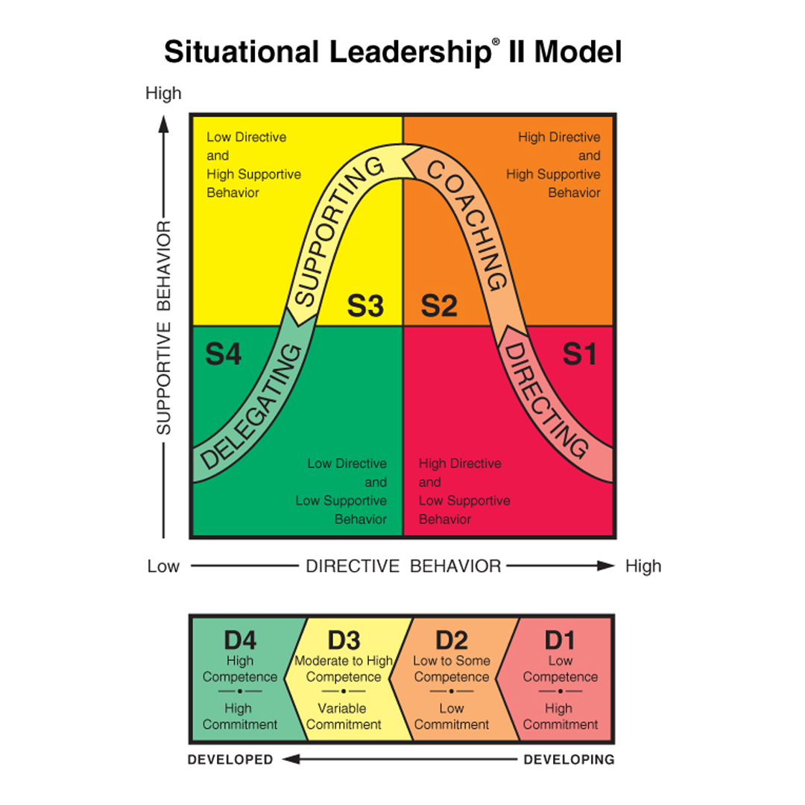
Hersey, P. (1985). The Situational Leader. New York, NY: Warner Books.
Remember, NMC standards are still over arching so coaching adds to the mentor “tool kit” in suporting learners in practice
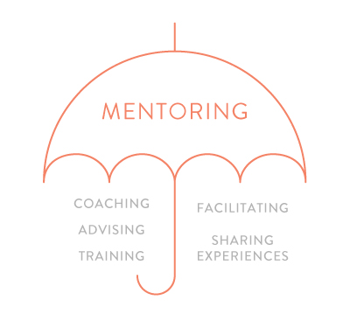
Graphic Copyright www.mchpositiveimpact.com
This work is licensed under a Creative Commons Attribution-NonCommercial-NoDerivatives 4.0 International License.
© 2017 University of East Anglia. All Rights Reserved.
CLiPTM was developed by Charlene Lobo in the School of Health Sciences at the University of East Anglia with the support of NHS Health Education East of England and can be downloaded at http://www.uea.ac.uk/foh/mpe/clip-project. If you have any questions about CLiPTM or wish to cite this work please contact David Huggins Email: d.huggins@uea.ac.uk Tel: +44 (0)1603 59 7049 Address: School of Health Sciences, University of East Anglia, Norwich Research Park, Norwich, NR4 7TJ

