Introduction to the Secure Base model:
promoting security and resilience in residential care

A TRAINING SESSION

Gillian Schofield, Julie Young and Mary Beek

Introduction for trainers

Background
- The Secure Base model of therapeutic caregiving is based on attachment theory and child placement research. It was developed (from 2006) by Gillian Schofield and Mary Beek at the University of East Anglia, who undertook a range of research on children in care. Although the model was initially applied to foster care and adoption, it has been found to be very relevant and helpful in building positive relationships in schools and in residential care.
- This training session specifically for residential care staff was developed in 2023 by Gillian Schofield with Julie Young, also at the University of East Anglia, and in consultation with residential home staff.
- This guide should be used in conjunction with the PPT presentation, An Introduction to the Secure Base model: promoting security and resilience in residential care (https://www.uea.ac.uk/web/groups-and-centres/centre-for-research-on-children-and-families/secure-base-model/resources )
- Notes listed under each slide (below and in the PPT talk) provide additional information and points for the trainer to raise with participants as appropriate.
The training session
- The session introduces the core concepts and the five dimensions of the Secure Base model for staff working in residential care Each dimension is explored in turn, with an accompanying participatory exercise.
- The session allows participants to discuss how they can apply the model to the practice, policies and ethos of their agency, with opportunities for case discussion.
Preparation
- Further information on the Secure Base model and relevant resources and publications can be found at https://www.uea.ac.uk/groups-and-centres/centre-for-research-on-children-and-families/secure-base-model
Timing
- This training session is designed to be presented in one day (e.g. 9.30-3 including breaks) The amount of material to be covered requires the trainer to maintain awareness of the time and the need to cover all the dimensions of the model.
- The programme could be delivered in two shorter sessions – but sessions should be fairly close together as the five dimensions interact and support each other, so understanding the whole model is important for practice.

Participants
- This session is suitable for all staff – including residential care workers, managers, psychologists, teachers etc.
- In order to promote participation and discussion, a total of no more than 30 participants is recommended.
Advice for trainers
- Be alert to issues that may arise in relation to, for example, ethnicity, class, culture, religion, disability, family structure, language, gender identity and sexual orientation.
- Respectfully challenge assumptions and stereotypes.
- Confidentiality: state that no information regarding young people and participants which emerges during discussion should be shared outside the group. The only exception would be if someone was felt to be at risk, in which case the trainer would discuss with the participant in private.
- This session touches on some sensitive areas of young people’s experience – feelings associated with attachment, separation, trauma and loss. These can be difficult feelings for all of us to think about, but for some participants they may be particularly difficult.
- The trainer should mention this at the beginning and advise that if anyone feels strongly affected at any point in the session, they might wish to take a break or speak to the trainer privately at the end.
Practical preliminaries
- Ensure that participants are comfortable and able to see and hear the trainer
- Mention location of toilets and fire exits
- Advise that phones should be switched off or put on silent mode
- Confirm the end time and approximate timing of breaks.

SECURE BASE MODEL TRAINING SESSION: GUIDE FOR TRAINERS

SLIDE 1

An introduction to the Secure Base model:
promoting security and resilience in
residential care

A TRAINING SESSION

NOTES
- Trainer introduces themselves and welcomes participants.
- Invites all to briefly introduce themselves and their professional role.
- Explain that the Secure Base model of therapeutic caregiving is based on attachment theory and child placement research. It was developed (from 2006) by Gillian Schofield and Mary Beek at the University of East Anglia, who completed a range of research on children in care.
- The Secure Base model was first recommended by the Department for Education (2007) and has since been implemented across the UK and internationally, from Norway to China, Thailand and Ukraine.
- Although the model was initially applied to foster care and adoption, it has been found to be very relevant and helpful in building positive relationships in schools and in residential care.
- This training session specifically for residential care staff was developed in 2023 by Gillian Schofield with Julie Young, also at the University of East Anglia, and in consultation with residential home staff.
- Materials for use in all settings are on the Secure Base model website. They are accessible and free to use https://www.uea.ac.uk/groups-and-centres/centre-for-research-on-children-and-families/secure-base-model (Just Google Secure Base model).

SLIDE 2
Outline of the session
- Theory underpinning the Secure Base model – the significance of providing a secure base, security and resilience for children
- The Secure Base model of therapeutic caregiving
- Practical applications of the Secure Base model in residential care

NOTES
READ SLIDE
- As a model of therapeutic caregiving that builds security and resilience, the Secure Base model focusses on small everyday interactions, each of which has the potential to develop a Secure Base relationship. It helps us to recognize and reflect on positives in caregiving and children’s development so we can build on them, talk about them with others, work together as a team, use a common language. But also identify gaps and challenges for each child that we can use the model to address.
- The session will provide an explanation and applications of the Secure Base model in residential care, including using examples provided by young people and residential care staff from UEA research interviews.
- Exercises will be used to involve participants and ensure the model feels relevant to their everyday care of children e.g. how it can be used in assessment, when talking and thinking about a young person’s strengths and difficulties, at reviews / team meetings.
- Participation is important for learning – so the session will aim to promote discussion in a safe learning environment, with respect for each other.
- The discussion of case examples and professional and personal experiences needs to be kept confidential. It’s important to observe your usual rules of confidentiality regarding details of young people and staff.

SLIDE 3
Significance of providing a secure base for child development
- All infants / children /adolescents need a caregiver who provides a secure base – a safe haven and comfort when they are distressed, which reduces the child’s anxiety and enables the child to explore, learn and enjoy activities.
- This caregiving helps a child to feel secure – and offers a wide range of developmental benefits in other relationships with adults and peer groups.
- Early relationships create the child’s set of beliefs and expectations about themself and others. Secure base caregiving leads to a belief that ‘I am loved and lovable’ and ‘Caregivers can be trusted to care for me’.

NOTES
- It’s important to understand the theory that is the foundation of the Secure Base model.
READ first two bullet points
- First is the key idea in attachment theory that children need a ‘secure base for exploration’. It stresses the importance of warm, supportive secure early relationships for positive wellbeing. John Bowlby’s original concept from the 1950s was that for children to feel secure, they need a caregiver who is sensitive and responsive, providing a safe haven to go to for comfort when anxious (for example, the child is feeling hungry or lonely or hears a frightening noise). ‘Sensitive’ here means adults being attuned to the mind of the child – being ‘mind-minded’ – thinking about what the child is thinking so they respond in a way that will meet the child’s needs.
- When the child’s anxiety is reliably reduced (when they don’t have to worry about hunger or survival), the child (from infancy to adolescence) has a secure base to engage more confidently with play, learning and exploring the world, as they have a safe and responsive person to return to. This has a range of developmental benefits, such as self-esteem, that we will explore.
READ third bullet point
- A child’s beliefs and expectations about self and others develop in early relationships and are key to building security and resilience. BUT changes for better or worse in the child’s security, beliefs and expectations can occur during childhood and adolescence if the caregiving environment changes- for example, if caregivers feel better supported or become more stressed.

SLIDE 4
Significance of attachment and a secure base for young people in residential care
- Because of the impact of abuse, neglect and loss on development, young people in residential care will need a therapeutic, secure base everyday caregiving environment.
- In this supportive relationship context, there is the potential for all young people to become more secure, better able to manage their feelings and become more confident and competent at school, in activities and with friends.
- The young person’s beliefs and expectations about themselves and others needs to change from negative to positive – from ‘I am not lovable’ and ‘Other people can’t be trusted’ to ‘I am lovable’ ‘Other people are available, understand me and can be trusted to support me’.

NOTES
- It’s important to think about the impact on the child’s thinking, feeling and behaviour of their previous experiences of caregiving before entering residential care – and the implications for the care they now need.
READ first two bullet points
- The Secure Base model shows how each moment of each day in residential care is an opportunity for therapeutic care- which here means promoting positive experiences and healing / helping the child to recover from earlier difficulties and learn to trust relationships. Children can feel more secure / build new attachment relationships at any age - attachment theory and a secure base is not just about infancy and early childhood.
READ third bullet point
- Young people may have developed negative beliefs such as e.g. ‘I’m not a good person’ ‘adults can’t be trusted’, ‘other children don’t like me’, ‘The world is frightening and unpredictable’.
- Young people in residential care with these beliefs still need to get their needs met, so often have patterns of behaviour/relating to others that may have helped them survive in their previous relationships (for example, withdrawing and not sharing their feelings).
- However, young people’s beliefs and expectations can change to become more positive over time, as they start to trust residential care staff.

SLIDE 5
Building resilience during childhood and adolescence - significance in residential care
- Key to building resilience for young people is focussing on positive relationships and constructive activity, talents and interests that build competence and confidence to approach future challenges.
- Building resilience and providing a secure base are linked through core concepts such as trust and self-esteem.
- Promoting resilience includes helping young people to understand, explore, come to terms with and resolve feelings about the past - and have a balanced and coherent story / narrative. This supports a positive identity /sense of self and helps build positive, reciprocal relationships.
- Life story work is relevant at all ages and stages.

NOTES
- Security and resilience are linked concepts – young people react differently to stress but they are not born resilient- they become resilient with the right kind of supportive caregiving that helps them develop their engagement and enjoyment in relationships, activities.
READ first two bullet points
- Promoting resilience, especially for adolescents in residential care, is essential to enable them to cope and fulfil their potential in the outside world and in adulthood. Even brief interactions – how you greet a child when they wake up or after school – can make a difference to their sense of self - I matter to someone.
READ third and fourth bullet point
- An important area of building resilience and having a ‘secure base for exploration’ for children in care is to explore their history and find a way to manage difficult feelings and stories – but also to identify positive experiences from the past in birth families or in care.
- Life story work is important for identity and a positive internal working model. ‘Things that happened in the past were not my fault. There are reasons why they happened’. Life story work can be relevant at any stage - and updated before leaving care as it can be a last chance to ensure a young person has the information they need and provides an opportunity to reflect constructively on their childhood as they enter young adulthood.

SLIDE 6
EXERCISE 1
- Make a list of key people who helped you to feel more secure and confident - in your childhood and teens? And as an adult?
- List the qualities in these people who had such a positive impact on you.

NOTES
- Explain that before looking at the Secure Base model in more detail, this exercise is an opportunity for personal reflection on what participants have learned from the value of close relationships in their own life.
- It is helpful when thinking about what children need from relationships for staff to reflect on the varied people and the range of support in their own lives that may have helped them and made a positive difference.
READ SLIDE
- EXERCISE 1 should be done as an individual task and only shared to the extent that participants wish to share.
- After about 5 minutes invite participants to discuss the qualities that made a difference for them - and reflect on what may be helpful to young people.

SLIDE 7
The Secure Base model caregiving dimensions that promote security and resilience
- Availability - helping the child to trust
- Sensitivity - helping the child to manage feelings
- Acceptance - building the child’s self-esteem
- Co-operation - helping the child to feel effective
- Family membership - helping the child to belong

NOTES
- These are the five dimensions that make up the Secure Base model
READ out the five dimensions on the slide:
- Can further explain the caregiving concepts as you read the slide
- Availability - being there physically/emotionally- helping the child to trust.
- Sensitivity - tuning into what the child is thinking/feeling- helping the child to manage feelings.
- Acceptance - accepting the child unconditionally - building the child’s self-esteem.
- Co-operation –offering choice /working together – helping the child to feel effective.
- Family membership – valuing the child as a member of the group/supporting birth family relationships - helping the child to belong.

- The first four caregiving dimensions and the developmental benefits of each came from attachment theory and research, combined with UEA child placement research. They were all recognized as important for caregivers providing a secure base/ helping a troubled child to feel secure. The dimensions are relevant for children of all ages. For example, Availability - helping the child to trust is essential for infants, primary age children and teenagers.
- Schofield and Beek added a fifth caregiving dimension to the Secure Base model from child placement research that helps children to feel more secure - Family membership - helping the child to belong. A sense of belonging is very important for all children, but especially for children in care who may have experienced multiple families, but also includes feeling a sense of belonging in the residential unit.
- Invite participants to reflect on how these dimensions fit with the qualities they recalled earlier as important in making them feel more secure and confident.
- These five dimensions will be explored during this session to show their role in residential care– but key to note first is that these dimensions interact (next slide).

SLIDE 8
The Secure Base model
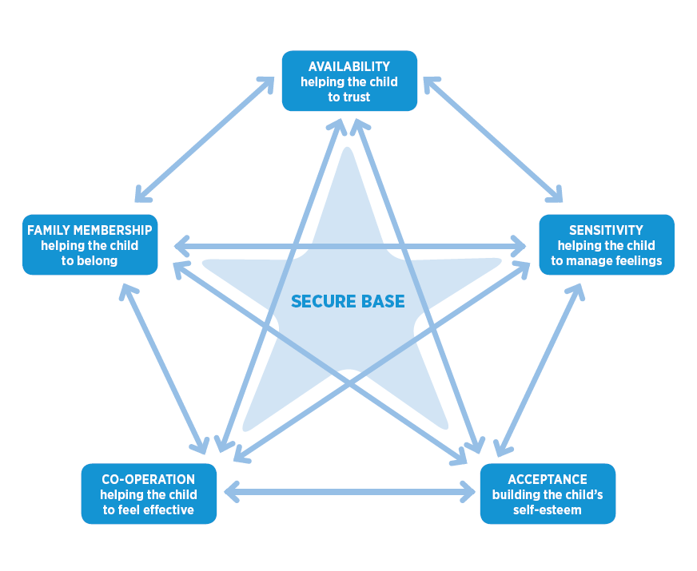

NOTES
- This is the diagram that represents the Secure Base model and shows how the five dimensions interact. For example, availability supports sensitivity, tuning in to the child and managing feelings. Acceptance is needed not only to build self-esteem, but also to help a child feel they belong.
- It’s therefore important to think about and use all the dimensions when caring for and planning for young people as they work together to provide a secure base and contribute to young people’s healthy, secure development.
- But separating the dimensions out for assessment or to target a care plan is important - some children need more initial help in some areas e.g. learning to trust before they can build their self-esteem.
- The model is useful for staff teams - suggests that not every member of staff needs to fulfil every dimension at all times. But all staff can make a contribution that collectively ensures all children have the support they need to feel secure.
- Where a member of staff has a key role for a young person they can use the dimensions as a way of summarizing their needs and checking progress.

Slide 9
Practice applications of the Secure Base model
- Assessment and working with children and caregivers.
- Matching children and placements, including multi-agency plans for support.
- Caregivers / social workers setting goals for children in each Secure Base dimension and monitoring progress.
- The Team as a Secure Base – model for supporting staff.

NOTES
READ SLIDE
- Although the Secure Base model was initially focused on informing and supporting foster carers and adopters, and the practitioners who work with them, it is relevant for all situations where adults are caring for children e.g. family support, fostering, kinship care, adoption, residential care and schools.
- The Secure Base model is relevant to children of all ages - from infancy to late adolescence- and a range of areas of practice in residential care, from planning a young person’s admission, to settling them in, reviews, planning for return home, moving to foster care or leaving care.
- The secure base concept also applies to adults – we all need a secure base in our relationships to allow us to fulfil our potential- managing our feelings, self-esteem. Staff in their working environments benefit from relationships with managers and colleagues that reduce anxiety and help them feel secure, be resilient and meet the needs of young people.
- Materials on the Secure Base model website include the Team as Secure Base.

SLIDE 10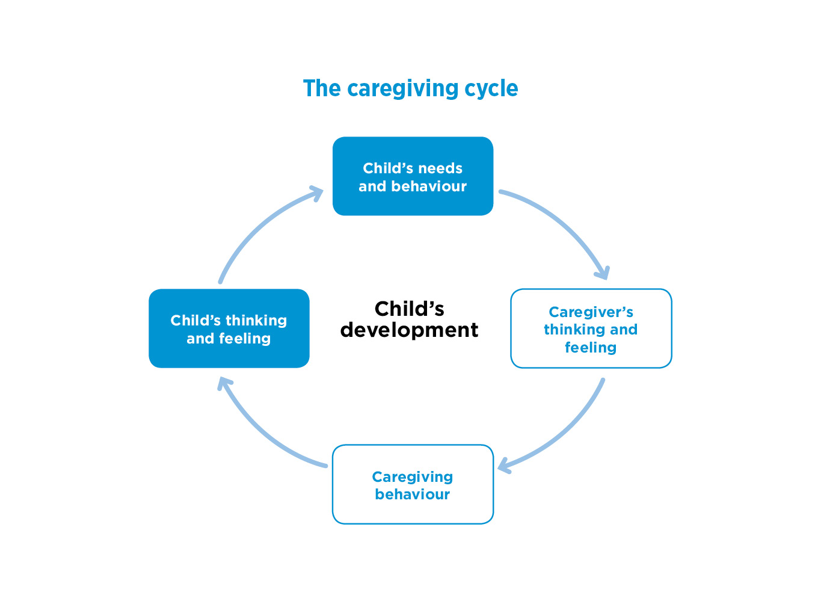

NOTES
- The caregiving cycle is an important part of the Secure Base model. It shows what happens in an interaction between caregiver and child – behind every behaviour are thoughts and feelings.
READ round the cycle
- The cycle demonstrates the links between what is going on in the mind of a caregiver and their behaviour in response to the child’s needs and behaviour; the impact of this caregiving behaviour on the mind of the child, their thinking and feeling; and how this is turn affects the child’s behaviour. These cycles go round many times in the day for every child – from waking in the morning to bedtime.
- The cycle shows how helping to change a child’s behaviour needs to start with changing their thinking and feeling – and this starts with the thinking, feeling and behaviour of the caregiver.
- The caregiving cycle can be positive or negative. For example, a caregiver believing positively ‘I can help this child’ will lead to supportive behaviour and build positive self-esteem in the child. Negative caregiver thinking – such as ‘this child doesn’t like me’ can lead to anxious or negative feelings and behaviour towards the child, increasing the child’s anxiety and doubts about their lovability- in turn affecting their behaviour towards the caregiver. So it’s helpful to reflect in supervision on what may be happening in a relationship with a particular child.
- What caregivers are thinking is important – we need to think flexibly, empathically about the child’s inner life, how they see their world. Sensitive thinking and responding from staff/carers is central to secure base relationships that support the young person’s healthy development- and will also be more rewarding to staf

SLIDE 11
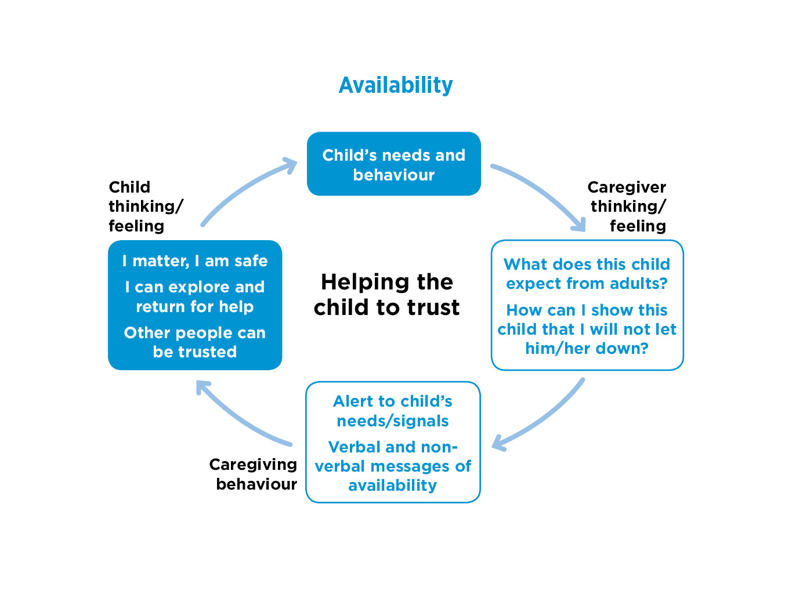

NOTES
- Now we will go through each dimension in turn. First Availability- helping the child to trust
READ round the cycle on the slide, starting at the top.
- The caregiving cycle is used for each dimension – showing the interaction of minds and behaviour in the relationship between caregivers and young people.
- Availability here is the first dimension and underpins the others - because of the importance of the caregiver’s practical and emotional availability and the link to the equally important child’s need to learn to trust.
- Availability is about being there physically and emotionally, helping children and young people to trust and feel safe, knowing that there is help when they need it, and that they will be helped – they matter. They are safe.
- Emphasise the idea of availability as a secure base for exploration and caregiver thinking – does this young person seem to lack trust? Do they think they won’t be safe? When? What do I know about their early life/background that is relevant here? How can I show them that they are safe here, that we will be there for them?
- Caregiver behaviour - noticing young people’s signals. Signaling interest, care and concern for them. Showing you are thinking of them, showing how they can be safe and supported in this home.
- The importance of these goals for young people’s thinking in residential care – ‘I matter, I am safe, I can explore...and return for help to trusted people when needed.’
- Helps young people to express /communicate their needs next time.

SLIDE 12
Why young people in residential care may lack trust
- Young people have often lacked consistent care and protection from reliable caregivers and have experienced moves and losses
- Parents may have been unavailable through drug misuse, mental health problems, learning disabilities, their own childhood experiences - or a combination.
- Parents may have, for example,
  - rejected the young person’s emotional demands
  - responded unpredictably, because of their own needs
  - been frightening or frightened
- Young people will have developed defensive strategies to cope with each kind of caregiving e.g. shutting down on feelings if rejected / becoming excessively demanding / being controlling.

NOTES
READ SLIDE
- Draw attention to the links – for example the link between the child experiencing rejection from parents when they expressed feelings to then shutting down and avoiding showing their feelings in later relationships.
- Young people in residential care may also lack trust if they have experienced multiple moves – they may have felt that carers and professionals had let them down or given up on them, making promises that weren’t kept.
- Participants may have other examples of reasons that young people lack trust e.g. rejection in their peer group.
- Defensive strategies for coping are often taken into later relationships/situations, including into school, into a children’s home. Young people need help to feel secure and safe enough to be able to trust the people who care for them.

SLIDE 13
Availability – helping the child to trust: checklist
Does the child/young person- at least sometimes:
- respond positively to a caregiver - seek comfort/help appropriately?
- use a caregiver as a secure base i.e. seek comfort, have anxiety reduced, then be confident to try new activities?
- trust people outside the family appropriately e.g. teachers, activity leaders, peer groups?
- discriminate between familiar people and strangers in seeking out / showing affection?
- manage friendships with peers successfully, able to trust and be trusted appropriately?

NOTES
- A benefit of the Secure Base model and these related questions is that it guides thinking about and understanding a young person, focusses your assessment, can prompt and facilitate a team discussion – here in relation to the first dimension, the child’s capacity to trust and their need for available caregivers.
READ SLIDE
- These questions come from the Secure Base checklist for age 11-18 (available on the Secure Base model website). They can be used for assessment at an early stage in a placement and at points of review to identify strengths and difficulties, plan support and check on a young person’s progress. They can be used by staff sharing ideas but also adapted to be explored directly with the young person.
- To answer these questions about the child’s capacity to trust, it will be important to carefully observe /note/share with the staff team how the child behaves – and discuss whether the child can trust other people, what the child might be thinking and feeling and how this, and their history, may be driving their behaviour. These connections are often complex and need flexible thinking - and the capacity to listen to the young person.

SLIDE 14
A young person lacking trust that they would be cared for or cared about
- The first few weeks...I was breaking out, fighting and punching the staff because I wanted to go home. I was genuinely really not liking it. My experience in my heart was I just did not want to be there... I am not proud, but it was a distressing time definitely.’ (Young person)

NOTES
- This is an example of a young person lacking trust that they would be cared for or cared about
READ quote from slide
- Then check out with participants - do they recognise the young person’s troubled reaction in the early days of a placement? Subsequent sense of shame? What might be the emotions behind this behaviour?
- Young people will react very differently to moving into a children’s home. Some young people who have had some good experiences in the past may be more hopeful and able to trust. Other young people may be calm at first but develop angry and aggressive behaviour later, sometimes once they feel able to express their feelings.
- What other experiences or reactions / coping strategies have participants seen in young people? Ask for ideas e.g.
  - Not asking for help, always saying they are fine.
  - Looking worried but can’t say why.
  - Avoiding eye contact.
  - Having low expectations of adults/professionals – assume a lack of care so distrust staff.

SLIDE 15
Availability- helping the child to trust
Caregivers can:
- be there for young people – physically and emotionally.
- show this young person that they are reliable and trustworthy.
- provide nurture/reassurance and support exploration.
- ensure their availability is known to the young person.
- help the young person to know that they are thinking of them when apart.
- ensure that young people know who to turn to in their absence.

NOTES
- It’s important to think about how we show availability / respond to children who lack trust – how can I show this young person I will not let them down? That they will be safe here?
READ SLIDE
- The caregiver needs to start at the pace of the young person - try to give the young person space while learning how best to be there for this particular young person, taking account of their age, stage and how they respond. May need to be tentative at first/create opportunities.
- Being available while apart- holding the young person in mind but also signaling to the young person that you are thinking of them. (e.g. using texts – I was thinking of you.)
- Even small stresses/hassles in a young person’s life can give staff opportunities to support them, show reliability and trustworthiness. Give the young person confidence you will help when they need you.
- Care for the young person after challenging behaviour.
- Skills needed include: observation, patience, remembering things young people said/liked, clear communication, keeping promises, not being overly intrusive.

SLIDE 16
Residential care relationships - availability, trust and security
- Young people can get a sense of security from a range of trusting relationships – with individual staff members and with the staff group. These support the young person in building wider relationships at school and with friends.
- When care staff are off shift or on leave, young people need to know when they are going, when they will be back, that staff are thinking about them – and that trusted others in the team are available for them.
- Staff need to be available / be a secure base for each other – to reduce anxiety, promote staff well-being and maintain emotional and psychological availability for the young people.

NOTES
- This slide explains how the availability dimension translates into residential care, where children need to learn to trust key workers and a staff group rather than family caregivers.
READ first bullet point on slide
- The number and range of staff can have advantages – young people are drawn to / find different adults helpful for different needs- perhaps one more for food and comfort/ another for games and activities. Key workers can be helpful in taking responsibility for co-ordinating a young person’s care but may or may not be the staff member the young person feels most drawn to.
Read second bullet point
- Practical examples about managing time apart can be discussed e.g. do the young people know who will be on shift? how would staff let a young person know that they are going on holiday? What about illness, staff loss/changes?
Read third bullet point
- Ask participants - in their experience, what are the helpful ways in which relationships in the staff group and with managers provide a secure base to help them stay available for young people?

SLIDE 17
Messages of availability from the start of the placement
- ‘The key worker would go to meet them, be there for their first tea, be there on their first shift and introduce them to each person individually – so that as the weeks go by, they would feel more comfortable.’ (Residential worker)

NOTES
- It’s important to establish messages of available care for each child as an individual from the start of the placement – availability that all staff would offer and young people could trust.
READ quote on the slide
- Does that sound familiar? What settling in practices do participants have for young people?

SLIDE 18
Holding the young person in mind when apart
- ‘When you get back from holiday the key child is pleased to see you - you have brought back a little gift so you hold them in mind. You prepare them before you go and you bring them a little something, even if it’s a stick of rock: “I was thinking about you. I thought you might like this” ‘. (Residential worker)

NOTES
- This is an example of a staff member holding the child in mind while apart.
READ quote from slide
- Keeping the child in mind while apart is a complex issue in residential care. As mentioned earlier, staff at times will be off shift or on leave and do need breaks.
- But the child’s sense of continuity in the relationships can be beneficial – as it would be for any child with a parent /caregiver that needs to be away for blocks of time.

SLIDE 19
Transformative experiences – a young person’s trust in an available staff member
- ‘I loved him like a dad really, because whenever he was there he always took time out of his day to sit with me and help me. Whenever I got stressed about something he was always there for me to go and talk to. My favourite memories of me and him were we always used to love going swimming, that was my fondest memories.’ (Young person)

NOTES
READ SLIDE
- Trusting relationships with an available individual member of staff relieved stress, and made this young person feel cared about.
- This is an example of a young person feeling a bond with a particular person. Positive feelings about relationships are often linked to memories of shared activity.
- Note that although face-to-face contact with this staff member would have been interrupted by shift changes and leave, the relationship still felt continuous and gifted this young person long-term memories of feeling valued and being both loved and loving. This would translate into their internal working model of self and others and all future relationships.

SLIDE 20
The value of wider support being available in residential care
- ‘They just genuinely cared for our wellbeing. If there was ever any trouble in my life they were on to it straight away...Staff there were amazing.’ (Young person)

NOTES
READ SLIDE
- Availability and responsiveness of the whole staff group matters.
- Some young people talk of how a residential staff group can feel safer and more available than foster carers.

SLIDE 21
EXERCISE 2 Availability- helping the child to trust
Think of a young person in your care
- Are there times when the young person is able to trust adults e.g. seek comfort or help with activities?
- Are there times when the young person has difficulty trusting adults?
- Why do you think this young person lacks trust?
- What are ways of showing availability /helping this particular young person to trust? What has worked/not worked?

NOTES
READ SLIDE
- Discuss either in pairs or groups of 3-4. Feedback /discuss as whole group.
- Issues that may arise: How can a child be helped to feel ‘I matter’, ‘Here I am safe and adults will support me’?
- Even in a short–stay children’s home, carers can still give positive messages, contribute to laying the foundations of a young person’s secure base, creating a more positive internal working model - the young person can start to believe in the possibility that they are valued and that other people can be trusted.

SLIDE 22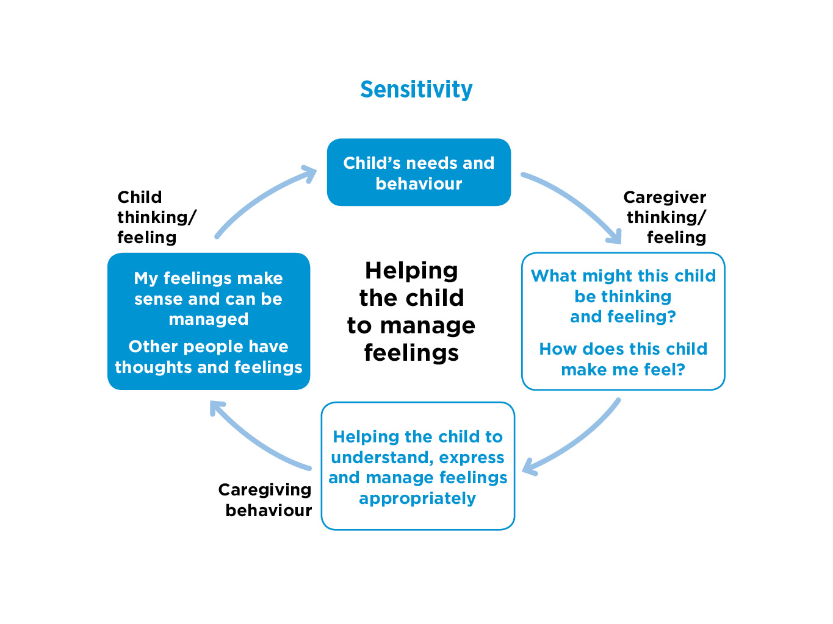

NOTES
- Next we move on to the second dimension: Sensitivity – helping the child to manage feelings.
READ round the cycle on the slide, starting at the top
- It’s important to emphasise with this cycle the significance of caregivers being interested in, curious about, tuning in to the mind of the young person, their thoughts and feelings as the best way to understand their behaviour.
- Emphasise also that ‘managing’ feelings is not about suppressing them, but about expressing them appropriately, whether happiness or sadness or anger, so those feelings can be understood and responded to - by adults and other young people.
- In infancy and early childhood parents ideally reflect back the child’s feelings via mirroring their expressions, talking about the child's emotions, showing interest in and recognition of feelings – teaching the child that feelings are OK and how to communicate them so that adults can respond to them helpfully.
- For older children and adolescents, their feelings need to be understood/validated - including more negative feelings. Tuning into young people who lack trust must be at their pace – so not intrusive. Often shared activities- such as cooking – can provide the best opportunities to share feelings.
- Also- important for caregivers to reflect on ‘how does this child make me feel’? Each child will trigger different feelings in caregivers – perhaps affection and protectiveness or anger and frustration. These feelings will need to be recognised and understood as they will affect caregiving behaviour.
- Staff need to model appropriate management of their own feelings, with support from colleagues and reflective supervision.

SLIDE 23
Young people who find it difficult to manage their feelings and behaviour
- Their feelings may not have been acknowledged, named, understood or responded to in their birth families.
- From infancy, young people may have been overwhelmed by their feelings.
- Feelings and behaviour may have been misunderstood or mislabelled.
- Feelings now cannot be expressed appropriately – so they may be expressed excessively or denied, repressed, dysregulated or dissociated.
- Young people’s feelings can sometimes be expressed through their bodies in confused ways: for example, self-harm, substance misuse, eating disorders.

NOTES
READ SLIDE
- These points suggest the kind of difficulties that can arise for young people who have experienced parenting that did not meet their emotional needs and may have been actively harmful.
- It’s helpful to give an example for the third bullet point- feelings and behaviour may have been misunderstood and mis-labelled: for example, a parent or carer may say that an accident (e.g. a child knocking something over) was deliberately done to upset the parent/carer. Children can then find it hard to believe their own feelings / experience.
- Each child will be different and have had different experiences of expressing feelings and how they have been responded to. This slide gives some ideas and examples - but getting to know how each child you work with currently experiences or expresses their feelings and what the links may be to their history requires time, thoughtfulness and patience.

SLIDE 24
Sensitivity - helping the young person to manage feelings: checklist
Does the child/young person - at least sometimes:
- express a range of positive feelings (excitement, pleasure, delight) but not get overwhelmed by them?
- express a range of negative feelings (anger, disappointment, sadness) but not get overwhelmed by them?
- communicate feelings accurately, with adults and peer group?
- talk about/reflect on their feelings and behaviour?
- talk about/reflect on the feelings and behaviour of others?
- have effective strategies for managing their feelings and behaviour?

NOTES
- It’s helpful to think about the range of healthy ways in which young people may communicate or manage their feelings – to see where a young person may have strengths and identify the difficulties/gaps.
READ SLIDE
- These questions, like the earlier slide on availability and trust, are from the Secure Base checklist and can be used at any stage for assessment, care planning and checking a young person’s progress.
- There will be very varied evidence in young people’s own accounts or in their behaviour of how the young person is experiencing feelings. So it’s important to think flexibly about a number of explanations e.g. anxious behaviour may be about current problems, perhaps at school, or connect to an earlier trauma /abuse/loss – or a combination.
- Signs of progress in a young person being able to express and manage feelings and behaviour constructively might include communicating their feelings in words or on paper or using trusted others for support rather than becoming depressed or resorting to aggression, substance misuse or self-harm to manage their feelings.

SLIDE 25
EXERCISE 3: Sensitivity- helping the child to manage feelings
- ‘My actions are completely beyond my control, like literally completely beyond my control. I can punch someone in the face and not even realise that I have done it until after I have done and no anger there just pumph and it is like “Why did I do that?” ‘ (Mark, age 13, came into care age 8 from a background of domestic abuse and his mother had episodes of depression. Mark has had three foster home moves.)
- Discuss why Mark may have had difficulties in understanding and expressing his feelings? May have become aggressive?

NOTES
- This exercise uses a case example of a young person who struggled to manage their feelings – starting with their own description of their behaviour.
READ SLIDE
- Discuss either in pairs or groups of 3-4. Feedback /discuss as whole group.
- This exercise is about tuning into /understanding possible reasons for a young person’s feelings and behaviour.
- Note that it is positive that Mark has some ability to reflect on his behaviour.

SLIDE 26
Sensitivity- helping the child to manage feelings
Caregivers can:
- think about what the young person is thinking and feeling.
- name possible feelings and help the young person to make links to their behaviour.
- support the young person’s emotional reflections about past, present and future- consider practical tools e.g. diary.
- name and model the appropriate expression and management of the caregiver’s own feelings.
- promote empathy in the young person – how do you / how might other people be thinking and feeling? Reflect together on other people’ feelings in daily events, books, television, films.

NOTES
- These are a number of examples of what a caregiver can do to help a young person to express and manage their feelings.
- READ slide straight through and then pause for some discussion – how easy is it to understand and respond to what children are feeling? Are these practical suggestions possible in daily life in the home where they work?
- How do participants help young people name and manage feelings? For example, after a violent outburst, getting a young person to focus on how their body felt/feels. Teaching them to recognize signs and develop better ways of expressing feelings.
- ALSO how do participants manage their own feelings when caring for young people? Some feelings can usefully be named and shared with young people – ‘I was worried about you when you were late back from school’.
- Other feelings , such as anger, can be discussed first with a colleague - have they been triggered by some aspect of the child’s behaviour? Sometimes a particular child will trigger a particular response unexpectedly because of our previous experiences. It can help to reflect with colleagues / seek support in supervision.
- What do you have in place as a team for mutual support/ supervision? Do you have established systems for recognising and sharing feelings?

SLIDE 27
The value for young people of knowing their feelings are understood
- What helped you to change your behaviour?
‘Key worker, home manager and deputy home manager. They have seen me every day constantly and they know what I am doing and all that lot and they know how I am feeling and they can see that I am upset or they can see that I am being really hyperactive, things like that.’ (Young person)

NOTES
READ SLIDE
- The value for the young person of somebody /more than one person knowing and understanding them.
- It helps the young person to know that their behaviour resulting from complicated feelings can make sense and that those feelings can be talked about and managed.

SLIDE 28
Changing behaviour through support for managing angry feelings
- ‘She (key worker) helped me get most of my anger under control. By that point I was still quite angry and violent, but she was the person who helped me get control of my anger and violence...She would show me ways of relieving my stress, like there was a boxing bag.’ (Young person)

NOTES
- This is an example of a young person being helped to manage their feelings and relieve stress.
READ SLIDE
- It’s important to think about practical ways of expressing and managing feelings specific to that young person. Here the example is a boxing bag, for others it might be listening to music or writing their thoughts down - or just having a hug.
- Have participants found these or other examples helpful for young people?
- This process still needs to be followed by opportunities for the young person to put their feelings and stresses into words, in order to find other strategies that can be used – if with friends or at school, for example.

SLIDE 29
Tuning in to the child’s thoughts and feelings - keeping the child in mind
- ‘It’s just a natural thing. I am the key worker for a younger child and especially during the first few months I would just be at home watching TV and MasterChef came on and they made spag bol and I immediately went, “Oh that is her favourite dinner”. And I would be walking along the street and see something in a shop, “Oh she would really like that” and so I think it is a natural thing.’ (Residential worker)

NOTES
READ SLIDE
- This is an example of keeping the child or young person in mind in everyday life. Do participants recognise this staff member’s description from their own experience?
- Obviously staff need to have time to focus on their life outside of work, but it’s understandable to still feel connections with / have thoughts about young people and their feelings, strengths and difficulties.

SLIDE 30
Keeping young people in mind when apart
- ‘They come home from school and their bedroom is done and it’s lovely and it’s ready and waiting for them and we have been thinking about them and who is going to pick them up from school and give them that kind of early experience that they didn’t have really of being loved.’ (Residential staff)
- ‘A few weeks ago we knew that (two young people) wanted to go bowling so during the day I called up the bowling alley and booked it- and then when they came back from school, I said ‘Oh you know I was thinking about you today and I know you like bowling so I have booked this for you while you were at school’ and for them that was really positive because they were like “Oh thanks for thinking about us” and they had a really good night.’ (Residential staff)

NOTES
- It’s helpful to hear about examples from residential care staff of keeping young people in mind when apart.
READ SLIDE
- Note the importance of the significance of staff thinking and action – to support young people and show that their feelings are thought about and valued by caregivers.
- Also note the importance of making this process of thinking about other people’s feelings, being empathic, explicit at times to young people.

SLIDE 31
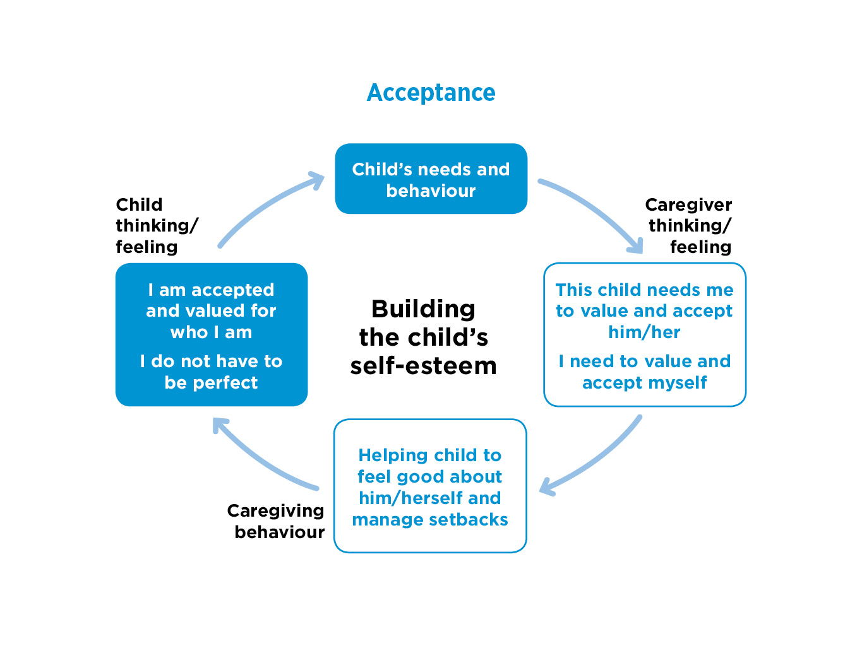

NOTES
- Now we move on to the third dimension: Acceptance -building the child’s self-esteem, which builds on the first two, both availability /trust and sensitivity/managing feelings.
READ round the cycle on the slide, starting at the top
- Acceptance is a broad and important concept – it means accepting the young person as they are, valuing their uniqueness, finding something to care about and love in them, even when the young person’s behaviour may be difficult, needs to change. This helps them to accept and value themselves, be considerate of others and be accepted by others.
- A key part of this process of acceptance /building self-esteem is about identifying and promoting the young person’s sense of their own qualities and achievements and also helping them cope with the inevitable gaps / setbacks that we all experience– both are crucial for security and resilience.
- The goal for the young person is a positive self-esteem that accepts that they / we all have strengths and limitations.
- Young people often say what they want most in life is ‘just to be accepted for who I am’- this is especially true for young people in care who may feel stigmatized.

SLIDE 32
Young people with low self-esteem
Many young people in residential care
- feel profoundly worthless, so find it difficult to trust praise or manage setbacks.
- may have experienced parenting that was negative and lacked support and encouragement.
- have experienced multiple separations within the birth family or in care that can lower self-esteem.
- tend to see other people in extremes - all good or all bad.
- defend against feelings of worthlessness – may be boastful or reluctant to compete, take risks, try new things.

NOTES
- This slide explores some of the reasons why young people in residential care may have low self-esteem.
READ SLIDE
- Do participants often find children /young people have low self-esteem when they arrive and find it difficult to trust and accept praise? Sometimes young people undermine attempts to offer praise by switching to negative behaviour.
- Important to remember that some young people may have had some good experiences they draw on to help them value themselves or certain aspects of themselves - important to identify and support areas of positivity /hopefulness.
- Note that some young people with low self-esteem can come across as boastful-‘I’m the best in my class at football’. They may be desperate to impress or just fit in. It can be hard to know how to respond when the reality is very different. But it’s important to find a way to validate the young person’s wish to be the best, while helping them feel pleased with what they do achieve.
- Note that young people who feel bad about themselves can erode other young people’s self-esteem – but they can also erode staff self-esteem too, push their buttons, demoralise them or make them feel inadequate. Staff need a place to acknowledge this, but also to feel respected and valued within the staff community. Staff need to feel accepted and be a secure base for each other.

SLIDE 33
Different kinds of problems with self-esteem
- Blaming themselves for being in care
‘Well kind of in some way it must be my fault you know. I must have done something wrong. ...The reason why I see I went into care is because of me, because I was so naughty.’ (Young person)

- Self-esteem, but from anti-social behaviour
‘I used to beat people up in town I really did - can’t stand disrespect. My mum said “If anyone hits you, hit them back and don’t listen to the authorities”.’ (Young person)
NOTES
- Young people describe very different problems with self-esteem.
READ SLIDE
- Feeling bad about themselves and even feeling to blame for being in care can contribute to low self-esteem – some children may have seen coming into care as a punishment.
- This is very common. Many young people do not know why they are in care – so too much is left to negative assumptions about themselves. This again shows the importance of life story work.
- Sources of self-esteem they have learned can be positive e.g. being good at sport, looking after family pets, but may also be damaging - such as a reputation for violence that may relate to what they saw as valued in families or powerful in their communities.

SLIDE 34
Acceptance - building the child’s self-esteem: checklist
Does the child /young person - at least sometimes:
- show positive self-esteem– think they are good at some things and able to accept not being so good at others?
- engage in purposeful activity that can build self-esteem?
- feel positive about / take pride in their appearance?
- feel positive about their school experiences?
- get involved in and enjoy activities or hobbies?
- manage the stresses of competing with others, academically and socially?
- cope with set-backs and disappointments without feeling despair?

NOTES
- As with trust and managing feelings, these questions from the Secure Base checklist can be used for assessment and planning at any stage. The aim is to look for evidence that the child has some elements of their self-esteem that are positive, while checking where the most significant needs to build self-esteem are.
READ SLIDE
- Are there signs that a young person has some elements of self-esteem that are positive? Can they be positive about aspects of their identity - birth heritage? Their ethnicity/culture?
- Where are there gaps/needs/evidence of low-self-esteem?
- How do they manage disappointments and set-backs?
- This detailed picture helps plan for what may help a particular child (next slide).

SLIDE 35
Acceptance - building the child’s self-esteem
Caregivers can:
- accept the child /young person for who they are, strengths and difficulties.
- find activities to do and to share, supporting achievements and enabling disappointments and setbacks to be managed.
- promote the idea ‘Nobody’s good at everything but everybody’s good at something’.
- model and teach the child to accept and respect different qualities and identities in self and others e.g. physical appearance, ethnicity, religion, personality, talents, sexual orientation, gender identity

NOTES
- There are a range of approaches to communicating acceptance / building self-esteem that need to be adapted to each young person – their age, history and current needs.
READ SLIDE
- These approaches to acceptance are important in one-to-one relationships between staff and young people, but are also important to build into the staff and group culture.
- How do participants look for opportunities for young people to shine/develop their strengths?
- Discuss the issue of challenging difficult behaviour while still showing understanding and acceptance of the young person.
- Praise – some young people like recognition of their achievements in front of their peers, others find this more difficult and need messages to be 1:1 or indirect e.g. staff talking positively to each other about a young person.
- In terms of a young person’s positive sense of identity – are there positive members of their birth family they can have contact with? Do they have other positive role models?

SLIDE 36
Acceptance, trust and feeling at home
- ‘I could just sit there and talk to him about anything and he don’t judge you.’ (Young person)
- ‘I had never had a best friend and when I was younger I used to class him (residential worker) as my best friend because every time he used to come into work he always used to like put a smile on me, because he used to put in a hundred and ten per cent effort. Like, you know, he would come in, give me a high five, give me a hug and all that and like proper make me feel like I actually was at home.’ (Young person)

NOTES
- These are examples of young people feeling accepted – linked to trust.
READ SLIDE
- These examples show the central importance for young people of not being judged - many have a history of this– so need to feel accepted, but also feel trust in members of staff that can help build hope that they will also be accepted by other people.
- Young people often talk of valuing staff who go the extra mile to meet their needs, and also offer a family/home like experience. This gives the message that there is a proper relationship- not ‘just a job’ - they like me, they want to help me.

SLIDE 37
Purposeful activities that build self-esteem
- ‘I have been trying to just improve my skills...I just came off a residential camping trip for four days which was quite an experience. I did canoeing which I was terrified of, abseiling, rock climbing, obstacle course. A barbecue cook out, campfire, it was just amazing!’ (Young person)
- ‘They was like helping me out... they did have a timetable for a weekly plan ...If I wanted an activity, if I wanted to go out, if I felt stressed they would take me out... and basically they was like a father and mother to us.’ (Young person)

NOTES
- These are examples from young people of acceptance and self-esteem linked to activities.
READ SLIDE
- Activities building self-esteem here are with support, at the pace of the young person and in the context of relationships. Acceptance that they are important – worth listening to, taking out and helping when stressed.
- Taking risks in a safe, secure base environment, getting over fears and anxieties leads to feelings of achievement. These may be risks or anxieties about physical activities but can be about cooking or engaging in social activities.
- Availability/trust and sensitivity- being tuned into the child - are also needed to make activities work to build self-esteem for the young person.
- Ask participants - do they find any particular kinds of activities helpful for young people in building self-esteem?

SLIDE 38
Feeling accepted and encouraged to be ambitious for themselves
- At the time I had no intention of going to university, but she said, “Well why don’t we put it in your Pathway Plan?” ... I was like fair enough.’ (Young person from previously disrupted school career who went on to complete a nursing degree)
- ‘Where would I be today if it weren’t for them? I would probably be in jail, drugs, fighting.’ (Young person)

NOTES
- Helping people to be ambitious for themselves may be about positive things they can achieve, but bearing in mind the negative pathways which can be avoided- as these examples suggest.
READ SLIDE
- Accepting and helping young people to be ambitious for themselves means encouraging them to fulfil their potential, whether in education or other ways. Also being realistic, but showing belief in someone’s potential is hugely important.
- This includes helping young people to be successful in prosocial ways e.g. finding activities that support self-esteem and help young people to avoid being drawn into problem behaviour.

SLIDE 39
EXERCISE 4 Acceptance – building a young person’s self-esteem
- Rob (13) had come into care at the age of 7 from a background of neglect. He has ADHD and learning difficulties. A positive long-term foster care placement had ended following bereavements in the foster family and growing difficulties in managing his anti-social behaviour. He came into residential care age 12, but continued to struggle at school and with peer relationships.
- What could staff in the home do to show acceptance and support Rob’s self-esteem?
- What may be the barriers (in the child or the home or the community) that make this difficult?

NOTES
- This exercise uses a case example that shows a combination of difficulties for a young person that is not unusual.
READ SLIDE
- Discussion -in small groups with group feedback- should highlight opportunities and challenges in the home, while also thinking of how staff work with schools, activity clubs etc. outside of the home.
- What opportunities does your home offer? How do you /could you work with schools? Activity clubs? Police?
- But it’s important to help with all aspects of the young person’s experiences of these ‘labels’ – for example not only taking account of the young person’s experience of an ADHD diagnosis and learning difficulties, but also their past positive experiences and experiences of loss, as for all young people in care.

SLIDE 40
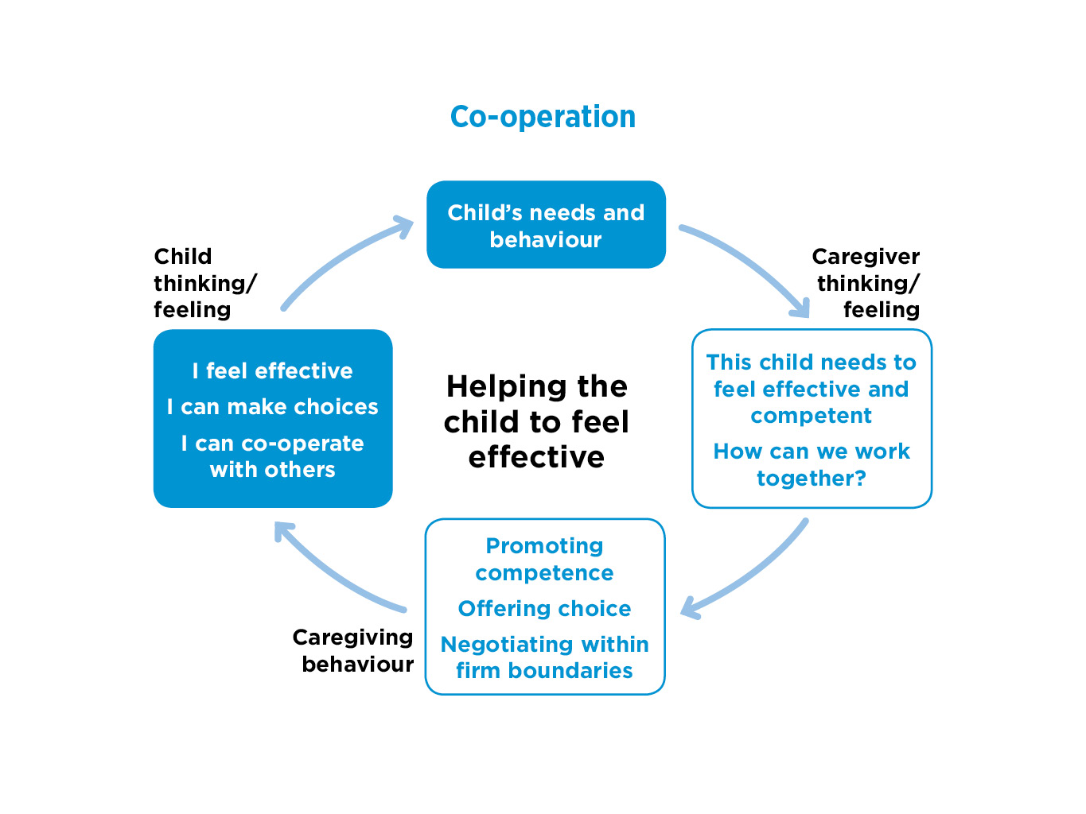

NOTES
- Next the fourth dimension that builds on the previous three - co-operation helping children and young people to feel effective
READ round the cycle on the slide, starting at the top
- This cycle needs extra thought – caregivers need to think about how important it is for young people to feel competent and confident/make choices within safe boundaries. AND to make connections between the young person starting to feel more effective and competent with becoming better able to negotiate and co-operate.
- Sometimes there can be a belief that the caregiver needs to be in a position of control before working together - but explaining expectations and boundaries builds mutual respect and helps to avoid battles. Being respectful reduces the need for the child to feel they have to hold onto power/control.
- Authoritative parenting is the aim - firm boundaries / expectations combined with high warmth and promoting autonomy. Boundaries need to be explained to the young person to engage them in making positive, safe choices in and outside the home.
- It’s important to be aware of the young person’s social context and the wider environment. Boundaries are necessary for adolescents, but also the ability to exercise their own judgement – both are needed to help young people stay safe where they are facing risk of, for example, racism, exploitation, stigma or homophobia in the community.

SLIDE 41
Young people who do not feel effective and find it hard to compromise or co-operate
Many young people who come into residential care
- lack confidence in getting their needs met
- have rarely experienced co-operative parenting – parents may have been too controlling and intrusive or too passive, ineffective or neglectful.
- have felt powerless or too powerful and controlling in birth families.
- have felt powerless in the care system (e.g. not feeling consulted about moves) or powerful in negative ways (e.g. intimidating foster carers, ending placements).

NOTES
- As with other dimensions, there are varied reasons why young people coming into residential care may not feel effective or be able to co-operate.
READ SLIDE
- It’s helpful to understand the varying contexts that young people may have experienced that led to difficulty in asserting themselves appropriately /resisting co-operation and compromise.
- Young people who may have felt powerless or too powerful in birth families or in care find it hard to trust in compromise or co-operation.
- Respect and co-operation may have seemed missing in their lives - sometimes from professionals too. Young people may have feelings that their voice was not heard or acted upon. Can lead to giving up, not asking for help or sharing needs and wishes - perhaps not even being able to tune into and name their own needs and wishes.

SLIDE 42
Co-operation- helping the young person to feel effective: checklist
Does the child /young person - at least sometimes
- think through options and make appropriate choices?
- assert themselves appropriately?
- feel effective and competent to get their needs met?
- co-operate with staff and other authority figures?
- co-operate with peers and siblings?

NOTES
- These questions from the Secure Base checklist are about the extent to which a young person feels effective – identifying the positive elements as well as gaps. These can be used to reflect on in assessments and in discussion with the young person.
READ SLIDE
- Where there are positive elements for young people -however uncertain and tentative – for example, a young person might at times be able to make positive choices or work together with other young people - these can be built on.
- When young people are unable to assert themselves appropriately or co-operate, they may become too passive and become victims of bullying or exploitation.
- In contrast, young people unable to assert themselves appropriately, for example taking other people’s needs and feelings into account, may become aggressive and perhaps bully others.
- In either case, their anxieties remain and they will struggle to build rewarding relationships or get their needs met. This leaves important areas to help young people with (as will be explored in the next slide).

SLIDE 43
Co-operation- helping the young person to feel effective
Caregivers can:
- promote choice and autonomy within safe boundaries.
- help the young person to achieve results on their own, feel effective but also accept help.
- form a co-operative alliance with the young person - help the young person to see and experience the benefits of negotiation and compromise.
- promote co-operative behaviour within the group of young people and between young people and staff.

NOTES
- There are a range of ways in which staff can support young people to feel effective - and be co-operative. These are just some ideas.
READ SLIDE
- These processes, such as offering choice, are relevant from the start of placement. Some young people find it hard at first to choose or make decisions from choice of breakfast cereals to much more difficult choices, such as how often they wish to have contact with a family member. They can feel overwhelmed by choice or just not be used to tuning into what they want or weighing up implications.
- Helping young people to make prosocial decisions about their own behaviour is essential- as is understanding the need for boundaries.
- There is a need for a group culture of enabling choice within boundaries / working together / sharing responsibility / taking turns, listening to each other.
- It can be difficult for staff to get the balance between being in charge /setting boundaries and enabling degrees of choice, given the need for boundaries around personal safety of staff and young people. But promoting co-operation can promote prosocial behaviour and reduce the need for restraint.

SLIDE 44
Being helped to be effective – staff not giving up on you
- ‘It was just, they supported you, they didn’t give up on you. They made you learn who you were…They help you realise that you can do things and you might act like a spoiled brat and you might not want to go to school, you might get kicked out of school, but they (staff) put your lives back on track and they sort of try and tell you, ‘You can do that’ –they don’t give up on you.’ (Young person)

NOTES
- This example focuses on helping young people to feel effective by giving the message – we won’t give up on you.
READ young person’s quote from the slide
- This young person is showing a healthy awareness that they had tested staff with their difficult behaviour, but staff had not given up on them. Note this isn’t about one member of staff- but the group of staff- ‘they supported you’.
- This quote links feeling effective / working together with feeling accepted. It also links to identity – learning who you are.
- And it shows the young person ‘We care about you, your future- so we won’t give up on you. We want you to make the right choices, to have a good life’. Supports a more positive internal working model.

SLIDE 45
EXERCISE 5 Co-operation- helping the young person to feel effective

Jack (15) stays out later than agreed and it’s not known where he has been.

- Consider what factors may lay behind Jack’s behaviour.
- How might you help Jack to feel effective and be co-operative within safe boundaries?

NOTES
- This exercise explores the link between being effective and co-operative.
READ SLIDE
- This exercise could be done as a whole group discussion or in small groups, depending on numbers. Ask participants for responses to the questions.
- Can add after discussion: this is a common problem in managing boundaries with young people - staying out late. But it’s important to consider the range of factors that Jack may have experienced and that he needs help with e.g. Not being aware of time? Peer pressure? Accepting there can be risk at night?
- Then the question of what can be helpful - motivating Jack to stay within boundaries to keep himself safe.

SLIDE 46
Being supported to become more confident and competent after leaving residential care
- ‘She’s a lovely lady. If it weren’t for her (leaving care worker) I probably still wouldn’t be ringing up about the bills. She would ring up like the council because I wouldn’t have a clue. And I would be just watching her and I am like, ‘At least I don’t have to do it’. It got to the point like, ‘No, I’ll do it now, I’ll do it.’
But she’ll still come round for coffee. I don’t see her as often and I don’t really notice that, but I think it’s because I don’t need her as much. I still think she is there if I need her. If I got really stuck in the dirt, I can turn to her and just sort of say, “I need help”.’ (Young person)

NOTES
- This is an example of staff building competence in key skills by helping, demonstrating – and then enabling the young person to take over.
READ SLIDE
- But once young people are ‘independent’ young adults, it’s still important for them to know there is support available after leaving residential care.
- Leaving care- important example of the combination of the need for developing self-reliance but in the context of co-operative relationships and a secure base.

SLIDE 47
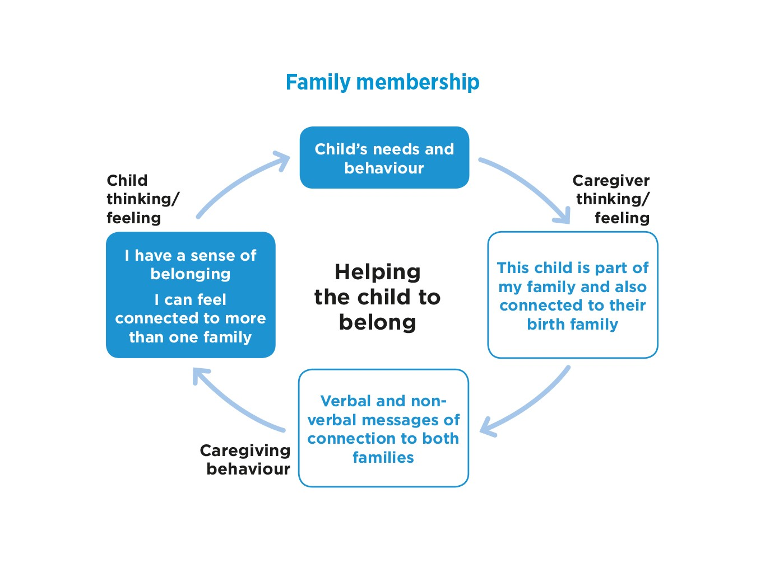

NOTES
- Family membership and a sense of belonging- this is an important dimension to think about in relation to residential care. There can be a sense of belonging / membership of the children’s home group as a ‘family’ alongside other families- birth family, foster family, adoptive family.
READ round the cycle on the slide.
- Some children have never felt they belong anywhere, not valued as part of their family/previous foster family.
- But there may be some potentially life-long links in the birth family that need to be identified /promoted.
- Caregivers need also to support a young person’s wider sense of belonging - in community groups e.g. football team, LGBTQ youth club, theatre group.
- Helping young people to negotiate their identity and sources of support into adulthood is an important part of this dimension. Where can they belong in the future? Is there an activity / hobby that they can take into a new environment / adulthood?

SLIDE 48
Young people who do not feel they fully belong - in any family or group
- Young people may have felt rejected by their birth, foster or adoptive families
- But they may still long for a connection to those families
- In a residential home they may find it hard to join in with the group
- Young people may lack trust and resist encouragement to belong
- The idea of the home /staff as ‘like a family’ will be valued by some young people, but rejected by others.

NOTES
- It’s important to understand why some young people do not feel they fully belong - in any family or group.
READ SLIDE
- Young people at the point they move into a children’s home often feel they lack roots or an identity they can feel positive about, so they are anxious about new relationships / the group.
- Young people may also feel ambivalent about previous families. They may have had some positive and some negative experiences in birth or foster families or children’s homes – or perhaps want to be loved by birth family members who have rejected them. All are difficult feelings to be managed.

SLIDE 49
Family membership- helping the child to belong: checklist
Does the child/young person - at least sometimes
- seem comfortable spending time with the staff group?
- seem comfortable spending time with the group of young people?
- seem willing/happy to be involved in group activities?
- enjoy special occasions with the group?
- have a balanced sense of identity with their peer group e.g. value their opinions but can be true to themselves?
- have a positive relationship with at least one birth family member?
- have a coherent life story for their birth family and care history?

NOTES
- So if we think about an individual young person - we need to ask some questions about their relationships and sense of belonging /identity.
READ SLIDE
- These are important questions - it can be difficult to get a sense of a young person’s identity /sense of belonging, so it’s useful to start by exploring the young person’s level of comfort with adults /peer groups / different families.
- And then think about what areas of positive identity or sense of belonging can be supported and where there are difficulties that need active help (next slide).

SLIDE 50
EXERCISE 6 Family membership- helping the child to belong:
Caregivers can:
- ensure the young person new to the home understands how the home does things.
- include the young person in home activities, photos etc.
- enable the young person to have their own space and identity.
- help the young person to feel valued for themselves and as part of the group – develop a positive sense of belonging.
- enable the young person to make sense of the past, talk about / value their birth family identity and other relationships.
- manage contact with birth family and significant others to promote the young person’s development and well-being.

NOTES
- These are some suggestions for ways in which young people can be helped to belong – here used as an exercise / basis for discussion.
READ SLIDE
- Ask group for any ideas about what they do to support children’s identity and sense of belonging? What are the challenges? What seems to work for some young people?
After discussion - could add /summarise key points
- Establishing identity and a sense of belonging is an important task in adolescence that needs extra support for young people in residential care e.g. through life story work; photos; personal and shared spaces.
- Care staff and social workers need to support successful contact and maintenance of previous relationships that are significant to the young person. This could include extended family members and former foster carers, who may be available to offer support in adulthood. Potential life-long links should be promoted.

SLIDE 51
Making their room and the home their own
- ‘I could settle a bit more... because I had my own room. I could pick my own colours, everything like that.’ (Young person)
- ‘I felt really good because we got to like raise money – we raised money for what we called the games room because it had a table tennis table, but we changed it to a chill out room, so we got a sofa and some bean bags and just like decorated the room’
Was it better than before?
‘Yes because we made it our own.’ (Young person)

NOTES
- These are examples from young people of the value of practical ways in which individual and group sense of belonging and identity can be enhanced.
READ SLIDE
- These are also good examples of young people having choice and feeling effective/making a difference.
- Ask participants if they have experience of similar examples.

SLIDE 52
Staff were like parents – not just ‘paid to care’
- ‘When I first moved in I thought she (residential worker) was paid to care - but if I stayed out all night she’d be ‘I was really worried about you’, like kind of how a parent would be.’(Young person)

NOTES
- Research with young people and staff often reflects a strong sense of positive residential care feeling like a family.
READ SLIDE
- Young people wish to feel cared about for themselves – as in a family with caring parents.

SLIDE 53
Residential home giving a sense of belonging to a family: young people’s comments
- ‘Instead of it being a house it became an actual home for us where we could actually feel like where we lived was a family.’
- ‘They spoke to you like a family, “How are you today?”. Like any mum and dad would do.’
- ‘They actually took me on as their own family that loved me, they loved me they did.’
- ‘Before I left I said to them, you’re like my actual family, because I have got my actual family, but you are like a second family. You have helped me through life when it gets tough.’

NOTES
- These are more examples of the ways in which young people try to put that experience of feeling part of a family in residential care.
READ SLIDE
- Different elements of family and home are identified by young people.
- But it’s also important to identify birth family relationships- and work to make them as positive as possible (see next slide).

SLIDE 54
Birth family membership, contact and relationships
- ‘I can be closer to her (aunt) than I am to any other member of the family and it is nice knowing that she is there. It is kind of like a security and safe, because even though I have got a lot of people I can go to, this is an extra security. She doesn’t have a file on me like a social worker does and things like that, she has experience of me rather than files - she knows me better than most people.’ (Young person)

NOTES
- It’s important to identify positive birth family members and support constructive relationships.
READ SLIDE
- But for some young people, support is needed to manage boundaries around difficult birth family relationships and anti-social lifestyles.
- Important to talk about the birth family, help young people to empathise and understand why parents may have struggled to care for them (e.g. mental illness/special needs/ their own parenting/upbringing). Help young people make positive decisions around family – including setting boundaries when necessary.

SLIDE 55
Leaving residential care- the need for a secure base into early adulthood
- I think when they get to that transitions stage their stress behaviour, that they have learned from when they were tiny, all comes out and we have found 18-year-olds that will go back to being 8 - “I can’t look after myself, I can’t wash, I can’t do this.” They recall that time and they are absolutely terrified.’ (Residential worker)
- ‘You get attached to them (residential workers), but when it is time for you to leave it is actually kind of sad and emotional. You realise that you are not always going to wake up every day, going downstairs. It is not going to be the same, so it is kind of hard.’ (Young person)

NOTES
- Anticipation by young people of what will happen when they leave care can affect how they (and staff) feel throughout the time in the home – how much will young people invest in relationships if they expect to have a complete cut off after ‘leaving care’?
READ SLIDE
- Some young people get so anxious when they know they are reaching the age when they are due to leave that their challenging behaviour can precipitate an even earlier and unplanned move.
- However successful the home has been in providing a secure base for a young person to help them thrive, they will need support into adulthood - as all young people do, but with extra vulnerabilities- psychologically and practically.
- How have your care leavers reacted to leaving? And when living independently? What lessons have been learnt?

SLIDE 56
Summary outcomes of the Secure Base dimensions 10 –18 years:
- Trust: capacity to trust adults and peers, as a secure base for exploration
- Managing feelings: capacity for expressing and regulating emotions.
- Self-esteem: capacity for positive feelings about self and coping with set-backs.
- Feeling effective: confident to make choices; able to co-operate and negotiate.
- Belonging / family membership: coherent sense of family belonging /connection to significant people.

NOTES
- Now that we have looked at the five dimensions of the Secure Base model, this slide helps put the dimensions together as a summary of what we are aiming for in young people’s development.
READ SLIDE
- Examples can be given to show how all the dimensions work together:
- increasing a young person’s trust may enable them to express and manage their feelings. (e.g. turning to positive people not to aggression, drugs, self-harm).
- Trust to try new activities supports self-esteem – staff being with young people when they try new activities helps build trust.
- Improving arrangements for contact may help with family membership, but also self-esteem and identity.
- And important to observe, record and discuss –celebrate- even slow steps of progress (see next slide).

SLIDE 57
Use of the Secure Base model to support young people’s progress
- Observation, recording and discussion across each dimension can highlight a young person’s strengths and progress as well as difficulties and areas for intervention.
- Ideas for future positive caregiving can be generated and the child’s progress in each dimension recorded and reviewed.

NOTES
- It’s important to have procedures and systems that build the Secure Base model into daily practice as part of promoting each child’s well-being.
READ SLIDE
- Recording in order to share and discuss aims and progress can use different formats (see next slide).
SLIDE 58
Young person’s progress record
 | Current situation | Caregiving approaches | Review
Availability/trust
Sensitivity/
managing feelings
Acceptance /self-esteem
Co-operation/ feeling effective
Family membership /belonging

NOTES
Explain slide
- A progress record can be formatted as a table, as in this example, or the dimensions can be sub-headings in a report.
- It can be used as a record for the files and basis for discussion at key points in a young person’s time in the children’s home and for regular reviews - or when a young person may be struggling.
- Daily records for a young person wouldn’t need to mention all dimensions just those that are relevant that day.
- This is to show how the model can be applied to thinking about individual young people. How are they managing in each of these areas? How is their development / life in the home progressing? What can be offered to help the young person achieve their potential?

SLIDE 59
Exercise 7 Providing a secure base for young people in residential care
- Residential staff who provide secure base care and relationships are a key therapeutic resource for young people.
- The Secure Base model can provide a framework for promoting caregivers’ strengths and improving outcomes for young people into adulthood.
- Discussion: what practical ideas can you suggest for implementing the Secure Base model in your workplace / current work with young people?

NOTES
- This is an opportunity for the group to discuss how the Secure Base model could be taken forward into practice, documentation etc. in their children’s home.
READ SLIDE
- What do participants think? How could they implement this model? What are they already doing? What could they improve?
- How do they discuss a young person’s progress or difficulties? Track progress? Assess and review? Work with other professionals? How would using these dimensions fit?

SLIDE 60

NOTES
- Final words- it’s worth reflecting on the starting point of the session – the aim to understand and use the Secure Base model to help staff help young people in residential care to become more secure and resilient.
- The explanation of attachment and resilience and the practical examples and discussion of their own experiences have helped to apply these ideas to their daily role in providing positive care and relationships.
- There is an implementation guide on the website - and each home/staff group can think about ways of taking it forward in their own context.

- Thank you for attending. We hope you enjoyed the session and that it has been useful.

